Atmo 170A1 Name_______________________________
Optional Assignment

1. During combustion fossil fuels and ______ react to form ______, _______ and _______.
a. nitrogen (N₂) b. oxygen (O₂) c. carbon monoxide (CO)
d. water vapor (H₂O) e. carbon dioxide (CO₂) f. Ozone (O₃)

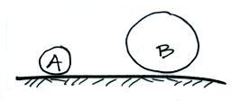
2. Objects A and B at right have the same weight.
Object A has larger _______, smaller ______,
but the same _______ than(as) Object B.
a. composition b. density
c. mass d. volume

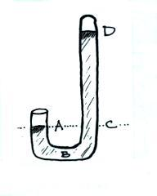
3. The atmospheric concentration of _________________________ can range from near 4% in warm tropical locations to a fraction of 1% in cold polar regions.

4. You would expect to find unusually HIGH LOW sea level pressure values in the center of a strong hurricane.

5. The pressures at Point A and at Point _______
on the mercury barometer at right would be equal.
The pressure at Point _______ should be zero.
At sea level the distance between Point D and
Point _______ should be about 30 inches.

6. If the force of gravity on the earth were to increase but the amount (mass) of air in the atmosphere remained the same, would atmospheric pressure at sea level INCREASE, DECREASE, or remain the SAME?

7. Water vapor is an invisible gas. We can see clouds because clouds are composed of ________________________ and/or _________________________ which scatter light.
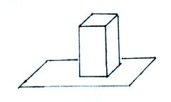
8. The figure at right shows a brick standing on its
end. If you multiplied the area of the end of the
brick by the height of the brick you would get
the brick’s ____________________. If you
divided the mass of the brick by its volume you
would get the brick’s ____________________.
The weight of the brick divided by the area of the
end of the brick would be the ____________________ exerted by the brick on the surface supporting it.

9. Air pressure DECREASES INCREASES with increasing altitude in the atmosphere. This produces a net UPWARD DOWNWARD pointing force.

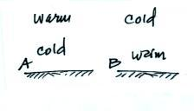
10. Would you expect to find a temperature pattern
like that shown in FIG. A or FIG. B on a warm
summer afternoon. Would the pattern shown in
FIG. A or in FIG. B produce stable atmospheric
conditions.

11. At the summit of Mt. Lemmon (9000 ft. altitude) the pressure will be _______________, the air density will be _______________, and the air temperature will be _______________ than(as) in the Tucson valley (about 2500 ft. altitude).
[fill in each blank with HIGHER, LOWER, or the SAME)

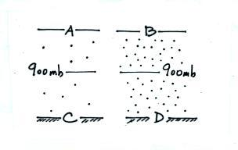
12. Based on the pressure and air density information
shown in the figure at right show where you would
expect to find each of the following pressure values.

820 mb_______ 990 mb_______

780 mb_______ 1020 mb_______

13. The ozone layer is centered near 25 km altitude where there are optimal amounts of _________________________ and _________________________.
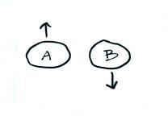

14. The two balloons at right have the same volume
and both contain air. How could you explain the
fact that one balloon is rising and the other is
sinking?

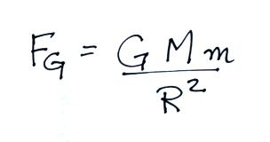
15. The gravitational force that the earth exerts on the moon is given by the equation below. Who discovered or formulated this equation. What do the variables M, m and R represent.

