Atmo 170A1 Name_________Answers_____________
Optional Assignment

1. During combustion fossil fuels and ___b__ react to form ___c__, __d___ and __e____.
a. nitrogen (N₂) b. oxygen (O₂) c. carbon monoxide (CO)
d. water vapor (H₂O) e. carbon dioxide (CO₂) f. Ozone (O₃)
many people also pointed out that energy is also produced during combustion

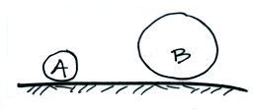
2. Objects A and B at right have the same weight.
Object A has larger _density_, smaller _volume_,
but the same __mass__ than(as) Object B.
a. composition b. density
c. mass d. volume

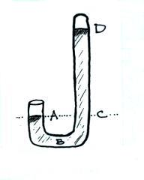
3. The atmospheric concentration of ______water vapor____________ can range from near 4% in warm tropical locations to a fraction of 1% in cold polar regions.

4. You would expect to find unusually HIGH LOW sea level pressure values in the center of a strong hurricane.

5. The pressures at Point A and at Point ___C___
on the mercury barometer at right would be equal.
The pressure at Point ___D___ should be zero.
At sea level the distance between Point D and
Point ___C___ should be about 30 inches.

6. If the force of gravity on the earth were to increase but the amount (mass) of air in the atmosphere remained the same, would atmospheric pressure at sea level INCREASE, DECREASE, or remain the SAME?
Pressure depends on the weight of the atmosphere. Weight is determined by both mass and gravity. If gravity increases the weight will increase also even if the mass stays the same.

7. Water vapor is an invisible gas. We can see clouds because clouds are composed of cloud droplets (water = liquid) and/or ice crystals (solid) which scatter light.
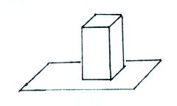
8. The figure at right shows a brick standing on its
end. If you multiplied the area of the end of the
brick by the height of the brick you would get
the brick’s ______volume________. If you
divided the mass of the brick by its volume you
would get the brick’s ______density________.
The weight of the brick divided by the area of the
end of the brick would be the _____pressure________ exerted by the brick on the surface supporting it.

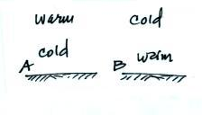
9. Air pressure DECREASES INCREASES with increasing altitude in the atmosphere. This produces a net UPWARD DOWNWARD pointing force.

10. Would you expect to find a temperature pattern
like that shown in FIG. A or FIG. B on a warm
summer afternoon. Would the pattern shown in
FIG. A or in FIG. B produce stable atmospheric
conditions.
Temperature in Fig. A is increasing with altitude, that’s a temperature inversion.

11. At the summit of Mt. Lemmon (9000 ft. altitude) the pressure will be ___LOWER___, the air density will be ___LOWER__, and the air temperature will be ___LOWER___ than(as) in the Tucson valley (about 2500 ft. altitude).
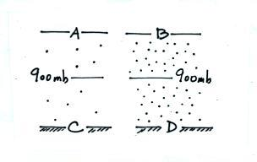
[fill in each blank with HIGHER, LOWER, or the SAME)

12. Based on the pressure and air density information
shown in the figure at right show where you would
expect to find each of the following pressure values.

820 mb___A___ 990 mb___C___

780 mb___B___ 1020 mb__D____

The pressure will change more slowly with altitude in the lower density air in the left picture. It decreases 80 mb as you go from 900 mb to Point A. It increases 90 mb when going from 900 mb to Point C.
The pressure changes more rapidly in the denser air at right. Pressure drops from 900 mb to 780 mb at Point B, a 120 mb drop. Pressure increases 120 mb when going from the 900 mb level to Point D.

13. The ozone layer is centered near 25 km altitude where there are optimal amounts of _______oxygen____________ and ____ultraviolet light_________________.
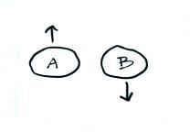

14. The two balloons at right have the same volume
and both contain air. How could you explain the
fact that one balloon is rising and the other is
sinking?
The air in A must be warmer and have lower density than the air in B.

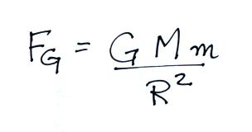
15. The gravitational force that the earth exerts on the moon is given by the equation below. Who discovered or formulated this equation. What do the variables M, m and R represent.

This is Newton’s Law of Universal Gravitation. F is the gravitational force that one object (mass = M) has on another (mass = m). R is the distance between the 2 objects. G is a constant.

