Atmo 170 A1 Name_______________________________
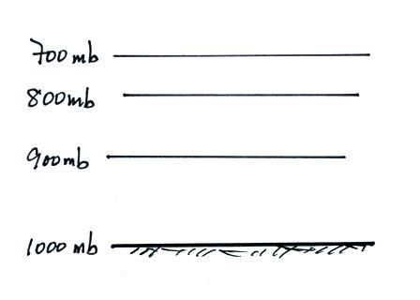
In-class Optional Assignment

1. What’s wrong with the picture at right

2. Temperature decreases with increasing altitude in the __________
The top of Mt. Lemmon (alt. 9000 ft) is in the __________
Thunderstorms can form in the __________
A temperature inversion between 20 and 50 km makes the _______ a very stable layer.
The ozone layer is found in the __________ (fill in each blank with a T for troposphere or an S for stratosphere)

3. If you start to add air to a rigid container, the number of air molecules N will __________, the container volume V will __________, and the pressure of the air in the container will __________. (fill in each blank with INCRease, DECRease, or remain the SAME; you can assume the air temperature remains constant)

4. If you warm a parcel (volume) of air in the atmosphere, the __________ and __________ will increase, the __________ will decrease, and the __________ and __________will remain constant. (fill in the blanks with Density, Number of air molecules, Pressure, Temperature, or Volume; each answer should be used once)

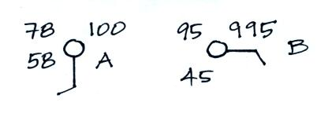
5. The atmosphere can be split into layers according to how air COMPOSITION DENSITY PRESSURE TEMPERATURE changes with altitude.

8. Does CITY A or CITY B have the highest relative humidity?
Does CITY A or CITY B have the highest actual amount of water vapor in the air?

6. A parcel of warm air will rise because the DENSITY PRESSURE of the air inside the parcel is HIGHER LOWER than that of the surrounding air.

7. If you double the volume, double the number of air molecules, and double the temperature of the air inside a parcel the pressure will INCREASE DECREASE remain the SAME.

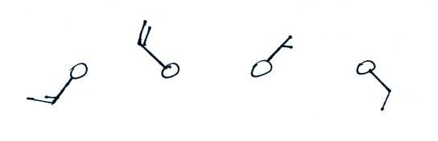
9. Which of the figures shows
northeasterly winds?

