We will check the various parts of the complex figure to be sure they are in energy balance. We will start with the atmosphere.
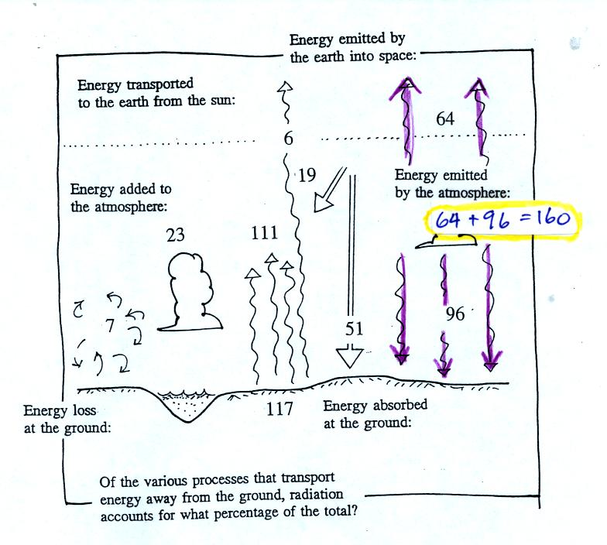
The atmosphere is emitting 160 units of energy. 64 units go up and into space, 96 units go down and are absorbed by the ground. How would you explain the difference between the amounts being emitted upward and downward. One explanation might be temperature. The upper atmosphere might be colder than the lower atmosphere. Colder air would emit less EM radiation than warm air. The air density at high altitude is lower than at low altitude. With less air it makes sense that there would be less emitted light.
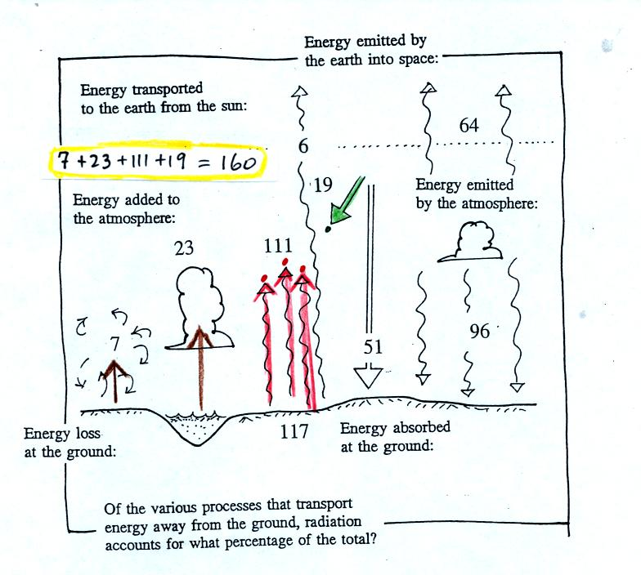
19 units of sunlight energy are being absorbed by the atmosphere. 111 units of IR radiation emitted by the ground are absorbed by the atmosphere. The 23 units at left is energy transported in the form of latent heat (water in the lake evaporates, heat is released into the atmosphere when the water vapor condenses and forms the cloud). Together conduction and convection transport 7 units of energy from the ground to the atmosphere. That is a total of 160 units and balances the 160 units of energy being emited by the air.
Next energy loss and gain at the ground
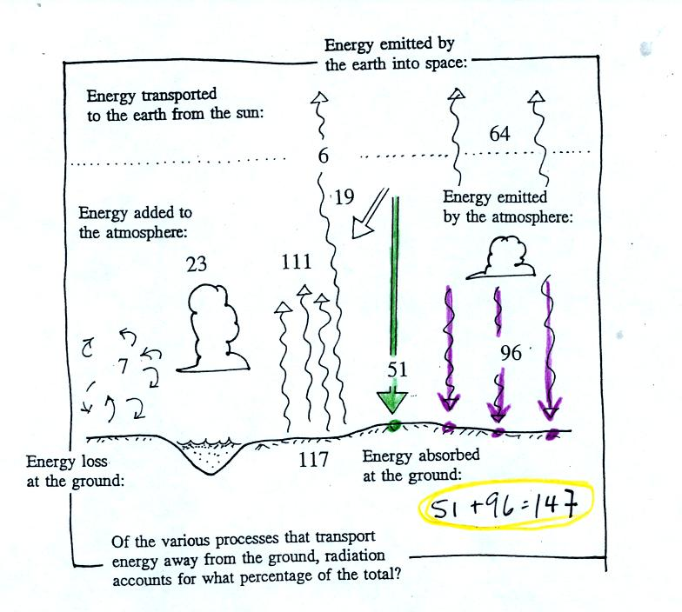
The ground is absorbing 147 units of energy. Surprisingly the ground gets almost twice as much energy (96 units) from the atmosphere as it gets from the sun (51 units). This is partly due to the fact that the sun is shining on any particular area for part of the day while the atmosphere is emitting IR radiation downward toward the ground all the time.
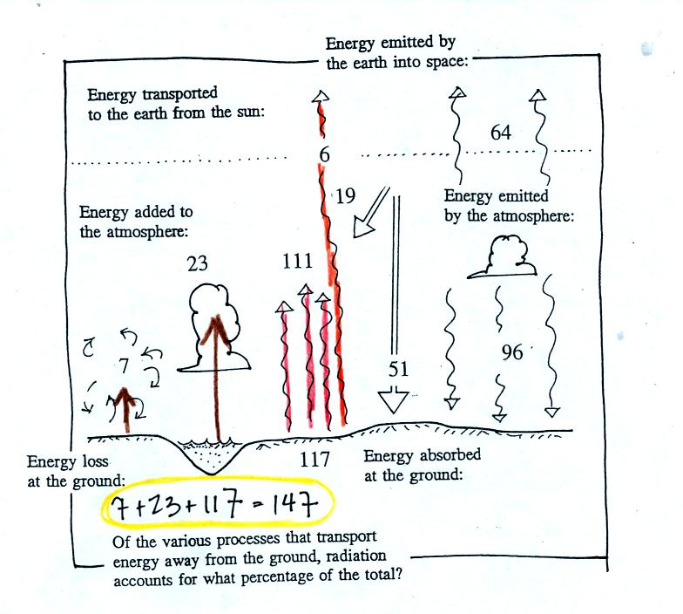
The ground is losing 147 units of energy, so everything is in balance at the ground.

Next we'll check energy arriving at the top of the atmosphere from space and energy leaving the atmosphere and going back out into space.
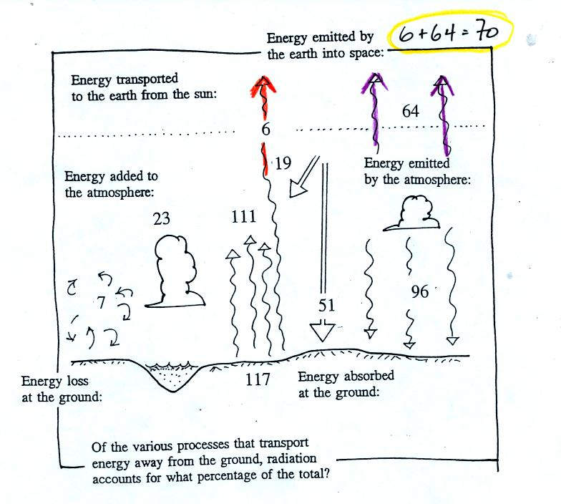
The earth and atmosphere send 70 units out into space. This is balanced by 70 units of sunlight arriving at the earth shown in the figure below.
