Clouds clean particulates and pollutants from the air | Particles (so called cloud condensation nuclei) play an essential role in cloud formation | clouds and climate change

When the air is saturated with water vapor (RH = 100%) the rates of evaporation and condensation above a flat surface of water will be equal.
It's hard for water vapor to condense and form a small droplet of water.
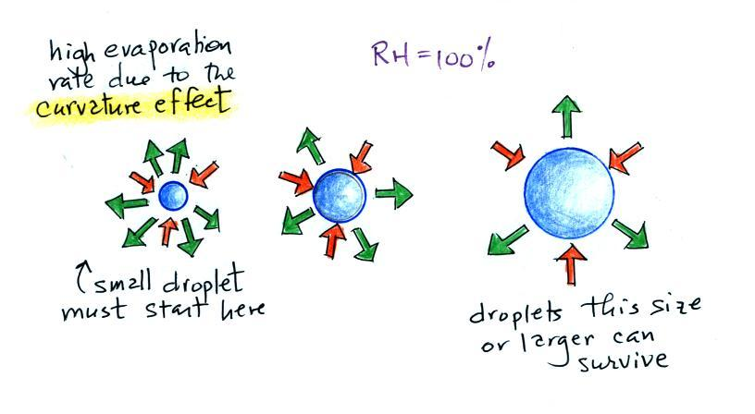

Small droplets evaporate at a very high rate. There's not enough moisture in the air, not enough condensation for the small droplet to survive.

If water vapor can condense onto a particle it effectively starts out much larger and is in equilibrium with the surroundings.

Here's another scenario. Some particles will dissolve when water condenses onto them (this would be true of small particles of salt). Note the solution has a lower rate of evaporation. Note also that it is possible for small droplets to form and be in equilibrium when the RH < 100%.

