ATMO 170A1 Optional Assignment Name__________________________________
(due at the start of class on Tue., Sep. 23)

1. Air pressure DECREASES INCREASES with increasing altitude. This produces a pressure difference force that always points DOWNWARD UPWARD. Air density DECREASES INCREASES with increasing altitude. The rate at which pressure changes with increasing altitude is DIRECTLY INVERSELY proportional to air density.

2. Which one of the following doesn't belong in the same group as the other three?
a. stable layer b. stratosphere c. temperature inversion d. thunderstorm

3. Which of the following would you expect to be part of a photochemical reaction?
a. water b. ultraviolet light c. an acid d. plants e. CFCs

4. When air is cooled to _________________________ the relative humidity increases to 100% and dew, fog, or clouds will form.

5. _______ are the two main greenhouse gases. _______ are the main summer and winter air pollutants of concern in Tucson. _______ were the most abundant gases in the earth's original atmosphere. (fill in the blanks)
a. Nitrogen (N₂) & oxygen (O₂) b. Carbon dioxide (CO₂) and water vapor (H₂O)
c. Hydrogen (H) & helium (He) d. Ozone (O₃) and carbon monoxide (CO)
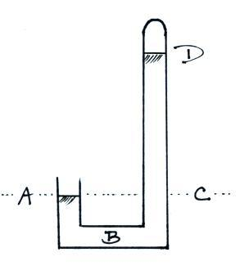

6. The same pressure would be measured at
Points _______ and _______ on the
barometer shown at right. The pressure is
zero at Point _______. The highest
pressure would be found at Point _______.
(each letter in the figure at right should be
used once as an answer)

7. Water vapor and carbon dioxide are added to the air during _______. _______ could add both carbon monoxide and sulfur dioxide to the air. Oxygen is added to the air by _______. (fill in each blank with C for combustion, P for photosynthesis, B for both combustion and photosynthesis, or N for neither combustion nor photosynthesis)

8. Ozone reacts with _________________________ to form photochemical smog.
9. If the force of gravity were to increase but the amount (mass) of air in the atmosphere remained constant would the atmospheric pressure at sea level INCREASE DECREASE or remain the SAME?

10. Is the blue color of the sky caused by scattering of sunlight by AIR MOLECULES or by PARTICULATE MATTER.

11. If the number of air molecules, N, and the temperature, T, of air molecules inside a volume were both to double, the volume, V, would need to _______ in order for the pressure, P, to stay constant.
a. increase by a factor of 2 b. increase by a factor of 4 c. remain constant
d. decrease by a factor of 2 e. decrease by a factor of 4

12. Record setting HIGH LOW values of sea level atmospheric pressure have all been set by hurricanes.

13. To determine whether an object will float or sink when thrown into water it would be best to known the object’s
a. density b. mass c. volume d. weight

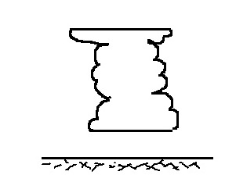
14. If you warm a parcel of air, the ______ will increase, the _______ will decrease, and the _______ will remain constant. (fill in each blank with P for pressure, V for volume, or
ρ for density)

15. The flat top of a thunderstorm cloud is called a(n)
ANVIL SHELF cloud and often marks the top of
the ATMOSPHERE STRATOSPHERE TROPOSPHERE.

