ATMO 170A1 Optional Assignment Name___________Answers________________
(due at the start of class on Tue., Sep. 23)

1. Air pressure DECREASES INCREASES with increasing altitude. This produces a pressure difference force that always points DOWNWARD UPWARD. Air density DECREASES INCREASES with increasing altitude. The rate at which pressure changes with increasing altitude is DIRECTLY INVERSELY proportional to air density. Pressure changes more rapidly in high density air than in low density air.

2. Which one of the following doesn't belong in the same group as the other three?
a. stable layer b. stratosphere c. temperature inversion d. thunderstorm
A thunderstorm indicates unstable atmospheric conditions. Temperature increases with increasing altitude in the stratophere. That's a temperature inversion and produces stable atmospheric conditions.

3. Which of the following would you expect to be part of a photochemical reaction?
a. water b. ultraviolet light c. an acid d. plants e. CFCs

4. When air is cooled to ___the dew point___________ the relative humidity increases to 100% and dew, fog, or clouds will form.

5. ___b___ are the two main greenhouse gases. ___d___ are the main summer and winter air pollutants of concern in Tucson. ___c___ were the most abundant gases in the earth's original atmosphere. (fill in the blanks)
a. Nitrogen (N₂) & oxygen (O₂) b. Carbon dioxide (CO₂) and water vapor (H₂O)
c. Hydrogen (H) & helium (He) d. Ozone (O₃) and carbon monoxide (CO)
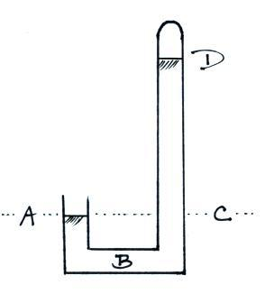

6. The same pressure would be measured at
Points ___A___ and ___C___ on the
barometer shown at right. The pressure is
zero at Point ___D___. The highest
pressure would be found at Point ___B____.
(each letter in the figure at right should be
used once as an answer)

7. Water vapor and carbon dioxide are added to the air during ___C___. ___C___ could add both carbon monoxide and sulfur dioxide to the air. Oxygen is added to the air by ___P___. (fill in each blank with C for combustion, P for photosynthesis, B for both combustion and photosynthesis, or N for neither combustion nor photosynthesis)

8. Ozone reacts with ______hydrocarbons____________ to form photochemical smog.

9. If the force of gravity were to increase but the amount (mass) of air in the atmosphere remained constant would the atmospheric pressure at sea level INCREASE DECREASE or remain the SAME? Pressure is determined by the weight of the air overhead. Increasing gravity even with no change in mass would increase the weight of the atmosphere.

10. Is the blue color of the sky caused by scattering of sunlight by AIR MOLECULES or by PARTICULATE MATTER. Adding particles to the air would turn the color of the sky from a deep blue to a bluish white.

11. If the number of air molecules, N, and the temperature, T, of air molecules inside a volume were both to double, the volume, V, would need to ___b___ in order for the pressure, P, to stay constant.
a. increase by a factor of 2 b. increase by a factor of 4 c. remain constant
d. decrease by a factor of 2 e. decrease by a factor of 4

12. Record setting HIGH LOW values of sea level atmospheric pressure have all been set by hurricanes.

13. To determine whether an object will float or sink when thrown into water it would be best to known the object’s
a. density b. mass c. volume d. weight

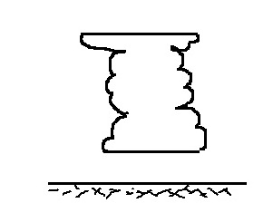
14. If you warm a parcel of air, the __V___ will increase, the ___ ρ ___ will decrease, and the ___P___ will remain constant. (fill in each blank with P for pressure, V for volume, or ρ for density)

15. The flat top of a thunderstorm cloud is called a(n)
ANVIL SHELF cloud and often marks the top of
the ATMOSPHERE STRATOSPHERE TROPOSPHERE.

