ATMO 170 Sept. 30, 2014 Name_____________________________________
In Class Assignment

1. A whole bunch of temperature data are shown below. Try to draw in a 40º F, 50ºF, and 60º F isotherm.

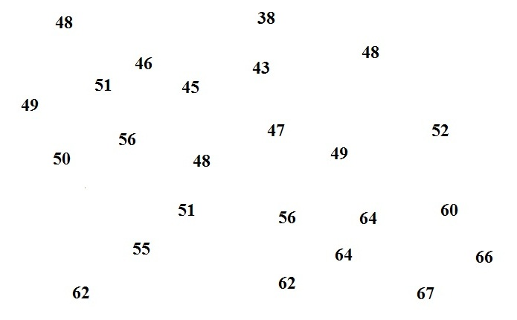

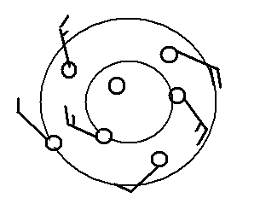

2. Does the figure at right show winds blowing in a CLOCKWISE or COUNTERCLOCKWISE direction? Are the winds CONVERGING
or DIVERGING?

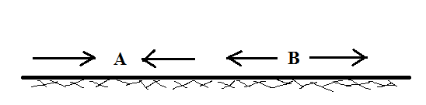
3. Do you see converging surface winds at
POINT A or at POINT B in the figure
at right. Would clouds be more likely to
form above POINT A or POINT B?

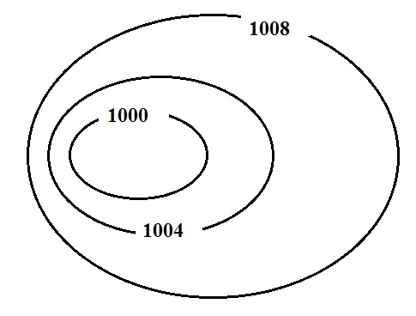

4. Which of the following would be true on a surface
weather map where the isobars are tightly spaced.
(more than one answer)
a. high pressure b. fast winds c. cold winds
d. weak pressure gradient e. slow winds
f. warm winds g. low pressure
h. dry winds i. strong pressure gradient j. moist winds

