ATMO 170 Optional Assignment Name_______________________________
Thermal circulations and the 3-cell model

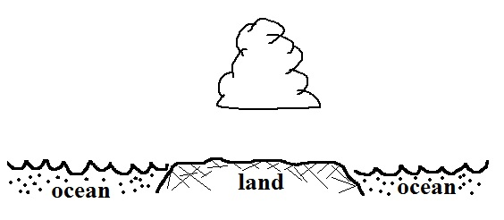
1. You can assume that winds in a thermal circulation
are responsible for the cloud development shown
in the figure at right. Would you expect to find RISING or SINKING air over the land. Would the land most likely be WARMER or COLDER than the ocean water. Would a cloud like this most likely develop during the DAY or at NIGHT? Would the surface winds be blowing ONshore or OFFshore.

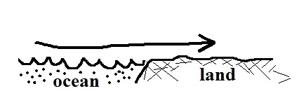
2. The Coriolis force plays a(n) IMPORTANT NEGLIGIBLE role in the development of a thermal circulation.

3. Would the surface winds shown in the figure at right
be called a SEA breeze or a LAND breeze.

4. _______, _______, and _______ are all found at about 30º latitude in the 3-cell model of the earth's global scale circulation. _______, _______, and _______are all found at the equator. (answers can be used once, more than once, or not at all)
a. intertropical convergence zone b. doldrums c. horse latitudes
d. trade winds e. high pressure belt e. calm winds

5. Low pressure belts or a center of low pressure are found at which two of the following latitudes in the 3-cell model?
a. 0º (equator) b. 30º c. 45º d. 60º e. 90º (poles)

6. Do the trade winds blow from the EAST or the WEST. Are the trade winds found at
TROPICAL(15º) or MIDDLE(45º) latitudes.

7. Tucson is located at 32º latitude which is near which of the following 3-cell model features.
a. doldrums b. polar front c. subtropical high pressure belt d. ITCZ
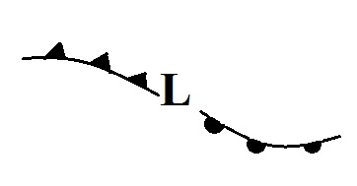
8. Would you expect the following storm system to be found in
the NORTHERN or SOUTHERN hemisphere. Would the
winds be spinning CLOCKWISE or COUNTERCLOCKWISE
around the low pressure center. Would the storm be moving from
EAST to WEST or from WEST to EAST.

