ATMO 170A1 Optional Assignment Name_______________________________

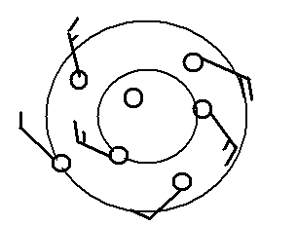
1. Does the figure at right show winds blowing in a CLOCKWISE
or COUNTERCLOCKWISE direction? Are the winds CONVERGING or DIVERGING? Does the figure show
a surface center of HIGH or LOW pressure.

2. Which one of the following would not cause rising air motions?
a. low pressure center b. high pressure center c. cold front d. warm front

3 The term cyclone is just another name for a center of HIGH LOW pressure.

4. The large L symbol that you usually see on a surface weather map indicates a region of
a. low altitude b. low air density c. low air pressure d. cold temperatures

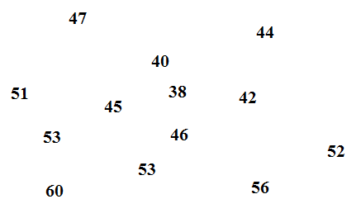
5. See if you can sketch in the 40º F and 50º F
isotherms on the figure at right.

6. Are clouds more likely to form when moist air COOLS or WARMS, when moist air RISES or SINKS?

7. Closely spaced isobars on a surface weather map would indicate the PRESSURE TEMPERATURE is changing RAPIDLY SLOWLY with distance. Will a strong pressure gradient on surface map cause RISING air, FAST winds, SLOW winds, or SINKING air.

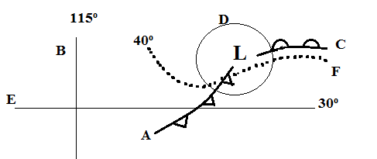
8. Find an example of each of the following
on the map drawn at right.

line of latitude__________
warm front __________
isotherm __________
cold front __________
isobar__________
line of longitude __________

9. Tropical cyclone is just another name for a _________________________.

