Wednesday Aug. 27, 2008
A couple of songs from Vampire Weekend 's 2008 CD were played in class today. Vampire Weekend will be appearing in Tucson at The Rialto on Sept. 23.

Signup sheets for the experiment reports were circulated in class today. If you didn't sign up today you can do so in class on Friday or next week. Experiment #1 materials will be distributed in class next Wednesday.
You can track the progress of Tropical Storm/Hurricane Gustav as it moves into the Gulf of Mexico and heads for the Gulf Coast at the National Hurricane Center website. A second storm, Hanna, might pose a threat to Florida or the East Coast of the US. You'll find satellite photographs of these storms here.
We reviewed some information on the evolution of the earth's atmosphere, not covered in class, that was stuck on to the end of the Monday Aug. 25 class notes. Briefly most of the gases in today's atmosphere, which is very different from the earth's original atmosphere, are thought to have come from volcanoes. Plants and photosynthesis, not volcanoes, are the source of most of the oxygen in the atmosphere however.
We returned to the topic of the origin of oxygen and its buildup in the atmosphere at the beginning of today's class. This is summarized on p. 1 in the photocopied ClassNotes.
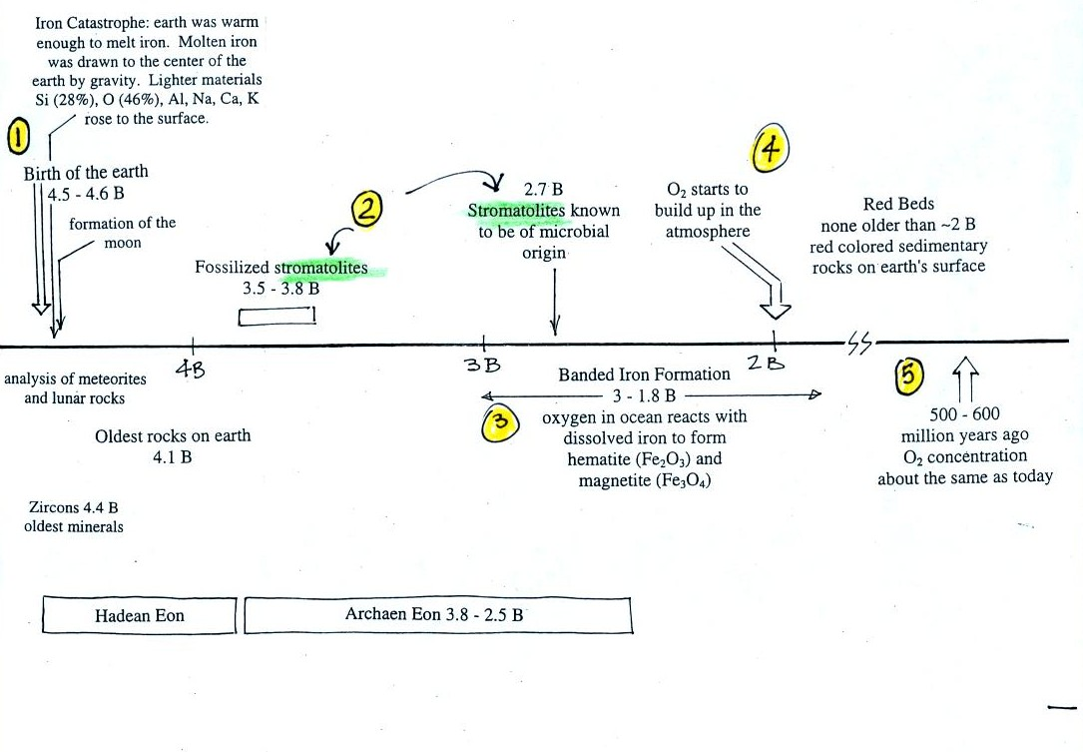

This somewhat confusing figure shows some of the important events in the history of the earth and evolution of the atmosphere. The numbered points were emphasized.
First, Point 1, the earth is thought to be between 4.5 and 4.6 billion years old.
The iron catastrophe was an important event (but wasn't discussed in class). Circulation of liquid metal in the core of the earth gives the earth a magnetic field. The magnetic field deflects the solar wind around the earth. Remember the solar wind may have swept away the earth's original atmosphere.
Stromatolites (Points 2 and 3) are column-shaped structures made up of layers of sedimentary rock, that are created by microorganisms living at the top of the stromatolite (note I've never actually seen a stromatolite, so this is all based on photographs and written descriptions). Fossils of the very small microbes (cyanobacteria) have been found in stromatolites as old as 2.7 B years and are some of the earliest records of life on the earth. Much older (3.5 to 3.8 B years old) stromatolites presumably produced by microbes but without microbe fossils have also been found.
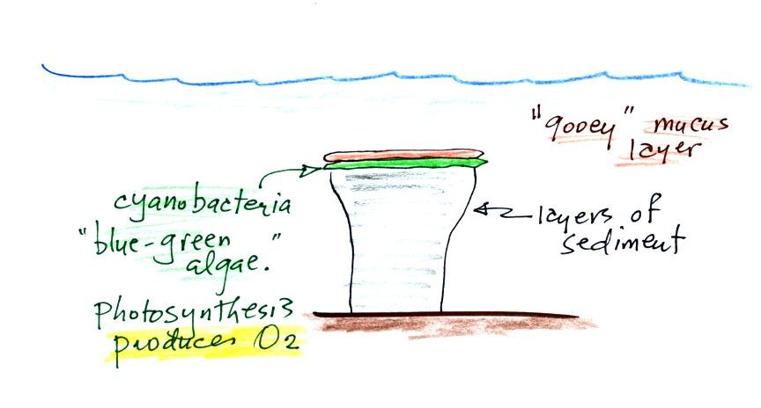
We're learning about stromatolites because the cyanobacteria were able to produce oxygen using photosynthesis.

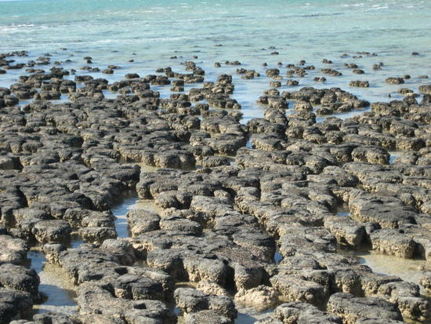
Living stromatolites are found in a few locations today. The picture above is from Coral Bay Australia, located on the western tip of the continent.
Once cyanobacteria began to produce oxygen in ocean water, the oxygen reacted with dissolved iron (iron ions in the figure below) to form hematite or magnetite. These two minerals precipitated out of the water to form a layer on the sea bed.
Periodically the oxygen production would decrease or stop (rising oxygen levels might have killed the cyanobacteria or seasonal changes might have slowed the photosynthesus). During these times of low dissolved oxygen concentrations, layers of jasper would form on the ocean bottom. Eventually the cyanobacteria would recover, begin producing oxygen again, and a new layer of hematite or magnetite would form. The rocks that resulted, containing alternating layers of black hematite or magnetite and red layers of jasper are known as the banded iron formation. A couple of small polished pieces of banded iron rock (actually "tiger iron") were passed around class. In addition to the red and black layers, the tiger iron contains yellow layers made of fibers of quartz.
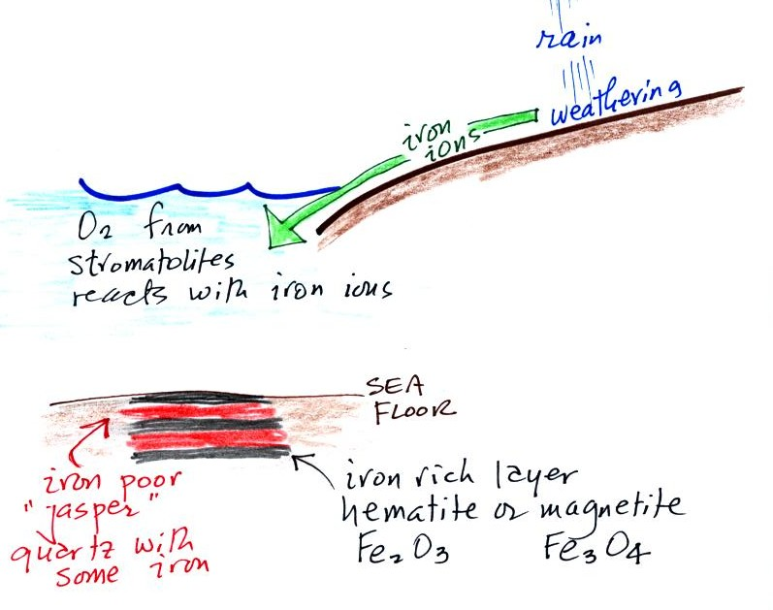

Eventually the dissolved iron in the ocean was used up (Point 4 in the timeline figure above). Oxygen produced by cyanobacteria diffused from the ocean into the atmosphere. Once in the air, the oxygen could react with iron in sediments on the earth's surface. This produced red colored sedimentary rock. None of these socalled red beds are older than about 2 B years old. Thus it appears that a real buildup up oxygen began around 2 B years ago. Oxygen concentrations reached levels that are about the same as today around 500 to 600 years ago (Point 5 in the figure).

We listed the 5 most abundant gases in the atmosphere in class on Monday. Several more important trace gases were added to the list in class today. Trace gases are gases found in low concentrations. Low concentrations doesn't mean they aren't important, however.

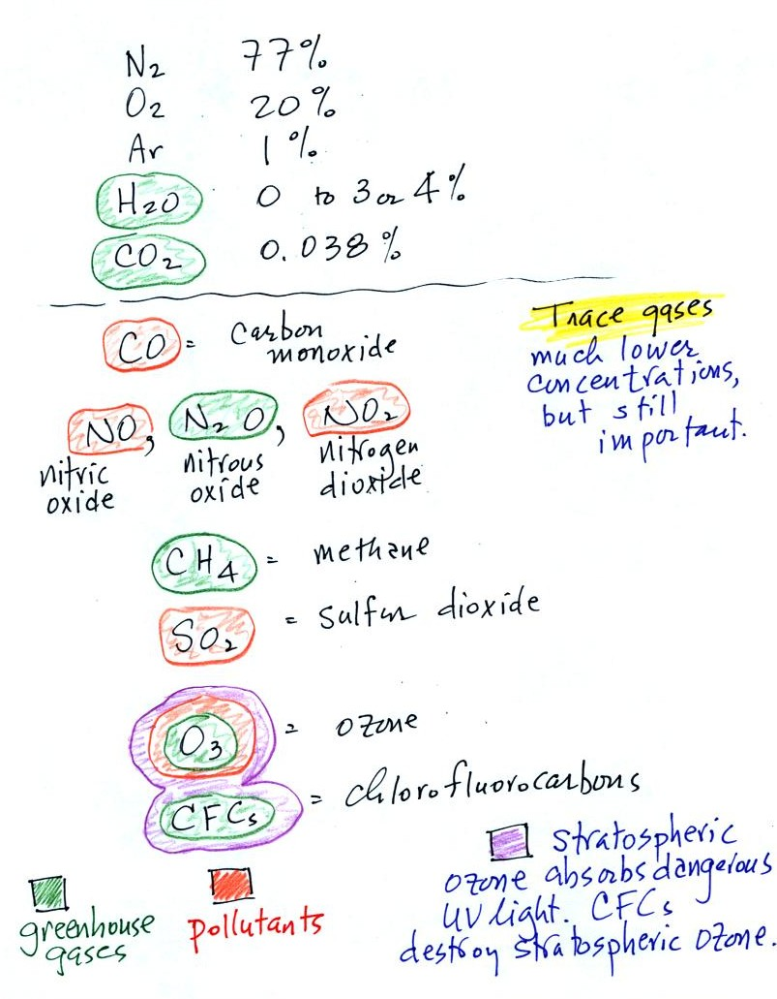

Water vapor, carbon dioxide, methane, nitrous oxide (N₂O = laughing gas), chlorofluorocarbons, and ozone are all greenhouse gases. Increasing atmospheric concentrations of these gases are responsible for the current concern over climate change and global warming. We'll discuss this topic more next week and learn more about how the greenhouse effect actually works later in the course.
Carbon monoxide, nitric oxide, nitrogen dioxide, ozone, and sulfur dioxide are some of the major air pollutants. We'll cover carbon monoxide on Friday and talk about sulfur dioxide and ozone next week.
Be careful with ozone:
(i) Ozone in the stratosphere (a layer of the atmosphere between 10 and 50 km altitude) is beneficial because it absorbs dangerous high energy ultraviolet (UV) light coming from the sun. Without the protection of the ozone layer, life as we know it would not exist on the surface of the earth. Chlorofluorocarbons are of concern in the atmosphere because they destroy stratospheric ozone.
(ii) In the troposphere (the bottom 10 kilometers or so of the atmosphere) ozone is a pollutant and is one of the main ingredients in photochemical smog.

We have been discussing the composition of air. Air is mostly composed on invisible gases. This past summer I thought it might be interesting to bring in several examples of gases that you can actually see (the gases are colored, not clear; you can't of course see the individual gas atoms or molecules). Once I started to do some research I found that many of these gases are very poisonous. In some cases a sample large enough for you to be able to see would be a potentially fatal dose if it were to be released accidentally into the classroom. You're going to have to settle for pictures of chlorine (a gas with a yellow-green color), and bromine (a liquid that evaporates, the resulting gas has a very vivid reddish color). The caution on the www.webelements.com website: "Bromine is a serious health hazard and maximum safety precautions should be taken when handling it" worried me a little bit. I will bring in some iodine (a solid that sublimates producing a gas with a faint pink color) later in the semester (it's poisonous but not nearly as scary as some of these other gases).
We did however make some nitrogen dioxide, a toxic pollutant. We did this by putting an ordinary copper penny (Cu(s) in the equation below) into a large 4 liter glass flask that contained a small amount of concentrated nitric acid ( HNO3(aq) ).
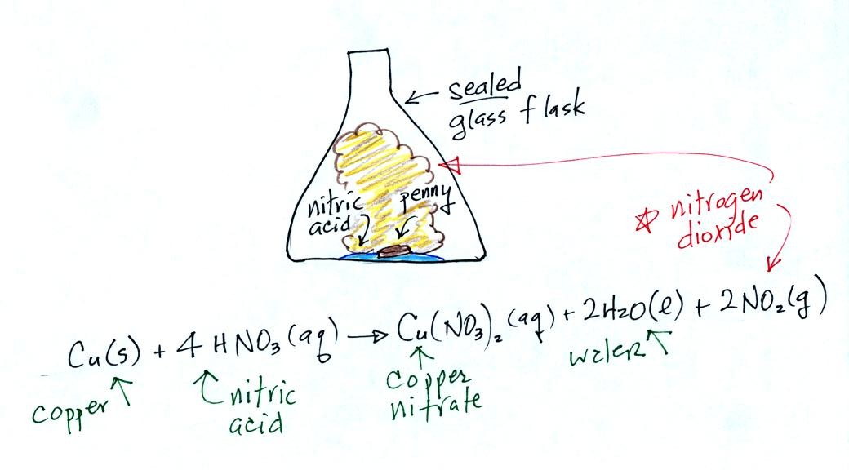

Air Pollution is a serious health hazard in the US and around the world. The following statistics were shown briefly at the end of class. A few additional details were added after class. Click here to download a copy of this handout (which was not distributed in class).
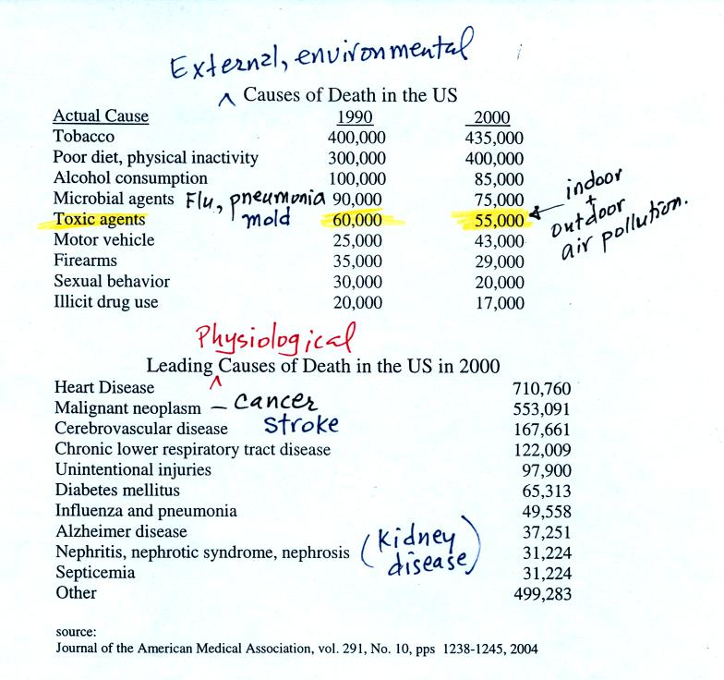
Keep in mind that many of these numbers are difficult to measure and some may contain a great deal of uncertainty. The row that is highlighted, toxic agents, contains estimates of deaths caused by indoor and outdoor air pollution, water pollution, and exposure to materials such as asbestos and lead both in the home and at the work place. It is estimated that 60% of the deaths are due to exposure to particulate matter, something that we will examine in a little more detail next week.
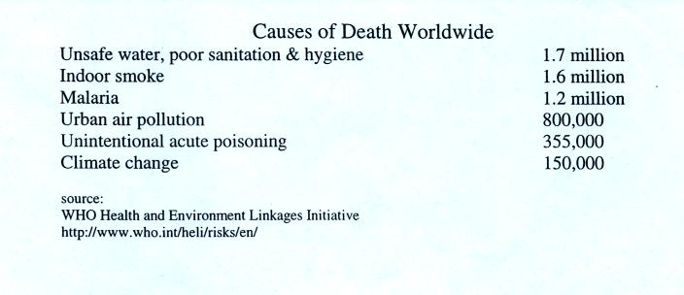
Air pollution is a serious hazard worldwide. Interestingly indoor air pollution is, in many places, a more serious threat than outdoor air pollution.

The Blacksmith Institute has listed the Top 10 polluted places in the world in a 2007 report. The report has received a lot of worldwide attention. If you go to this address, you can view the report online or download and print a copy of the report. Just in case you are interested.

That's about as far as we got in class on Monday, I won't add any new material to today's online notes that wasn't covered in class. We'll start with the section on Carbon Monoxide (pps 7-10) in the photocopied ClassNotes in class on Friday.

