Monday, Nov. 3, 2008
Music today was "J'ai ete au Zydeco," a selection from the Best of Beausoleil CD.
The Experiment #3 reports and the 1S1P Assignment #2 reports were collected today.
Quiz #3 is Wednesday this week. You'll find the times and locations of this week's reviews on the Quiz #3 Study Guide pt. 3

Class today began with a greeting (and a bit of a story)

NATS 101 World is the 50 minutes or so that many of you spend in class three days a week. Hopefully your visit to NATS 101 World isn't an unpleasant experience.
There's a funny thing that seems to happen once or twice a semester. NATS 101 World and the Real World intersect or overlap briefly. Once or twice a semester, you'll be out in the Real World and something will grab you and pull you back into NATS 101 world.
This happened to the course instructor over the weekend. He was in his kitchen reading the Sunday newspaper when he saw the following article:

You may remembered having heard about Auguste Piccard earlier in the semester. He was part of the two man team that first traveled into the stratosphere by balloon (I'll try to squeeze the video of that adventure into class at some point before the end of the semester). Jacques was Auguste's son. We watched a brief video segment, at the end of class today, showing Auguste and Jacques travelling to a depth of 10,000 feet in the ocean. It was a trial run of their bathyscaph. Later Jacques and US Navy Lt. Don Walsh would descend to the deepest point in the ocean (35,800 feet). Jacques' son Bertrand was part of the two-man team that completed the first non-stop trip around the globe by balloon.

We'll finish precipitation formation today
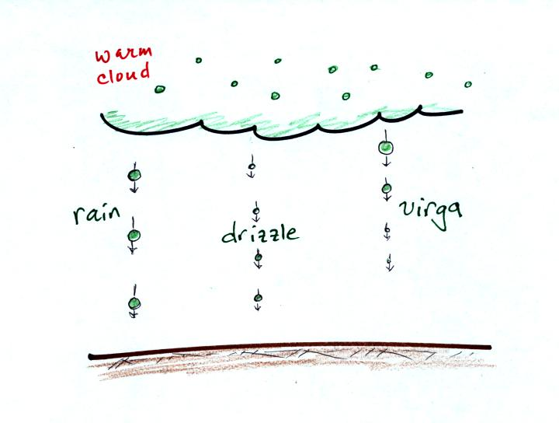
The collision coalescence process is pretty straight forward. It doesn't produce much of a variety in types of precipitation particles - really just rain. Virga is rain that evaporates before reaching the ground.
The ice crystal process on the other hand is more complex.
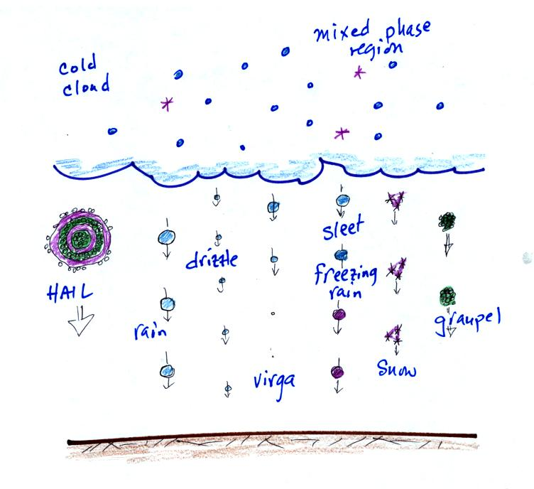
both in regards to what goes on inside the cloud and also in the types of precipitation that can fall from the cloud.
Before we look at how the ice crystal can produce such a variety of precipitation particles we will quickly review the process in cold clouds that gets everything started.
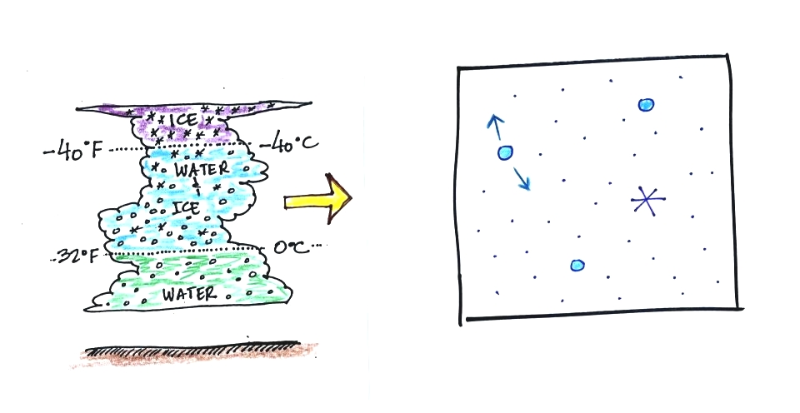
The ice crystal process works in the mixed phase region of cold clouds, where you find a mixture of ice crystals and supercooled water droplets. In the right figure, two arrows of evaporation from the water droplet are shown (different from the three arrows drawn in class last Friday - don't let that bother you). How many arrows should be drawn to accurately represent evaporation (sublimation) from the ice crystal (0, 1, 2, or 3)?
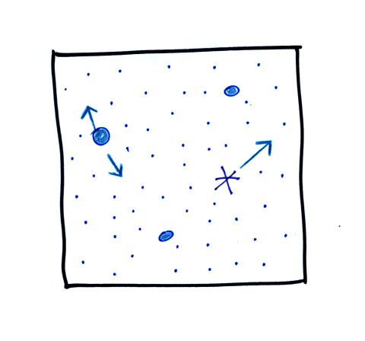
The ice crystal will be evaporating so there should be atleast one arrow. The ice crystal won't evaporate as quickly as the water droplet however. So the correct answer is 1 arrow.
How many arrows of condensation should be drawn going to the water droplet and to the ice crystal?
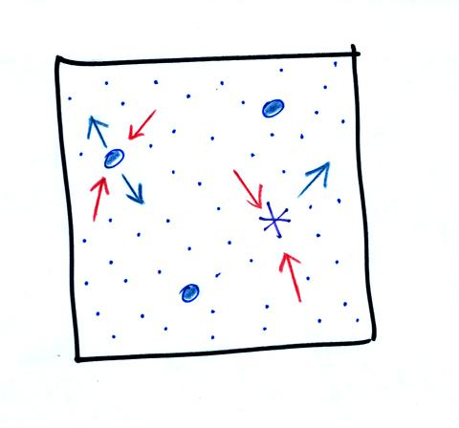
In order for the water droplets to be in equilibrium there must be 2 arrows of condensation to balance the 2 arrows of evaporation. The rate of condensation depends on the amount of water vapor in the air. Since the ice crystal is surrounded by the same moist air as the water droplet, there will be 2 arrows of condensation going to the ice crystal. The ice crystal will grow even when the water droplets do not.

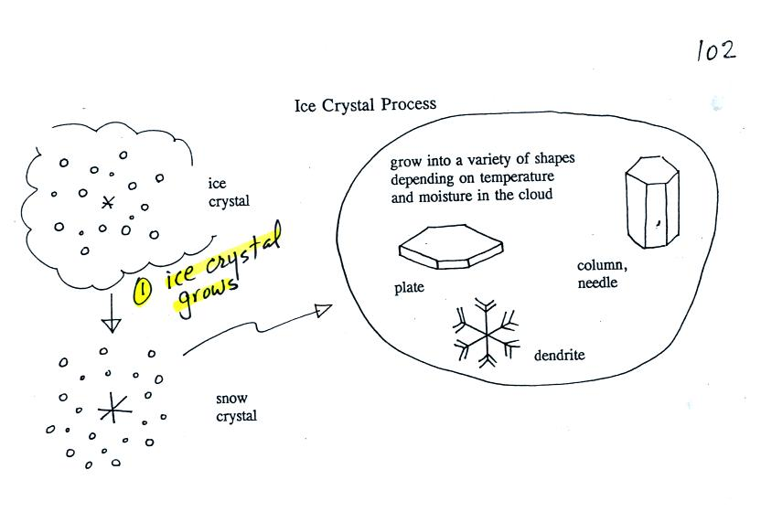

Once an ice crystal has grown a little bit it becomes a snow crystal (this figure is on p. 102 in the photocopied classnotes). Snow crystals can have a variety of shapes (called crystal habits) depending on the conditions (temperature and moisture) in the cloud. Dendrites are the most common because they form where there is the most moisture available for growth. With more raw material available it makes sense there would be more of this particular snow crystal shape.
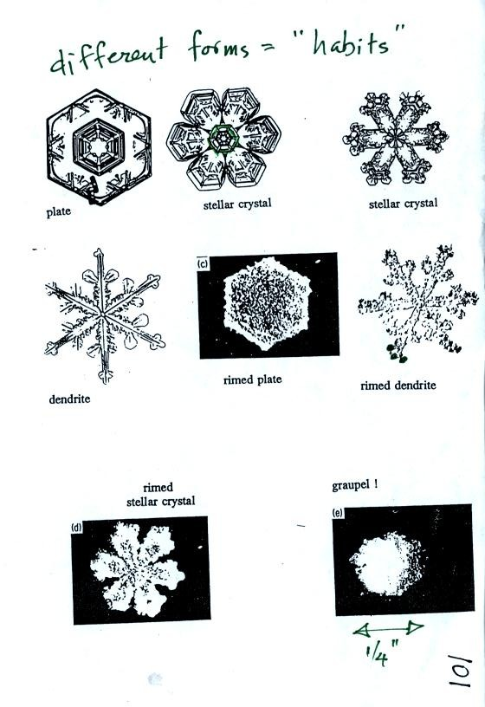
Here are some actual photographs of snow crystals (taken with a microscope). Snow crystals are usually 100 or a few 100s of micrometers in diameter (tenths of a millimeter in diameter).
You'll find some much better photographs and a pile of addtional information about snow crystals at www.snowcrystals.com
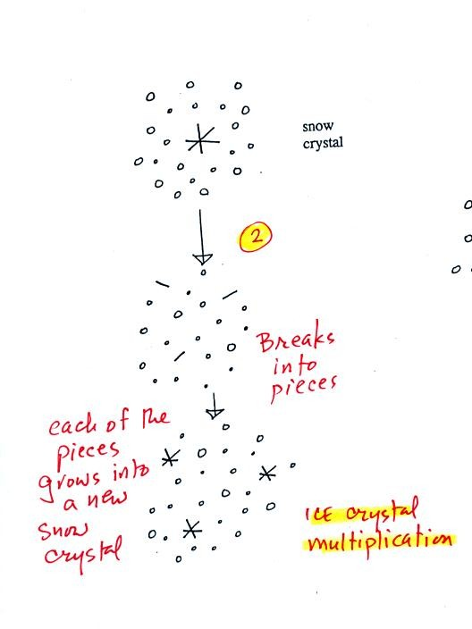
A variety of things can happen once a snow crystal forms. First it can break into pieces, then each of the pieces can grow into a new snow crystal. Because snow crystals are otherwise in rather short supply, ice crystal multiplication is a way of increasing the amount of precipitation that ultimately falls from the cloud.
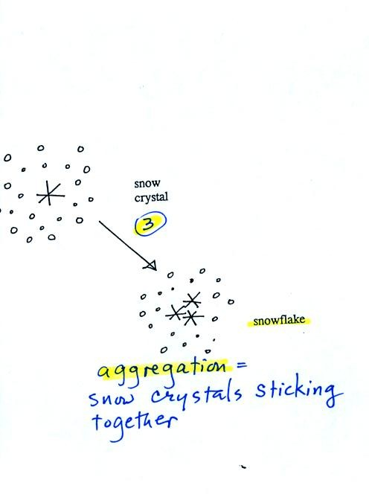

Several snow crystals can collide and stick together to form a snowflake. Snow crystals are small, a few tenths of a millimeter across. Snowflakes can be much larger and are made up of many snow crystals stuck together. The sticking together or clumping together of snow crystals is called aggregation.
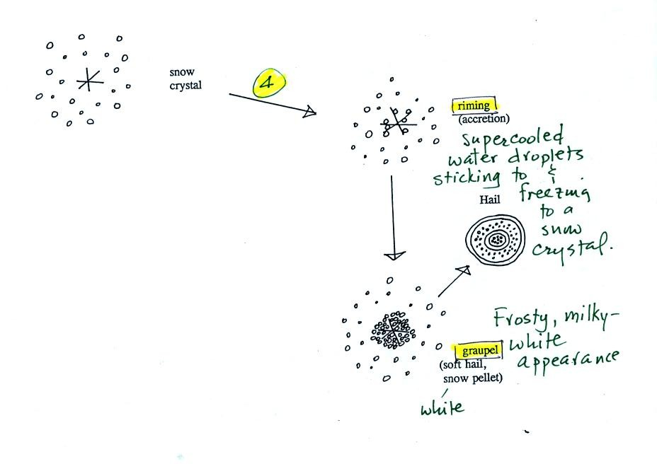
Snow crystals can collide with supercooled water droplets. The water droplets may stick and freeze to the snow crystal. This process is called riming or accretion (note it is really the same idea as collision and coalescence). If a snow crystal collides with enough water droplets it can be completely covered with ice. The resulting particle is called graupel (or snow pellets). Graupel is sometimes mistaken for hail and is called soft hail or snow pellets. Rime ice has a frosty milky white appearance. A graupel particle resembles a miniature snow ball. Graupel particles often serve as the nucleus for a hailstone.

The ice crystal process can produce a variety of precipitation particles inside the cloud. Further changes can occur once the particle falls from the cloud. The pictures were redrawn because I decided the figures on p. 103 were kind of ugly.
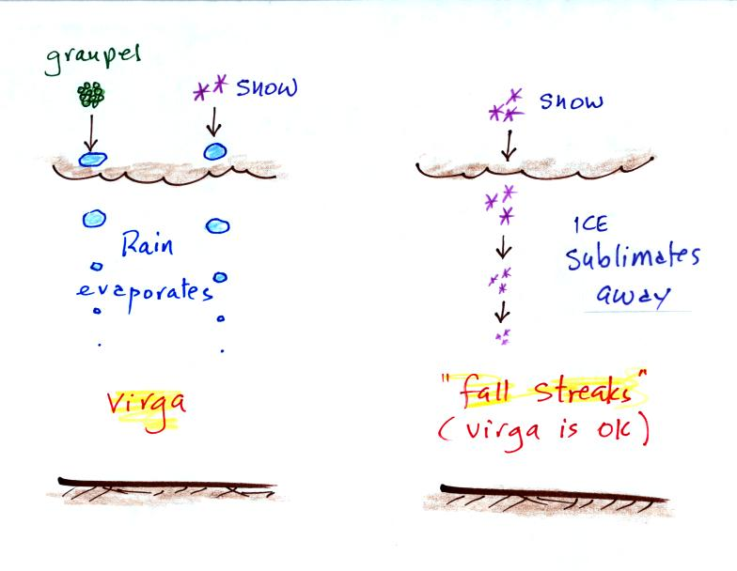
In the example above at left the ice particles (graupel or snow) first melt and then evaporate before reaching the ground. Rain that evaporates before reaching the ground is called virga.
A similar thing can happen with snow crystals or snow flakes. They sublimate away; the streamers of falling precipitation are called fall streaks (as far as I'm concerned you can use the name virga for this process since it is the same overall idea). You'll see white streamers of snow falling from high altitude cirrus clouds fairly often.
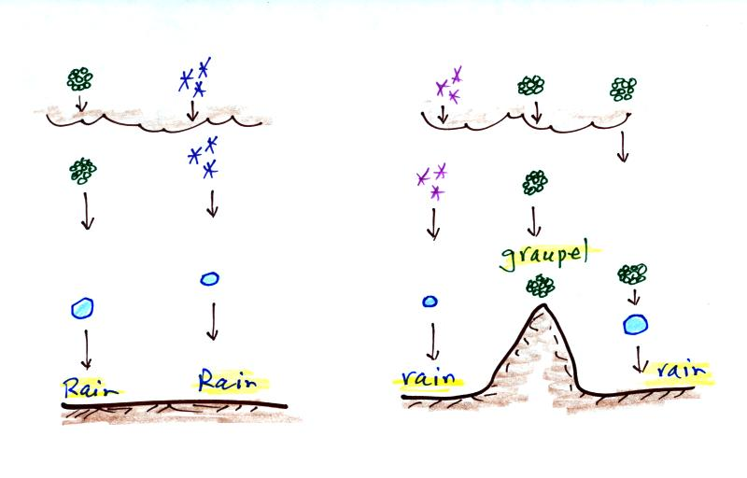
The frozen precipitation particles produced by the ice crystal process (graupel or snow) can melt before reaching the ground. This would be rain (or drizzle if the drops are small). This is where rain in Tucson comes from even in the summer. Rain in most locations at most times of the year starts out as frozen precipitation.
If you are on a mountain top you might see some of the frozen precipitation before it melts. You might see graupel falling from a summer thunderstorm, for example, while the people in the valley only observe rain.
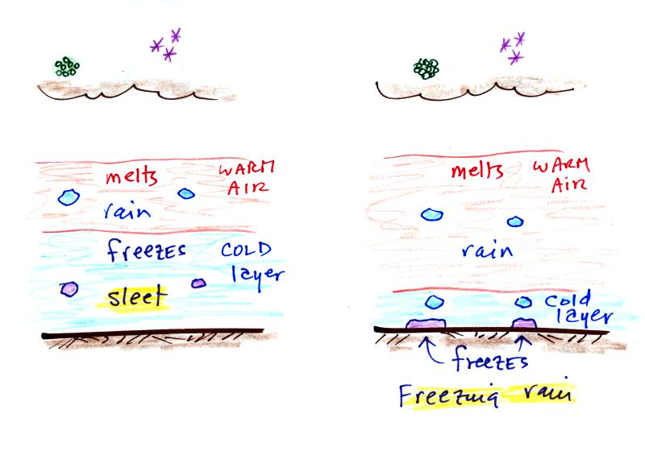
Sometimes the frozen precipitation will melt and then fall into a thick layer of cold air and refreeze. The resulting particle is called sleet (or ice pellets). Sleet is rain that freezes before hitting the ground. The clear ice in sleet is noticeably different from the frosty, milky white, rime ice in graupel.
Rain that falls into a shallow cold air layer and only freezes after reaching the ground is called freezing rain. It is nearly impossible to drive during one of these "ice storms." Sometimes the coating of ice is heavy enough that branches on trees are broken and power lines are brought down. It sometimes takes several days for power to be restored.

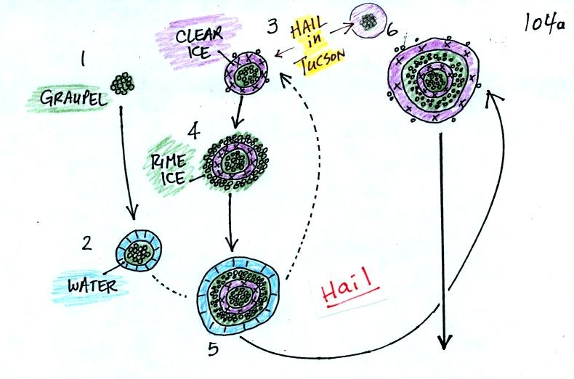
In the figure above a hailstone starts with a graupel particle (colored green to represent rime ice). The graupel falls or gets carried into a part of the cloud where it collides with a large number of supercooled water droplets which stick to the graupel but don't immediately freeze. The graupel gets coated with a layer of water (blue). The particle then moves into a colder part of the cloud and the water layer freeze producing a layer of clear ice (the clear ice, colored violet, has a distinctly different appearance from the milky white rime ice). In Tucson this is often the only example of hail that you will see: a graupel particle core with a single layer of clear ice.
In the severe thunderstorms in the Central Plains, the hailstone can pick up a new layer of rime ice, followed by another layer of water which subsequently freezes to produce a layer of clear ice.
This cycle can repeat several times; large hailstones can be composed of many alternating layers of rime and clear ice. An unusually large hailstone (around 3 inches in diameter) has been cut in half to show (below) the different layers of ice.
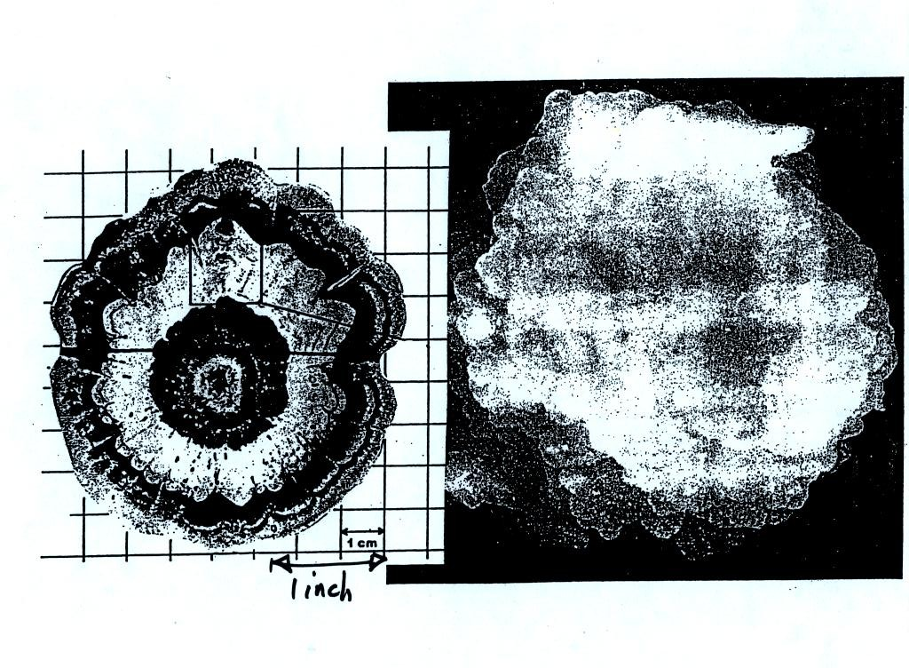
Hail is produced in strong thunderstorms with tilted updrafts. The figure below wasn't shown in class.
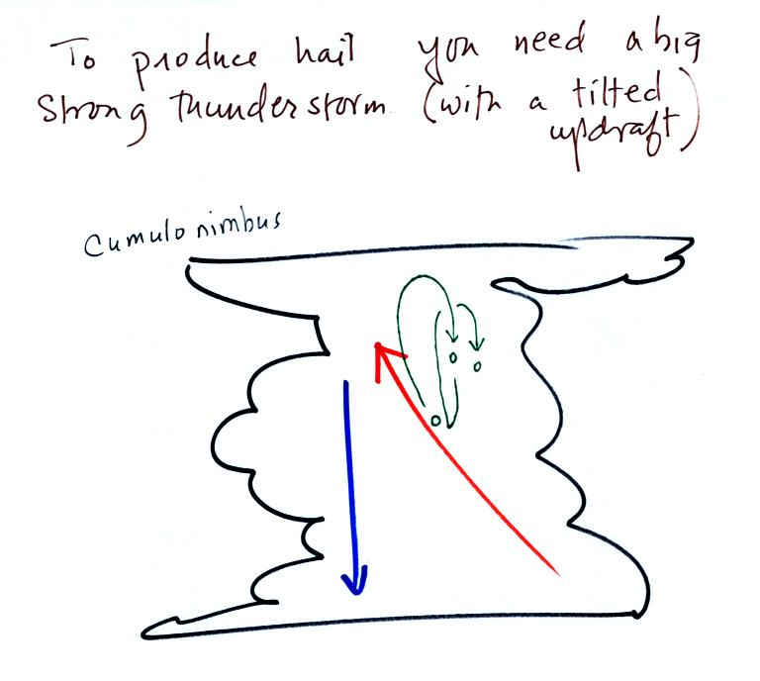
The growing hailstone can fall back into the updraft (rather than falling out of the cloud) and be carried back up toward the top of the cloud. In this way the hailstone can complete several cycles through the interior of the cloud.

