Wednesday Nov. 19, 2008
The music got off to a late start today. You only got to hear a minute or two from Jovert, a local (Tucson High School) steel drum band.
Now that the end of the semester is fast approaching there are a number of loose ends to tie up. One of these is showing you some pictures of my cats. You'll find them all in this cat photo gallery, together with some commentary

I wanted to be sure you understand what a wall cloud is and what they look like. Walls clouds are produced by the rotating updraft (the mesocyclone) in supercell thunderstorms. It is an extra little bit of cloud that encircles the updraft and extends a little bit below the rest of the base of the cloud. Here is a particularly nice photograph of one. An even better photograph was in a book passed around in class. The book was titled "Storm Chaser" and was written by Warren Faidley, a local photographer.
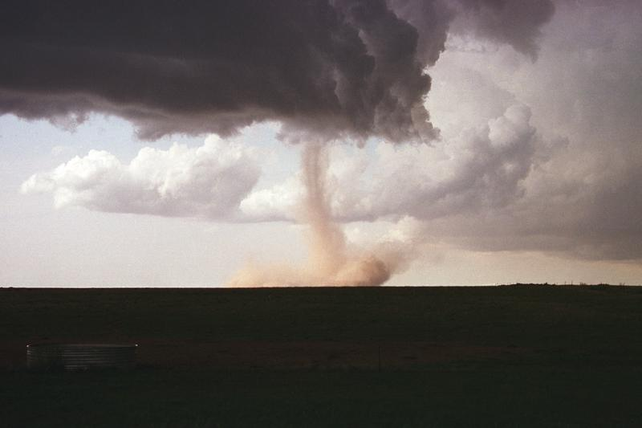

Wall cloud and tornado
(University Corporation for Atmospheric Research)
Supercell thunderstorms also often produce a very distinctive signature on weather radar called a "hook echo." We haven't covered weather radar in this class this semester. But, in some respects a radar picture of a thunderstorm is similar to an X-ray photograph of a human body.
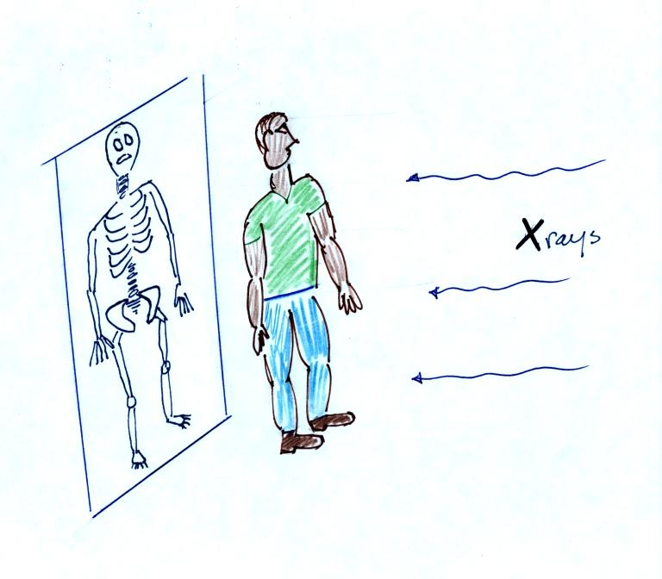
X-rays are high energy electromagnetic radiation that passes right through the flesh in a human body (the fat, muscle etc.). Bone does absorb some of the X-rays, however. So if you take an X-ray of a person you see only part of what is inside their body, you see the skeleton.
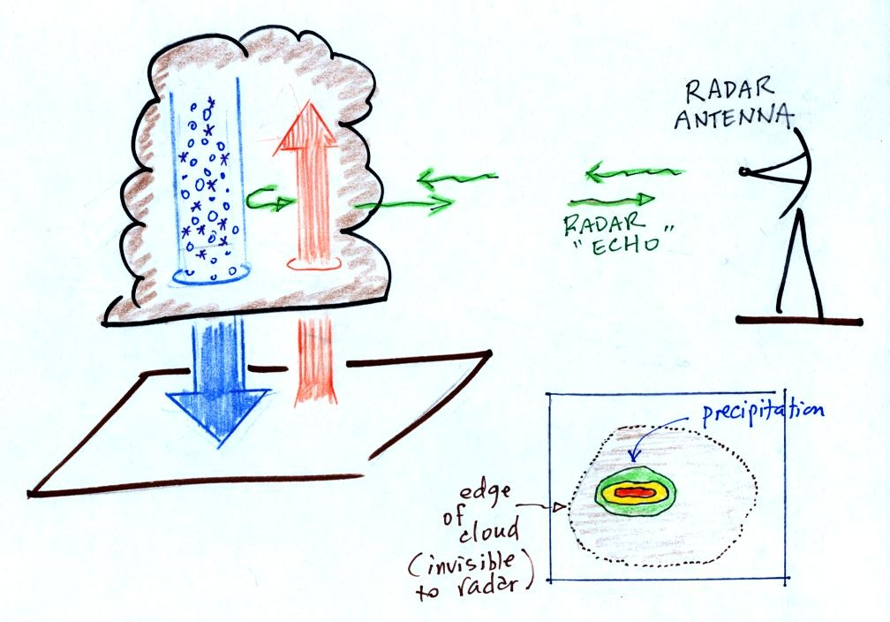
A radar emits microwave radiation. This radiation passes right through the cloud itself but is reflected by the larger precipitation particles (rain, graupel, etc). This reflected radiation is detected by the radar. A radar image of a cloud is usually just a horizontal slice through the cloud. In the picture above the radar would slice through the middle of the cloud and would detect only the column of precipitation. The intensity of the precipitation (determined by the size and number of precipitation particles) is color coded on the radar display (red would be heavy precipitation, green light precipitation).
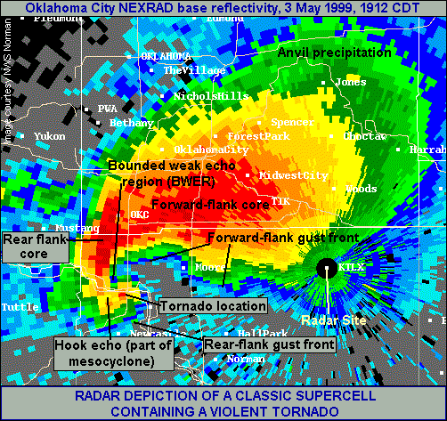
Here is a radar image of a strong supercell thunderstorm located near Oklahoma City in May 1999. The "hook" is at the left end of the radar image.
A hook echo is produced by the spinning mesocycle in a thunderstorm. This storm produced a very strong tornado (actually rated F6 with winds that might have exceeded 300 MPH)
How would you answer the following question? (you'll find the answer at the end of today's notes)
Which one of the following doesn't belong in the same group as the other three?
a. hook echo b. mesocyclone c. microburst d. wall cloud

The figure below shows the steps in the formation, intensification, and weakening of a tornado. This is sometimes referred to as the tornado life cycle. Don't worry about learning the names of the various stages. The idea is for you to be able to recognize an unusually strong tornado if you ever see one in person or on video tape. You might also be able to tell from a tornadoes appearance whether it is near the beginning or end of its life cycle.
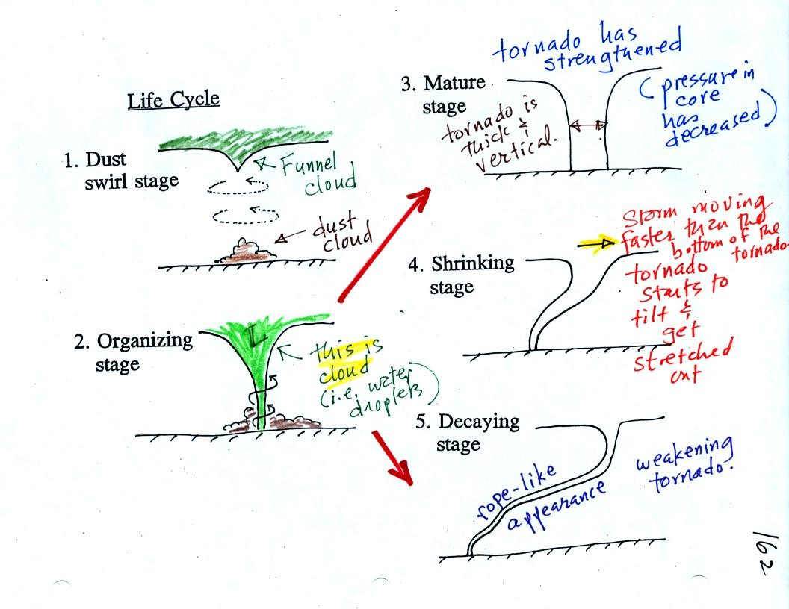
Tornadoes begin in and descend from a thunderstorm. You might see a funnel cloud dropping from the base of the thunderstorm. Spinning winds will probably be present between the cloud and ground before the tornado cloud becomes visible. The spinning winds can stir up dust at ground level. The spinning winds might also be strong enough at this point to produce some minor damage.
In Stage 2, moist air moves horizontally toward the low pressure in the core of the tornado. This sideways moving air will expand and cool just as rising air does (see figure below). Once the air cools enough (to the dew point temperature) a cloud will form.
Tornadoes can go from Stage 2 to Stage 3 (this is what the strongest tornadoes do) or directly from stage 2 to stage 5. Note a strong tornado is usually vertical and thick as shown in Stage 3. "Wedge tornadoes" actually appear wider than they are tall.
The thunderstorm and the top of the tornado will move faster than the surface winds and the bottom of the tornado. This will tilt and stretch the tornado. The rope like appearance in Stage 5 is usually a sign of a weakening tornado.
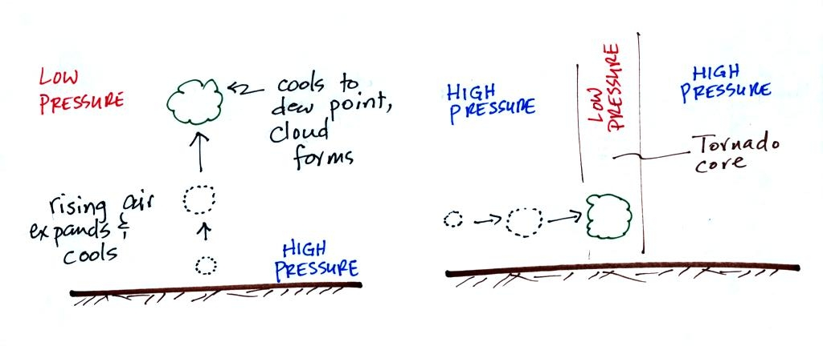
The tornado cloud forms when moist air moves into lower pressure in the core of the tornado. The air expands and cools to the dew point and a cloud forms. This is just like the cloud that forms when air rises.
At this point we watched another short video segment that illustrated well the first 3 steps in the formation of a tornado (dust swirl stage up to mature stage). The tornado was photographed near Luverne Oklahoma in May 1991. It was eventually rated an F3 tornado.

The Fujita Scale is used to rate tornado strength or severity. We most of the remainder of the class looking at photographs of tornado damage.
Simplified, Easy-to-Remember version of the Fujita Scale
winds < 100 MPH
F0
F1 | roof damage,  mobile home tipped over
microburst winds can cause this degree of damage
winds 100 to 200 MPH
F2 | roof gone,  outside walls still standing
F3 | outside walls gone,  inside walls intact
winds 200 to 300 MPH
F4 | home destroyed,  debris nearby
F5 | home destroyed,  debris carried away
Here are some photographs of tornado damage
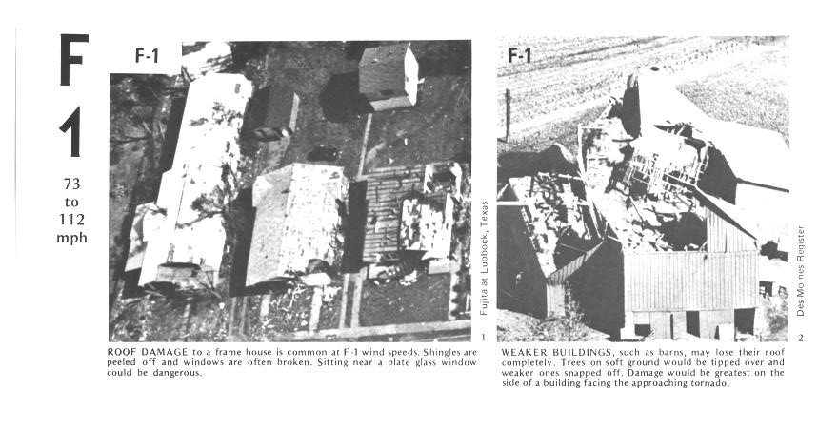
The buildings on the left suffered light roof damage. The barn roof at right was more heavily damaged.
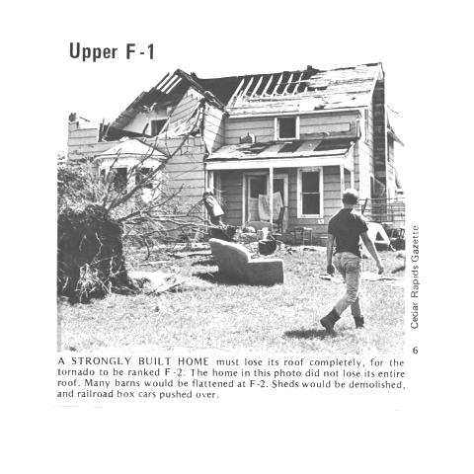
More severe damage to what appears to be a well built house roof.

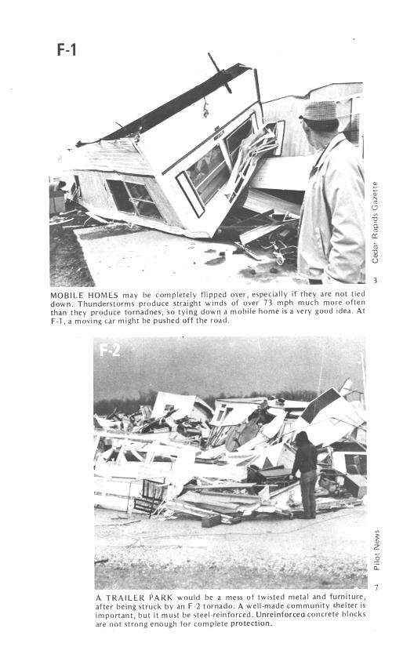
F1 tornado winds can tip over a mobile home if it is not tied down (the caption states that an F1 tornado could blow a moving car off a highway). F2 level winds (bottom photo) can roll and completely destroy the mobile home.
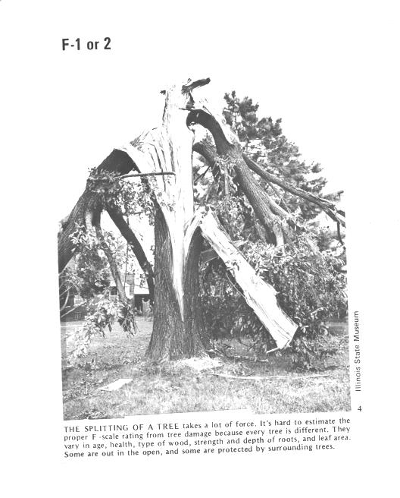
Trees, if not uprooted, can suffer serious damage from F1 or F2 tornado winds.
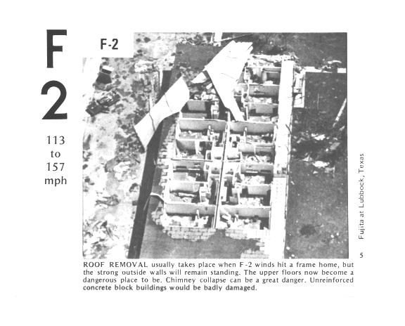
F2 level winds have completely removed the roof from this building. The outside walls of the building are still standing.
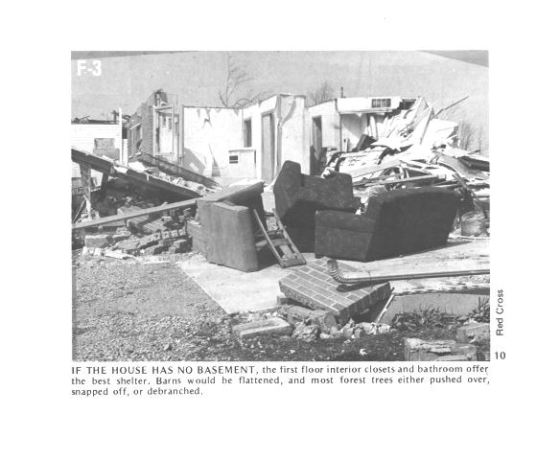
The roof is gone and the outer walls of this house were knocked down. This is characteristic of F3 level damage. In a house without a basement or storm cellar it would be best to seek shelter in an interior closet or bathroom.
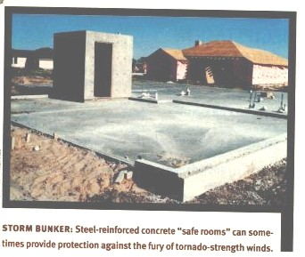
In some tornado prone areas,
people construct a small closet or room inside their home made of reinforced concrete.
A better solution might be to have a storm cellar located underground.
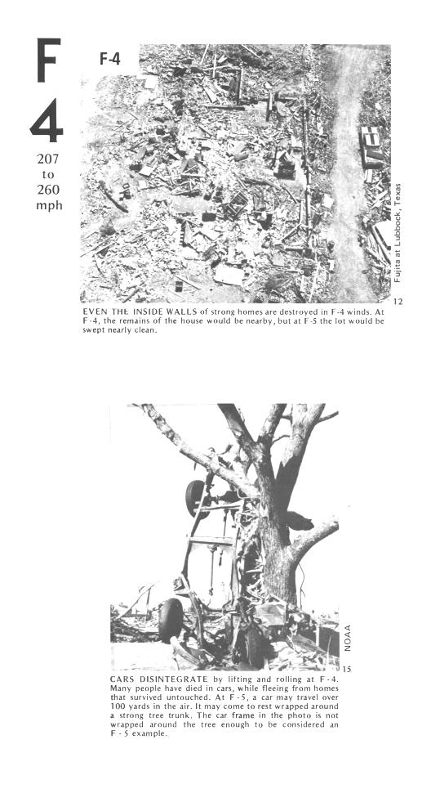
All of the walls were knocked down in the top photo but the debris is left nearby. This is characteristic of F4 level damage. All of the sheet metal in the car body has been removed in the bottom photo and the car chasis has been bent around a tree. The tree has been stripped of all but the largest branches.
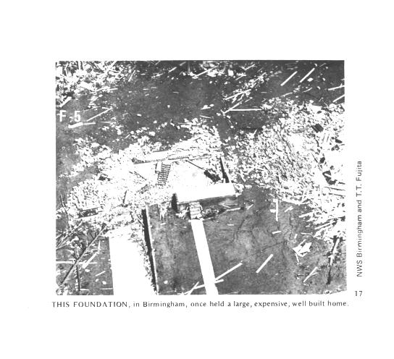
An F5 tornado completely destroyed the home in the photo above and removed most of the debris.
Only bricks and a few pieces of lumber are left.

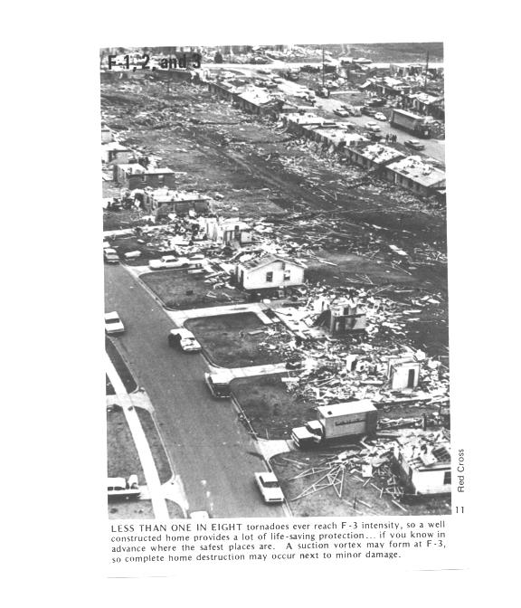
Several levels of damage are visible in the photograph above. It was puzzling initially how some homes could be nearly destroyed while a home nearby or in between was left with only light damage. One possible explanation is shown below
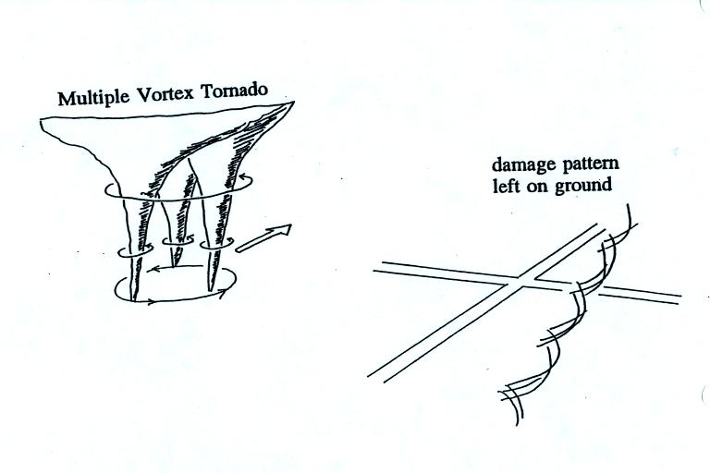
Some big strong tornadoes may have smaller more intense "suction vortices" that spin around the center of the tornado. Tornado researchers have actually seen the scouring pattern shown at right in the figure above that the multiple vortices can leave behind.
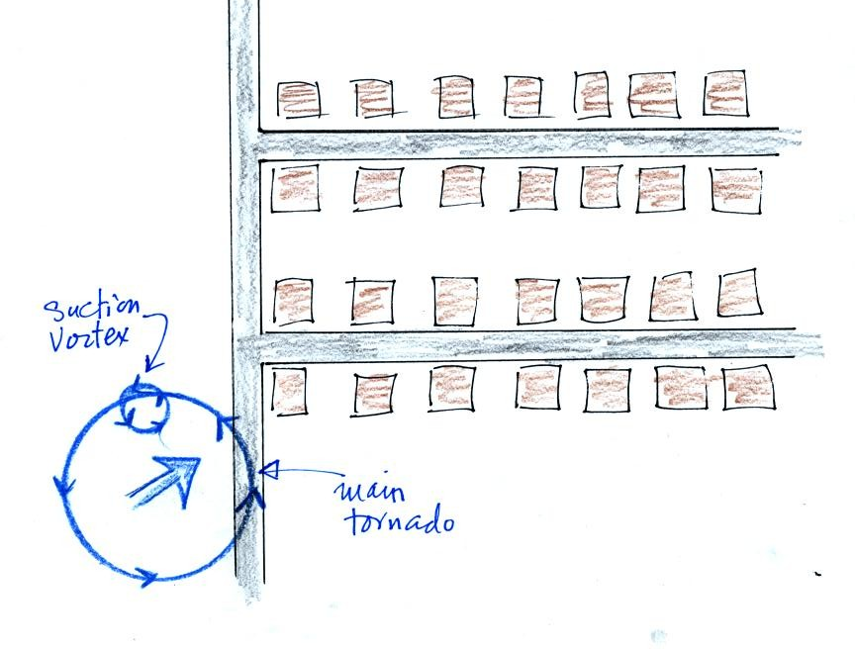
The sketch above shows a tornado located SW of a neighborhood.
As the tornado sweeps through the neighborhood, the suction vortex will rotate around the core of the tornado.
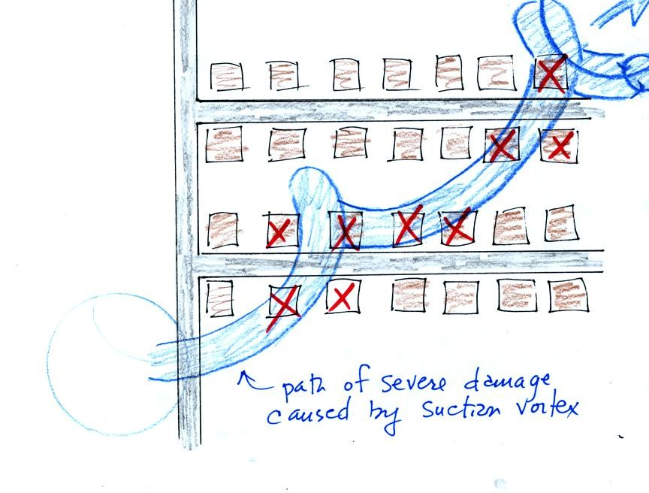
The homes marked in red would be damaged severely. The others would receive less damage (remember, however that there would probably be multiple suction vortices in the tornado).

At this point we watched the last of the tornado video tapes. It showed a tornado that occurred in Pampa, Texas. Near the end of the segment, video photography showed several vehicles (pick up trucks and a van) that had been lifted 100 feet or so off the ground that were being thrown around at 80 or 90 MPH by the tornado winds. Winds speeds of about 250 MPH were estimated from the video photography.
Answer to the earlier question
Hook echo (a radar signature indicating a thunderstorm with a rotating updraft), mesocyclone (rotating thunderstorm updraft),and wall cloud (produced by the rotating updraft) are all related. A microburst is a narrow intense thunderstorm downdraft.

