Wednesday Sep. 3, 2008
The Experiment #1 materials were handed out before class today. A few more sets of materials may be available in class on Friday in case you weren't able to pick up your materials today. You can read a little bit more about Expt. #1 here.
The Story, a song by Brandi Carlile song was played before class while the experiment materials were being handed out.

Last Friday we finished the first of the air pollutants that we will be covering in class. Here are some of the key things you should remember about carbon monoxide. (We will also list main points for ozone, sulfur dioxide, and particulate matter as we cover them. I suggested you put this summary on a single sheet of paper and stick that page in front of all your notes on air pollutants, where it can act as a sort of table of contents.)
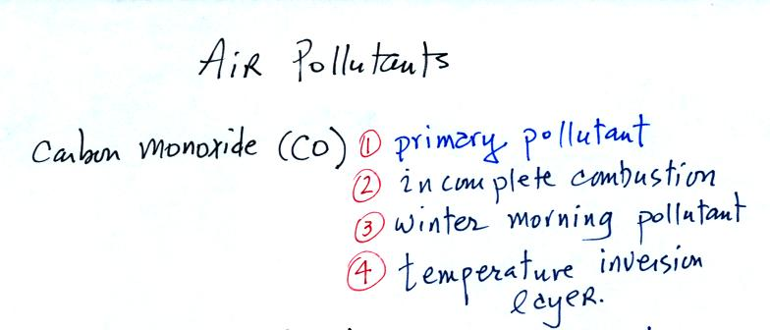
Next we turn our attention to another air pollutant, ozone.
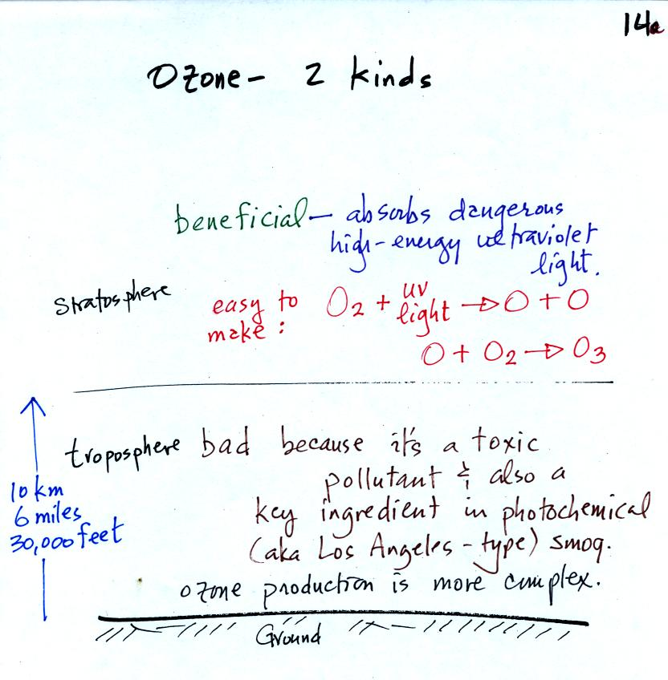
Ozone has a Dr. Jekyll and Mr. Hyde personality. Ozone in the stratosphere is beneficial, it absorbs dangerous high energy ultraviolet light (which would otherwise reach the ground and cause skin cancer, cataracts, and many other problems).
Ozone in the troposphere is bad, it is a pollutant. That is the stuff we will be concerned with today. Tropospheric ozone is also a key component of photochemical smog (also known as Los Angeles-type smog)
We'll be making some photochemical smog as a class demonstration. This will require ozone (and a hydrocarbon of some kind). We'll use the simple stratospheric recipe for making ozone in the demonstration rather than the more complex tropospheric process.
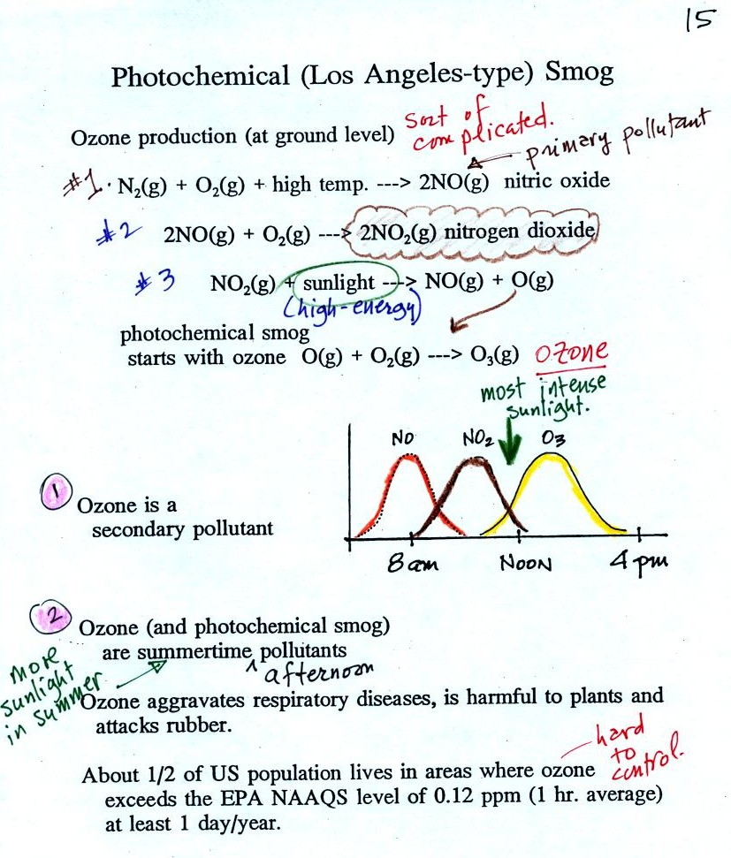
At the top of this figure you see that a more complex series of reactions is responsible for the production of tropospheric ozone. The production of tropospheric ozone begins with nitric oxide (NO). NO is produced when nitrogen and oxygen are heated (in an automobile engine for example) and react. The NO can then react with oxygen to make nitrogen dioxide, the poisonous brown-colored gas we made in class last week. Sunlight can dissociate (split) the nitrogen dioxide molecule producing atomic oxygen (O) and NO. O and O₂ react (just as they do in the stratosphere) to make ozone (O₃). Because ozone does not come directly from an automobile tailpipe or factory chimney, but only shows up after a series of reactions, it is a secondary pollutant. Nitric oxide would be the primary pollutant in this example.
NO is produced early in the day (during the morning rush hour). The concentration of NO₂ peaks somewhat later. Peak ozone concentrations are usually found in the afternoon. Ozone concentrations are also usually higher in the summer than in the winter. This is because sunlight plays a role in ozone production and summer sunlight is more intense than winter sunlight.
As shown in the figure below, invisible ozone can react with a hydrocarbon of some kind which is also invisible to make a product gas. This product gas sometimes condenses to make a visible smog cloud or haze.
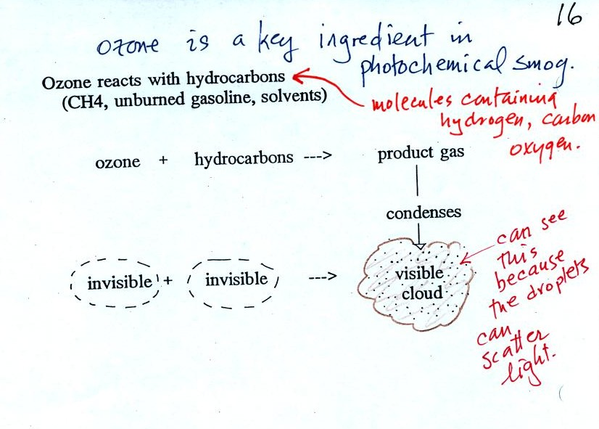
The class demonstration of photochemical smog is summarized below (a flash was used instead of the aquarium shown on the bottom of p. 16 in the photocopied class notes). We begin by using the UV lamp to fill the flask with ozone. Then a few pieces of fresh lemon peel were added to the flask. A whitish cloud quickly became visible (colored brown in the figure below).
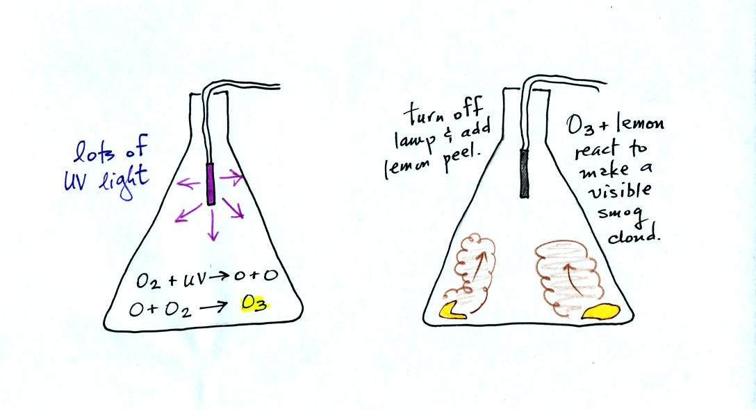

Here are some key points concerning tropospheric ozone.
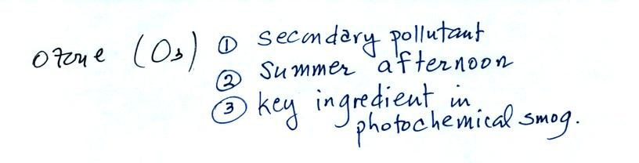

We were able to start the section on sulfur dioxide, another of the air pollutants we will cover. Here's some basic information from p. 11 in the photocopied ClassNotes.
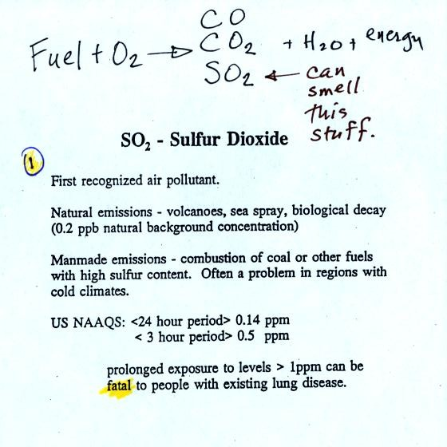
Sulfur dioxide is produced by the combustion of sulfur containing fuels such as coal. Combustion of fuel also produces carbon dioxide and carbon monoxide. People probably first became aware of sulfur dioxide because it has an unpleasant smell. Carbon dioxide and carbon monoxide are odorless. That is why sulfur dioxide was the first pollutant people became aware of.
Volcanoes are a natural source of sulfur dioxide.
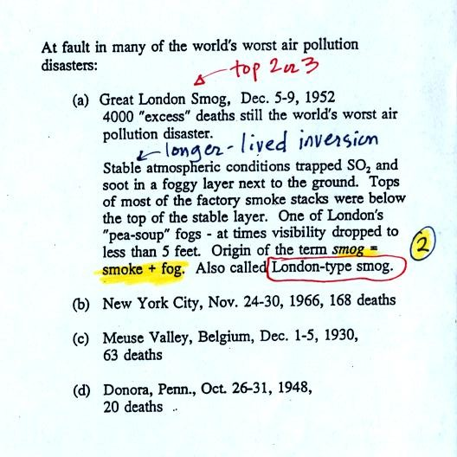
The Great London smog is still one of the two or three deadliest air pollution events in history. Because the atmosphere was stable, SO₂ emitted into air at ground level couldn't mix with cleaner air above. The SO₂ concentration was able to build to dangerous levels. 4000 people died during this 4 or 5 day period. As many as 8000 additional people died in the weeks and months following the December event. Some of the photographs below come from articles published in 2002 on the 50th anniversary of the event.
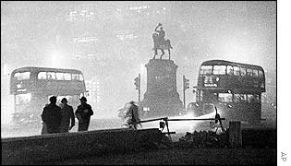  from:  http://news.bbc.co.uk/1/hi/uk/2542315.stm | 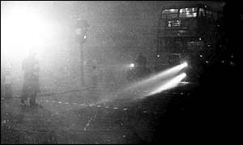  from:  http://news.bbc.co.uk/1/hi/health/2545747.stm
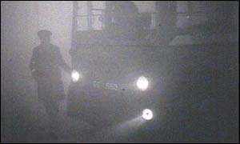  from:  http://news.bbc.co.uk/1/hi/england/2543875.stm | 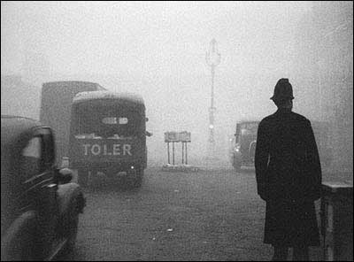  from:  http://www.npr.org/templates/story/story.php?storyId=873954
The sulfur dioxide didn't kill people directly. The SO2 aggravated an existing condition of some kind and hastened their death. The SO2 probably also made people susceptible to bacterial infections such as pneumonia. This link discusses the event and its health effects in more detail.
London type smog which contains sulfur dioxide and is most common during the winter is very different from photochemical or Los Angeles type smog. Los Angeles type smog contains ozone and is most common in the summer.
Some other air pollution disasters also involved high SO2 concentrations. One of the deadliest events in the US occurred in 1948 in Donora, Pennsylvania.
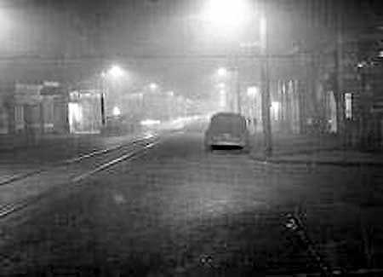
"This eerie photograph was taken at noon on Oct. 29, 1948 in Donora, PA as deadly smog enveloped the town. 20 people were asphyxiated and more than 7,000 became seriously ill during this horrible event."
from:
http://oceanservice.noaa.gov/education/kits/pollution/02history.html
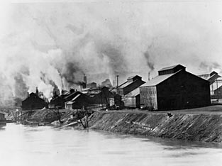
from:
http://www.eoearth.org/article/Donora,_Pennsylvania
"When Smoke Ran Like Water," a book about air pollution is among the books that you can check out, read, and report on to fulfill part of the writing requirements in this class (instead of doing an experiment report). The author, Devra Davis, lived in Donora Pennsylvania at the time of the 1948 air pollution episode.

Sulfur dioxide is one of the pollutants that can react with water in clouds to form acid rain (some of the oxides of nitrogen can react with water to form nitric acid). The formation and effects of acid rain are discussed on p. 12 in the photocopied Class Notes.

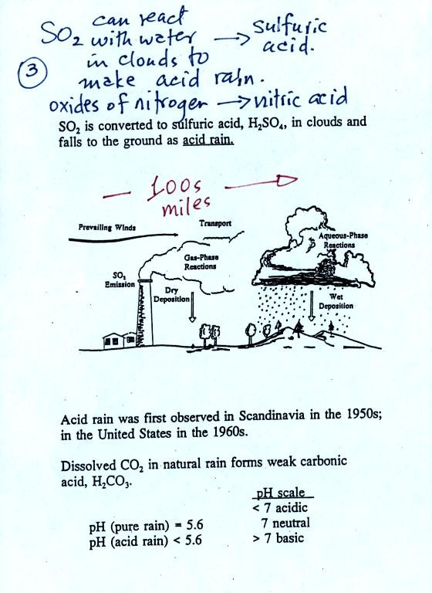

Note that clean unpolluted rain has a pH less than 7 and is slightly acidic. This is because the rain contains dissolved carbon dioxide gas. Acid rain is often a problem in regions that are 100s even 1000s of miles from the source of that sulfur dioxide that forms the acid rain.
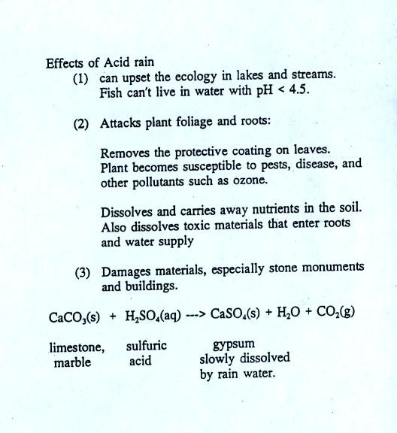
Some of the problems or consequences of acid rain.

Here are the key points that go with sulfur dioxide

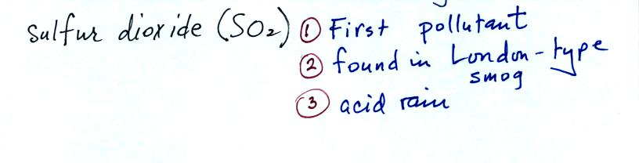
Click here for a sneak peek at the acid rain demonstration that we will perform in class on Friday.

