Friday, Sep. 5, 2008
Short segments from two or three Pink Martini songs were played before class today. If you click on the link you can listen to "Amado Mio", "Hang on Little Tomato," and "Hey Eugene" in their entirety. You really need to be able to hear the words to the 3rd song and the sound system in BioWest 301 isn't up to the task. Pink Martini is playing in Los Angeles on New Year's Eve 2008. I can't think of a better band for that occasion.
The Practice Quiz Study Guide is now available online in a preliminary form (that means there may be a few small changes made by early next week). The Practice Quiz is next Wednesday, Sept. 10. Even though the grade on the Practice Quiz won't count, do try to take the quiz seriously so that you will have a good indication of how you would have done on a real quiz. Reviews are scheduled for Mon. and Tues. afternoons next week in FCS 225 (Family and Consumer Sciences) from 4-5 pm.
Keep an eye on Hurricane Ike. Ike is a strong storm and some long range predictions show it getting very close to the southern tip of Florida early next week.

We quickly reviewed some basic information about acid rain stuck onto the end of the Wed., Sept. 3 notes.
Next we performed a sort of acid rain demonstration. The demonstration gives you an idea of how gases can dissolve in water and turn the water acidic.

The last pollutant that we will cover is Particulate Matter (PM), small particles (solid or liquid) that remain suspended in the air and not a gas. The designations PM10 and PM25 refer to particles with diameters less than 10 micrometers and 2.5 micrometers, respectively. A micrometer is one millionth of a meter. The drawing below might give you some idea of what a 1 micrometer particle would look like (actually it would probably be too small to be seen without magnification).
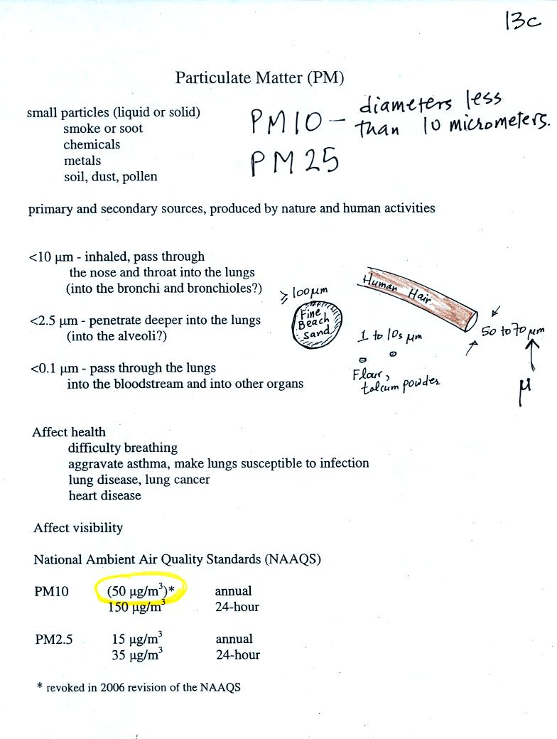

Particulate matter can be produced naturally (wind blown dust, clouds above volcanic eruptions, smoke from lightning caused forest and brush fires) and human activities produce particulates.
Particles with dimensions of 10 micrometers and less can be inhaled into the lungs (larger particles get caught in the nasal passages).
The figure below identifies some of the parts of the human lung mentioned in the figure above.

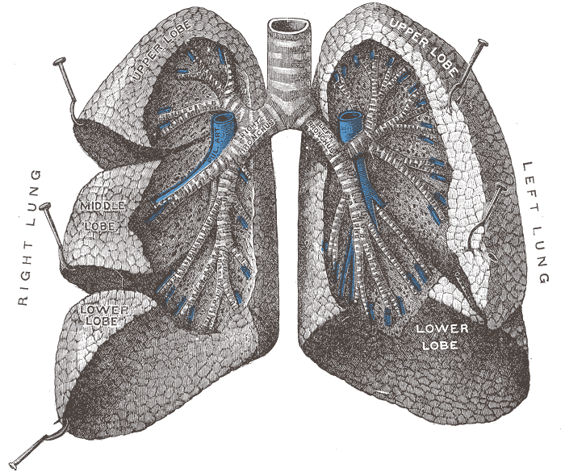  Crossectional view of the human lungs  from: http://en.wikipedia.org/wiki/Lung | 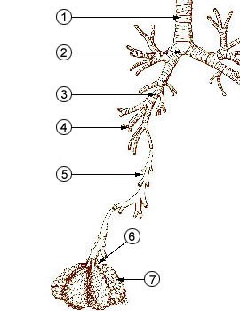  1 - trachea  2 - mainstem bronchus  3 - lobar bronchus  4 - segmental bronchi  5 - bronchiole  6 - alveolar duct  7 - alveolus  from http://en.wikipedia.org/wiki/Image:Illu_quiz_lung05.jpg

Particulates can affect visibility and can make the sky appear hazy. To understand this better we can look at how sunlight is scattered by clean and by dirty air.
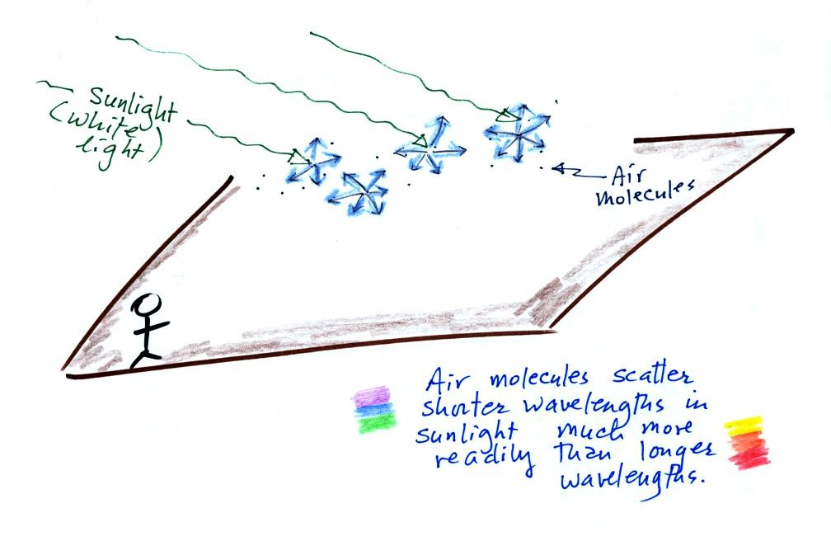
Air molecules scatter sunlight. Because the air molecules are small (relative to the wavelength of visible light) they scatter shorter wavelengths more readily than longer wavelengths. When you look away from the sun and toward the sky you see this scattered light, it has a deep blue color.
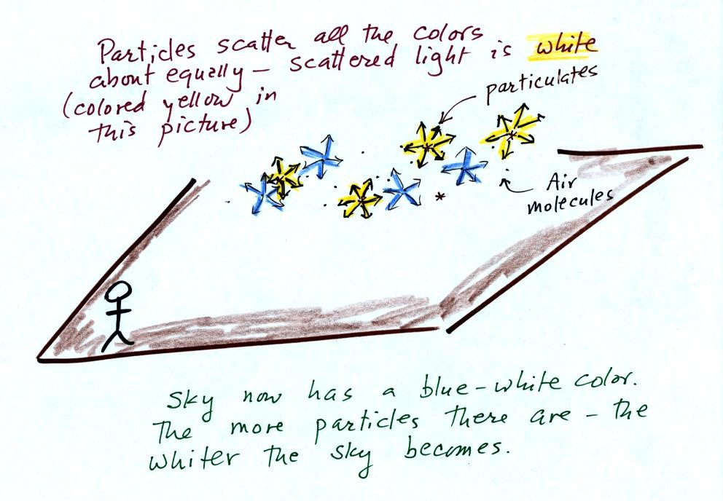
Particles also scatter light (remember the chalk dust used in the demonstration last week). But because the particle size is about equal to or somewhat greater than the wavelength of visible light the particles scatter all the colors equally. The light scattered by particles is white.
As the amount of particulate matter in the air increases the color of the sky changes from deep blue to whitish blue. The higher the particle concentration, the white the sky becomes.

Scattering of sunlight by air molecules turns distant mountains blue and eventually makes them fade from view
(there is eventually much more sunlight being scattered by air than there is sunlight being reflected by the mountains; there is a limit to how far you can see even when the air is very clean).
A nearby mountain might appear dark green or brown. You are mainly seeing light reflected off the mountain. As the mountain gets further away you start seeing increasing amounts of blue light (sunlight scattered by air molecules in between you and the mountain). As the mountain gets even further the amount of this blue light from the sky increases. Eventually the mountain gets so far away that you only see blue sky light and none of the light reflected by the mountain itself.
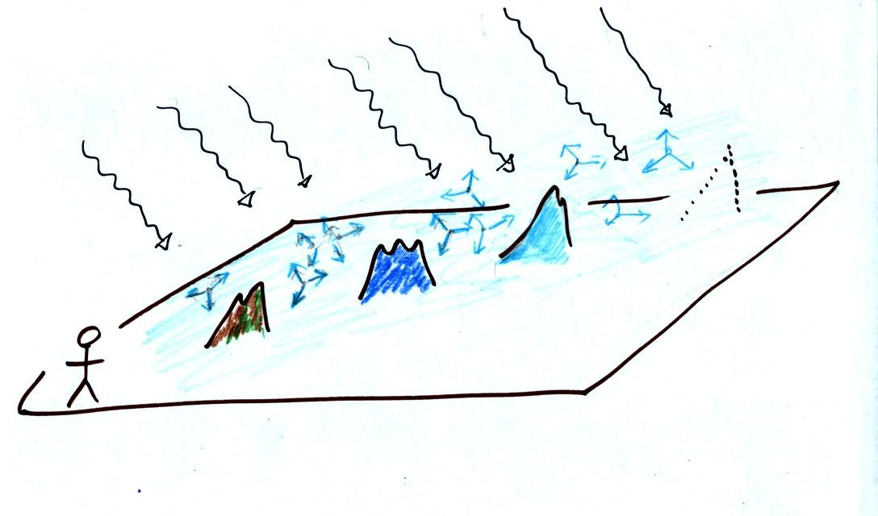

Note the PM10 annual National Ambient Air Quality Standard (NAAQS) value of 50 micrograms/meter3 at the bottom of p. 13c in the photocopied ClassNotes (shown above). The following list shows that there are several cities around the world where PM concentrations 2 or 3 times the NAAQS value.

There was some concern this past summer that the polluted air in Beijing would affect the athletic competition during the Olympic Games. Chinese authorities restricted transportation and industrial activities both before and during the games in an attempt to reduce pollutant concentrations. Rainy weather during the games may have had the greatest effect, however. The figure below wasn't shown in class.
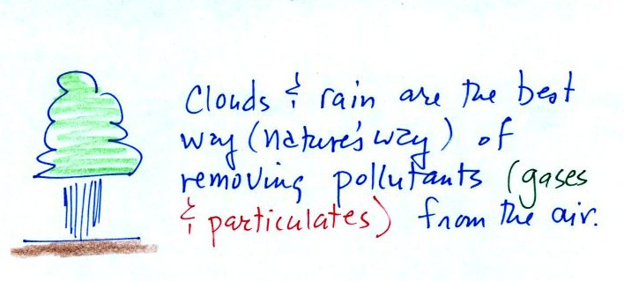
I included it here just to be sure you wouldn't miss the important fact that clouds are the best way of cleaning pollutants from the air.

Here are some of the key things to remember about particulate matter.
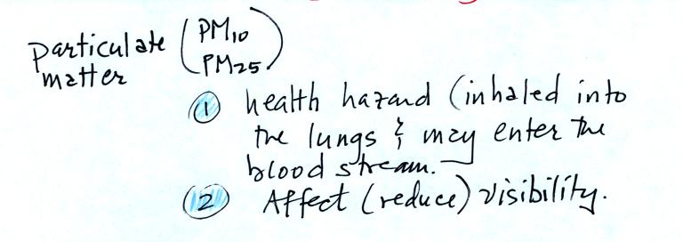

Today and next Monday we will take a brief look at the current concern over increasing concentrations of carbon dioxide in the earth's atmosphere and the worry that this might lead to global warming and climate change. This is a big, complex, and contentious subject and we will only scratch the surface.
We'll start with the information on the top of p. 3a in the photocopied ClassNotes (p. 3 was broken into a couple of pieces and redone for improved clarity). The numbered points were added after class.
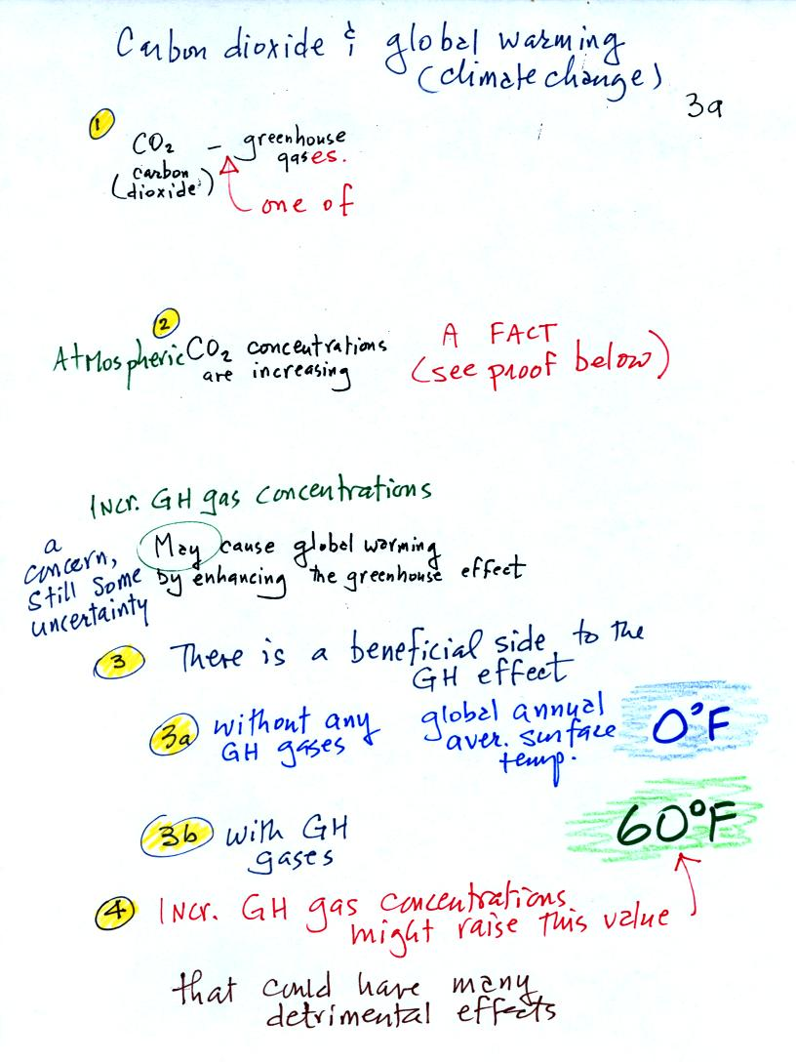
1. Carbon dioxide is one of several greenhouse gases. Much of what we say about CO₂ applies to the other greenhouse gases as well.
2. Atmospheric CO₂ concentrations are increasing. This is pretty generally accepted as fact. We'll look at some of the evidence below.
3. Before we look at enhancement of the greenhouse effect, it is important to understand first that the greenhouse effect is beneficial.
3a. If the earth's atmosphere didn't contain any greenhouse gases, the global annual average surface temperature would be about 0º F. That's pretty cold
3b. The presence of greenhouse gases raises this average temperature to about 60º F.
4. The concern is that increasing atmospheric greenhouse gas concentrations might cause some additional warming. This might not sound like a bad thing. However a small change in average temperature might melt polar ice and cause a rise in sea level and flood coastal areas. Warming might change weather patterns and bring more precipitation to some areas and less to places like Arizona.
Now some of the data that show atmospheric carbon dioxide concentrations are increasing.

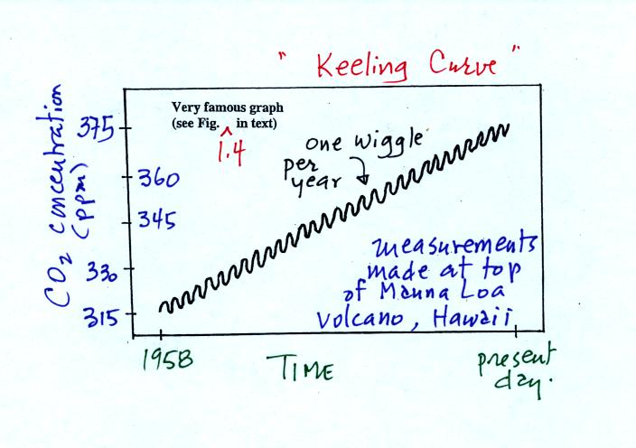

The "Keeling" curve shows measurements of CO₂ that were begun in 1958 on top of the Mauna Loa volcano in Hawaii. Carbon dioxide concentrations have increased from 315 ppm to about 385 ppm between 1958 and the present day. The small wiggles (one wiggle per year) show that CO₂ concentration changes slightly during the course of a year.
You'll find an up to date record of atmospheric CO₂ concentration from the Mauna Loa observatory at the Scripps Institution of Oceanography site.
Once scientists saw this data they began to wonder about how CO₂ concentration might have been changing prior to 1958. But how could you now, in 2008, go back and measure the amount of CO₂ in the atmosphere in the past? Scientists have found a very clever way of doing just that. It involves coring down into ice sheets that have been building up in Antarctica and Greenland for hundreds of thousands of years.
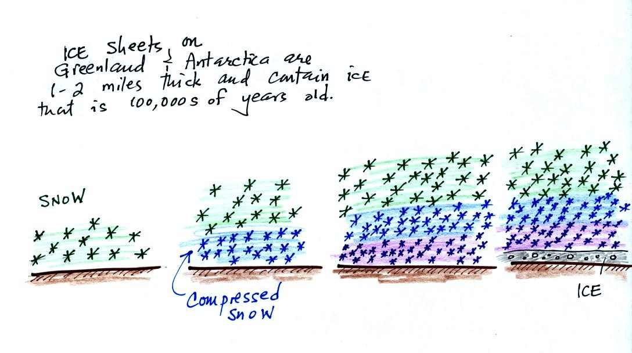
As layers of snow are piled on top of each other year after year, the snow at the bottom is compressed and eventually turns into a thin layer of solid ice. The ice contains small bubbles of air trapped in the snow, samples of the atmosphere at the time the snow originally fell. Scientists are able to date the ice layers and then take the air out of these bubbles and measure the carbon dioxide concentration. This isn't easy, the layers are very thin, the bubbles are small and it is hard to avoid contamination.
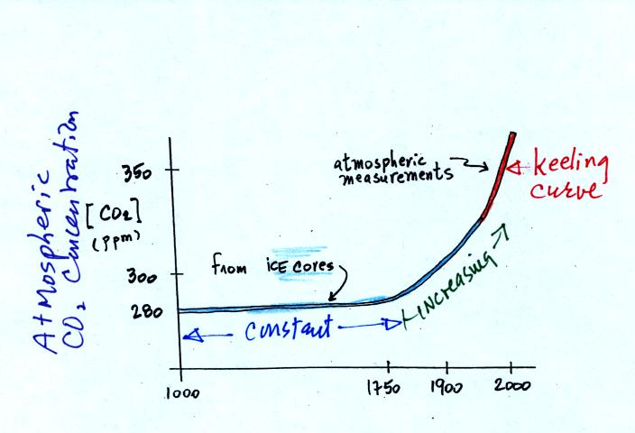

Using the ice core measurements scientists have determined that atmospheric CO₂ concentration was fairly constant at about 280 ppm between 1000 AD and the mid-1700s when it started to increase. The start of rising CO₂ coincides with the beginning of the "Industrial Revolution." Combustion of fossil fuels needed to power factories began to add significant amounts of CO₂ to the atmosphere.
Shown below are some more carefully drawn graphs of changing carbon dioxide, methane, and nitrous oxide concentrations during the past 1000 years from
Climate Change 2001 - The Scientific Basis
Contribution of Working Group I to the 3rd Assessment Report of the Intergovernmental Panel on Climate Change (IPCC) These figures weren't shown in class
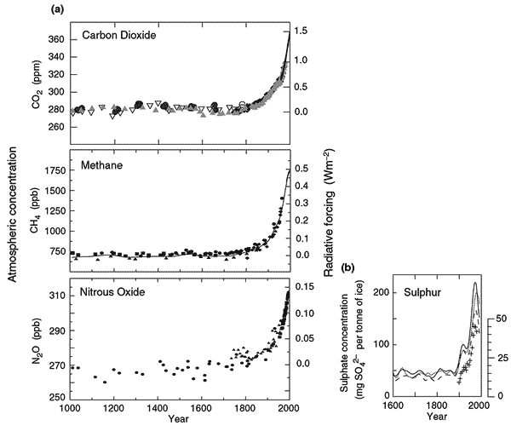
_______________________________________________________________________

In order to understand why atmospheric carbon dioxide concentration is increasing and before we look at what the earth's temperature has been doing during this period we will try to understand better how man has been able to change atmospheric CO2 concentrations. The following figure wasn't shown in class on Friday.
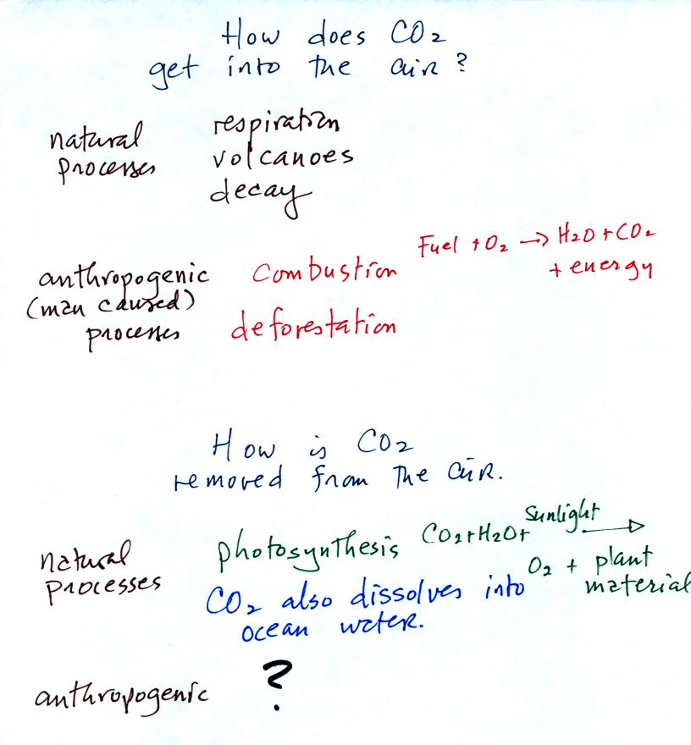

Carbon dioxide is added to the atmosphere naturally by respiration (people breathe in oxygen and exhale carbon dioxide), decay, and volcanoes. Combustion of fossil fuels, a human activity also adds CO₂ to the atmosphere. Deforestation, cutting down and killing a tree (or burning the tree) will keep it from removing CO₂ from the air by photosynthesis. The dead tree will also decay and release CO₂ to the air.
The chemical equation illustrates the combustion of a fossil fuel. The by products are carbon dioxide and water vapor. The steam cloud that you sometimes see come from a rooftop vent or the tailpipe of an automobile (especially during cold wet weather) is evidence of the production of water vapor during the combustion.
Photosynthesis removes CO₂ from the air (in some respects, photosynthesis is the opposite of combustion, photosynthesis manufactures fuel and adds oxygen to the air). CO₂ also dissolves in ocean water.
The ? means your instructor is not aware of an anthropogenic process that removes large amounts of carbon dioxide from the air.
We are now able to better understand the yearly variation in atmospheric CO₂ concentration (the "wiggles" on the Keeling Curve). The figure below was not shown in class.
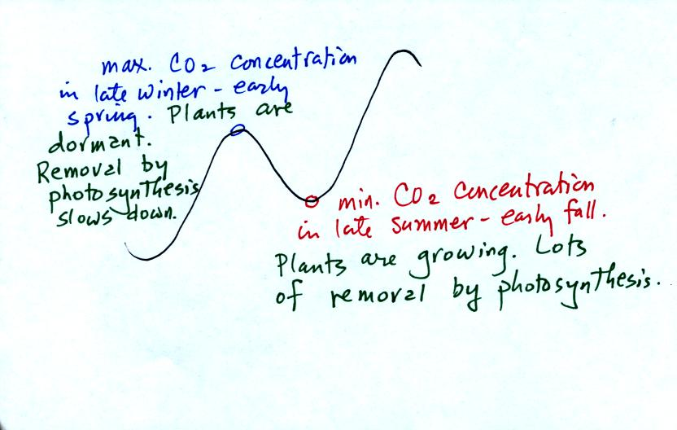
Atmospheric CO₂ peaks in the late winter to early spring. Many plants die or become dormant in the winter. With less photosynthesis, more CO₂ is added to the atmosphere than can be removed. The concentration builds throughout the winter and reaches a peak value in late winter - early spring. Plants come back to life at that time and start to remove the "excess" CO₂.
In the summer the removal of CO₂ by photosynthesis exceeds release. CO₂ concentration decreases throughout the summer and reaches a minimum in late summer to early fall.
With careful measurements you could probably also observe a daily variation in atmospheric CO₂ concentrations.

