Friday Sept. 12, 2008
"Born to be a Bachelor" by Gaelic Storm was the song played before class today.
For the latest news on Hurricane Ike as in makes landfall you might check the website for the Houston Chronicle newspaper.
The Practice Quiz has been graded and was returned in class today. The 64% average is pretty typical for a practice quiz. The average on Quiz #1 will most likely be higher, but not necessarily a lot higher. You'll find answers to all the Practice Quiz questions here.
An In-class Optional Assignment was handed out in class today, it was collected at the end of the period. If you download the assignment, answer the questions, and turn in the assignment at the beginning of class on Monday you can earn partial credit.

We reviewed the concepts of mass, weight, and density before the quiz last Wednesday. Today we will learn about pressure.
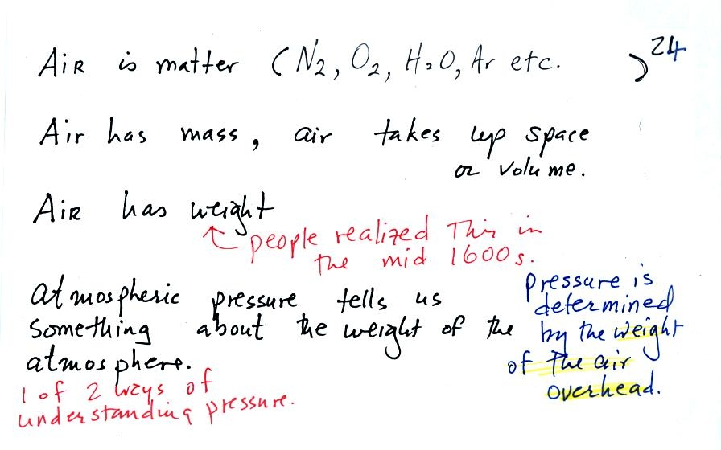
The air that surrounds the earth has mass. Gravity pulls downward on the atmosphere giving it weight. Galileo conducted (in the 1600s) a simple experiment to prove that air has weight.
Pressure is defined as force divided by area. Air pressure is the weight of the atmosphere overhead divided by the area the air is resting on. Atmospheric pressure is determined by and tells you something about the weight of the air overhead.
Under normal conditions a 1 inch by 1 inch column of air stretching from sea level to the top of the atmosphere will weigh 14.7 pounds. Normal atmospheric pressure at sea level is 14.7 pounds per square inch (psi, the units you use when you fill up your car or bike tires with air).
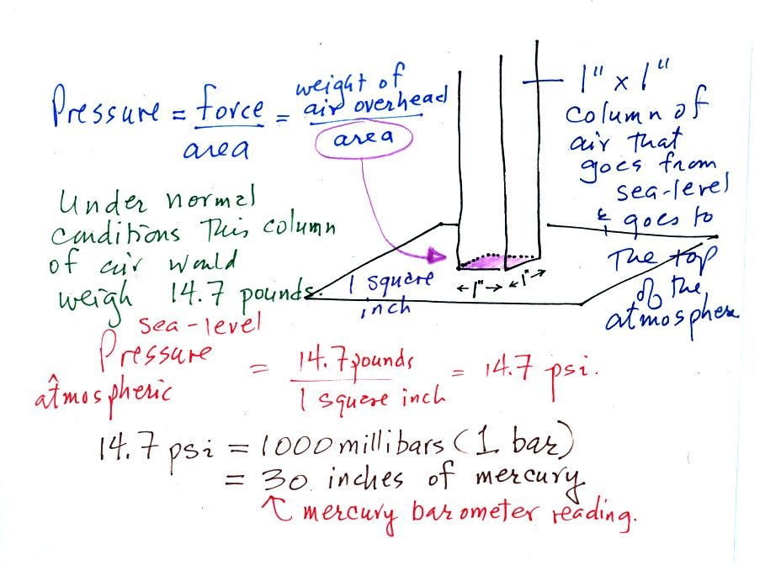
The iron bar that was passed around class on Wednesday also weighed 14.7 pounds. The following figure wasn't shown in class.
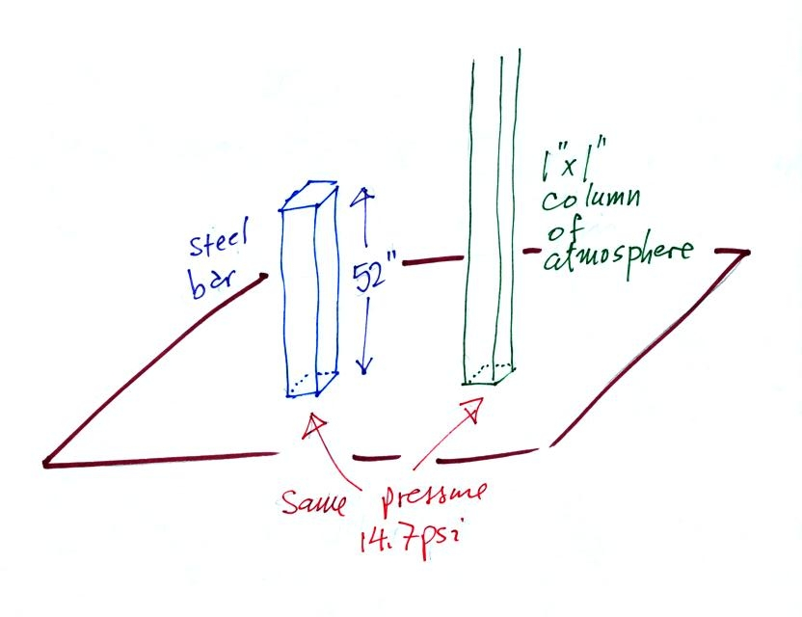
Steel is a lot denser than air, so the steel bar only needed to be 52 inches tall. The air column is a 100 miles or more tall.
Some of the other commonly used pressure units are shown above and repeated below.
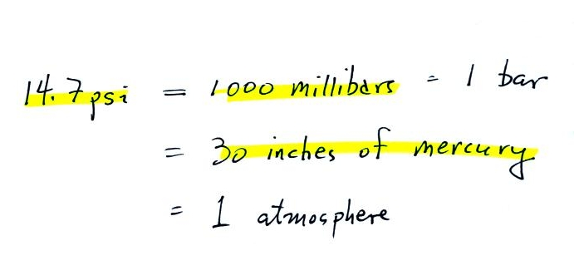
Typical sea level pressure is 14.7 psi or about 1000 millibars (the units used by meterologists and the units that we will use in this class most of the time) or about 30 inches of mercury (refers to the reading on a mercury barometer). If you ever find yourself in France needing to fill your automobile tires with air (as I once was, I owned a Peugeot 404) remember that the air compressor scale is probably calibrated in bars. 2 bars of pressure would be equivalent to 30 psi.
The word "bar" is used in a lot of meteorological terms:
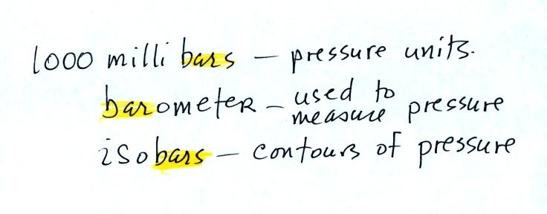

Pressure at sea level is determined by the weight of the air overhead. What about pressure at some level above sea level?We can use a stack of bricks to try to answer this question.
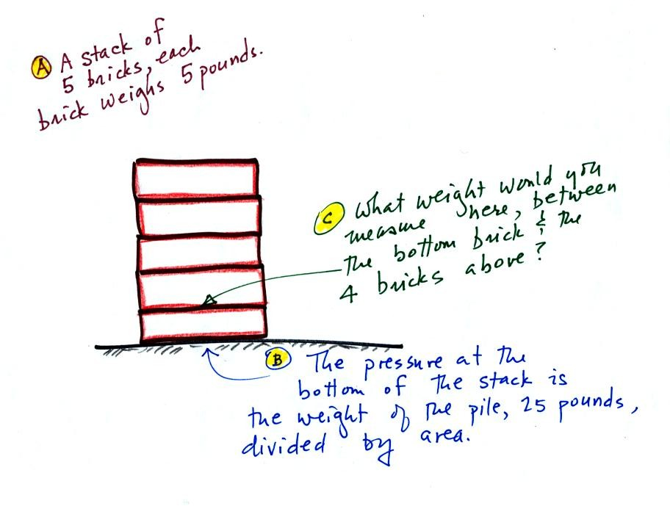
Each brick weighs 5 pounds. At the bottom of the 5 brick tall pile you would measure a weight of 25 pounds. If you moved up a brick you would measure a weight of 20 pounds, the weight of the four bricks still above. In the atmosphere, pressure at any level is determined by the weight of the air still overhead. Pressure decreases with increasing altitude because there is less and less air remaining overhead. The numbered points on the figure below were added after class.
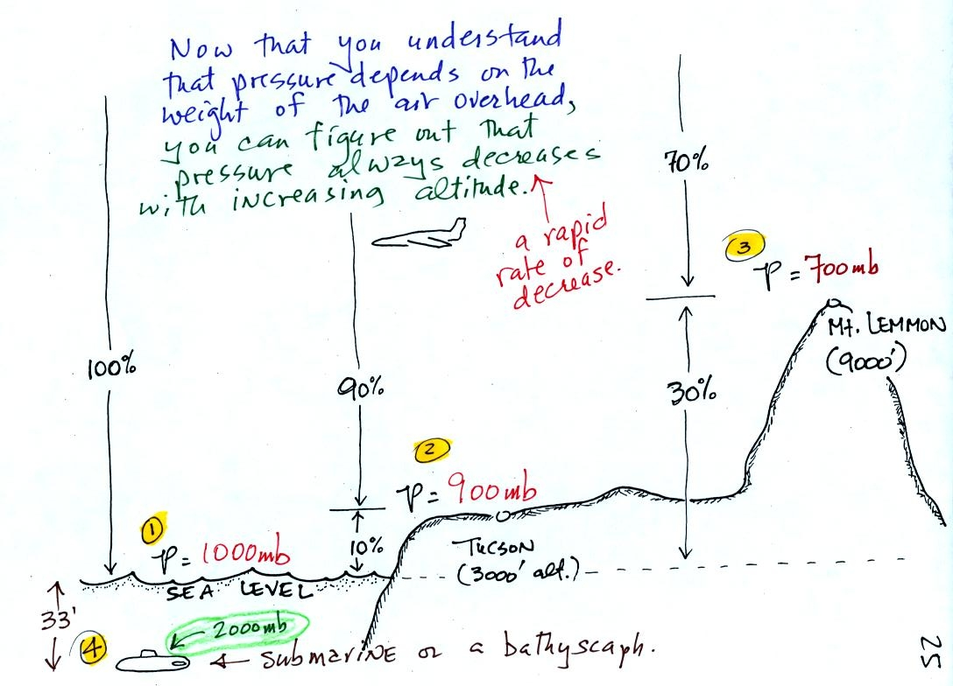
At sea level altitude, at Point 1, the pressure is normally about 1000 mb. That is determined by the weight of all (100%) of the air in the atmosphere.
Some parts of Tucson, at Point 2, are 3000 feet above sea level (most of the valley is lower than that). At 3000 ft. about 10% of the air is below, 90% is still overhead. It is the weight of the 90% that is still above that determines the atmospheric pressure in Tucson. If 100% of the atmosphere produces a pressure of 1000 mb, then 90% will produce a pressure of 900 mb.
Pressure is typically about 700 mb at the summit of Mt. Lemmon (9000 ft. altitude at Point 3) and 70% of the atmosphere is overhead..
Pressure decreases rapidly with increasing altitude. We will find that pressure changes more slowly if you move horizontally. It is small horizontal changes that cause the wind to blow however.
Point 4 shows a submarine at a depth of about 33 ft. The pressure there is determined by the weight of the air and the weight of the water overhead. Water is much denser and much heavier than air. At 33 ft., the pressure is already twice what it would be at the surface of the ocean.
The person in the picture below (from a Physics textbook) is 20 deep underwater. There is a large pressure pushing against his body from the surrounding water. If he puts his mouth on the snorkel (which runs up to the top of the water) he will collapse his lungs. The snorkel is connected to atmospheric pressure which is quite a bit lower than the pressure at 20 depth in the water.
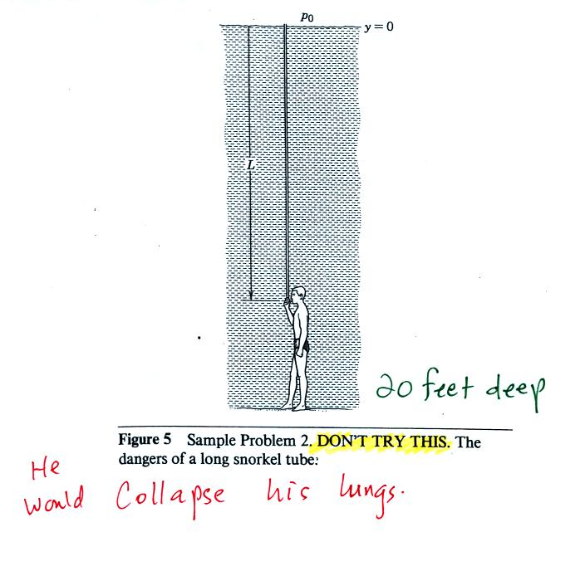

Next we'll learn that the rate of pressure decrease with increasing altitude depends on the air's density. I borrowed the figure below from the other section of the class because this picture is a little clearer than the one we produced on Friday.
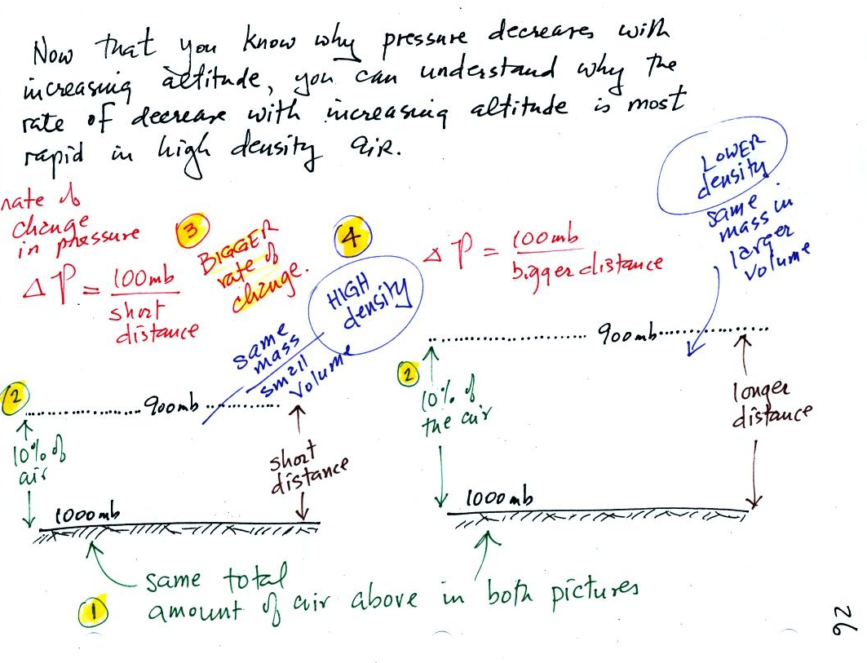
There is a lot going on in this picture. 1000 mb at Point 1 is a typical value for sea level pressure. The fact that the pressures are equal at the bottoms of both sides of the picture means that the weight of the atmosphere at the bottom of the picture on the left is the same as the weight of the atmosphere at the bottom of the picture at right. The only way this can be true is if there is the same total amount (mass) of air in both cases.
Point 2 - Moving upward from the ground we find that pressure decreases to 900 mb at the level of the dotted line in the picture at left. This is what you expect, pressure decreases with increasing altitude. In the figure at right you need to go a little bit higher for the same 100 mb decrease.
Since there is a 100 mb drop in both the layer at left and in the layer at right, both layers must contain the same amount (mass) of air.
Point 3 - The most rapid rate of pressure decrease with increasing altitude is occurring in the picture at left.
Point 4 - The air in the picture at left is squeezed into a thinner layer than in the picture at right. The air density in the left layer is higher than in the layer at right.
By carefully analyzing this figure we have proved to ourselves that the rate of pressure decrease with altitude is higher in dense air than in lower density air.
This is a fairly subtle but important concept. We will use this concept several times during the semester. In particular we will need this concept to understand why hurricanes can intensify and get as strong as they do.

Newton's Law of Universal Gravitation is an equation that allows you to calculate the gravitational attraction between two objects. We really didn't work through the following figures in class (except for filling in the boxes at the bottom of p. 28 with the English and Metric units for mass and weight). The reason that they have been included on the online notes is that with a little thought you can appreciate and understand why certain variables appear in Newton's Law and why they appear in either the numerator (direct proportionality) or in the denominator (inverse proportionality).
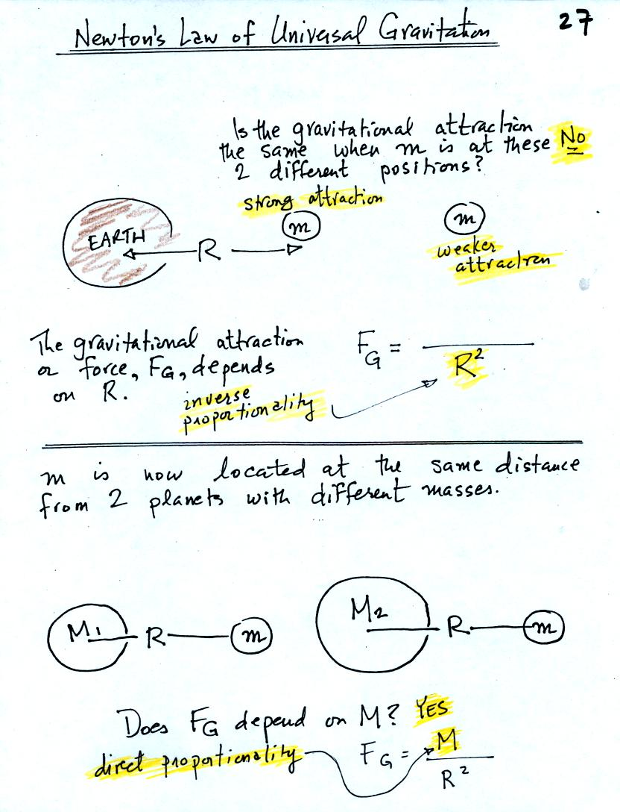
The gravitational attraction between two objects (M and m in the figures) depends first of all on the distance separating the objects. The gravitational force becomes weaker the further away the two objects are from each other. In the bottom picture above and the top figure below we see that the attractive force also depends on the masses of the two objects.
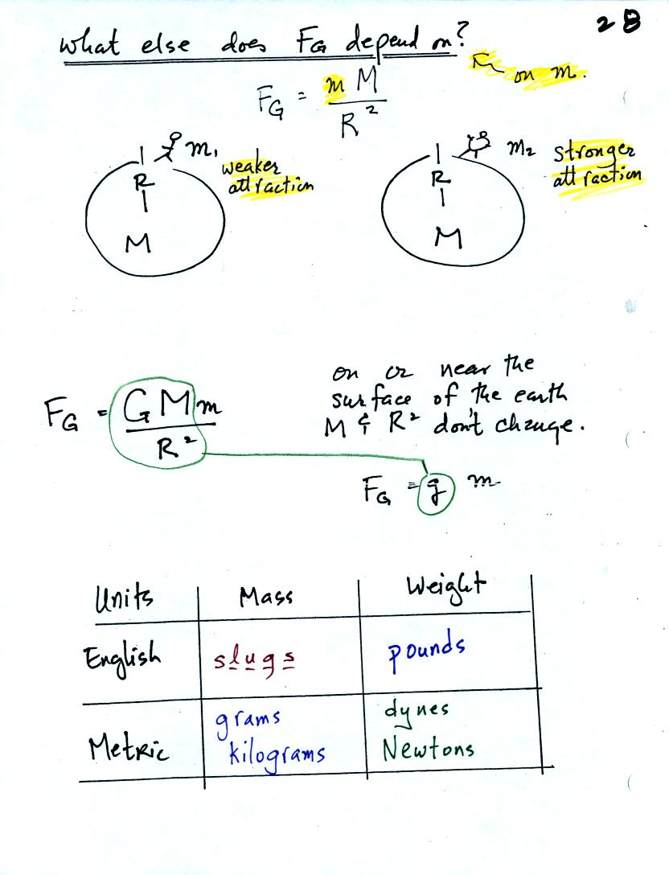

The complete formula is shown in the middle of the page above. G is a constant. On the surface of the earth G, M, and R don't change. The gravitational acceleration, g, is just the quantity [G times M_{earth} divided by ( R_{earth} )² ]. To determine the weight (on the earth's surface) of an object with mass m you simply multiply m x g.
Down at the bottom of the page are the Metric and English units of mass and weight. You have probably heard of pounds, grams, and kilograms. You might not have heard of dynes and Newtons. Most people have never heard of slugs.

Here's another page from the photocopied Class Notes that we didn't cover in class. The weight of a person on the earth and the moon is calculated in English and metric units.
The mass of a person would be the same on the earth and on the moon. The weight of a person depends on the person's mass and on the strength of gravity (the acceleration of gravity term, the g variable below).
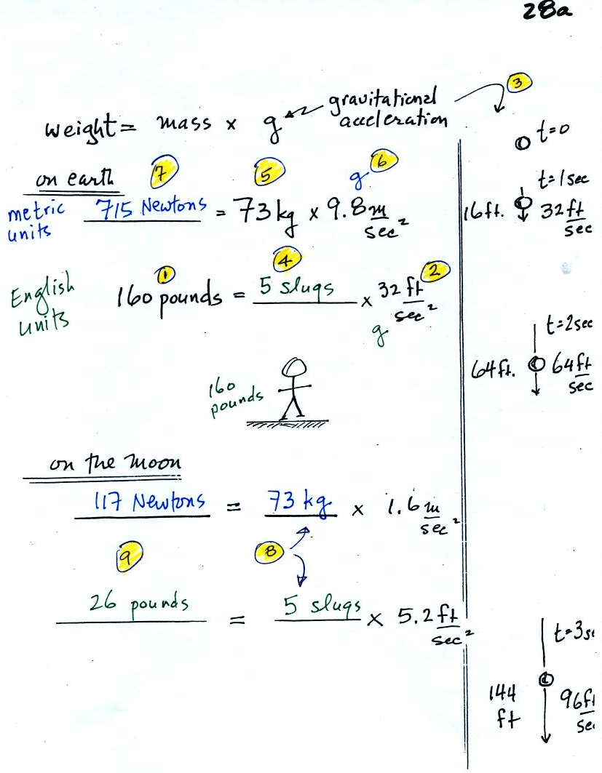
(1) After a long cold winter and without much bicycling or other exercise, the course instructor sometimes weighs as much as 160 pounds. In (2) we see that the gravitational acceleration (g) is 32 ft/sec2 in English units (on the earth). The meaning of this value is shown in (3). If you drop an object it will start to fall and will speed up as it continues to fall. Gravity will cause a falling object to fall 32 ft/sec faster every second. Dividing the instructor's weight by the gravitation acceleration in (4) we obtain the instructor's mass, 5 slugs, in English units.
In metric units, the instructor has a mass of 73 kilograms (5). The gravitation acceleration in metric units is 9.8 m/sec (6). Multiplying these two values, in (7), we find that the instructor weighs 715 Newtons.
On the moon, the mass stays the same. Gravity is weaker, so the value of g is smaller. The instructor would weigh quite a bit less (117 Newtons or 26 pounds) on the moon compared to the earth.

Mercury barometers are used to measure atmospheric pressure. A mercury barometer is really just a balance that can be used to weigh the atmosphere. A basic understanding of how a mercury barometer works is something that every college graduate should have. You'll find most of what follows on p. 29 in the photocopied Class Notes.
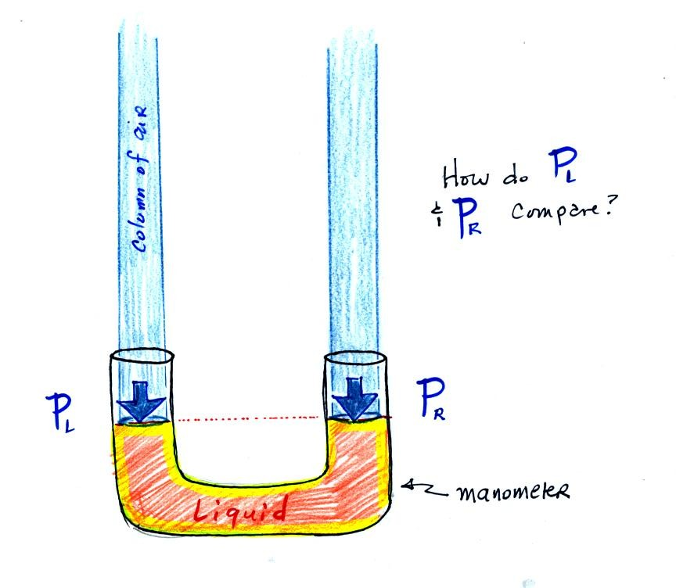

The instrument above ( a u-shaped glass tube filled with a liquid of some kind) is a manometer and can be used to measure pressure difference. The two ends of the tube are open so that air can get inside and air pressure can press on the liquid. Given that the liquid levels on the two sides of the manometer are equal, what could you about P_{L} and P_{R}?
The liquid can slosh back and forth just like the pans on a balance can move up and down. A manometer really behaves just like a pan balance.
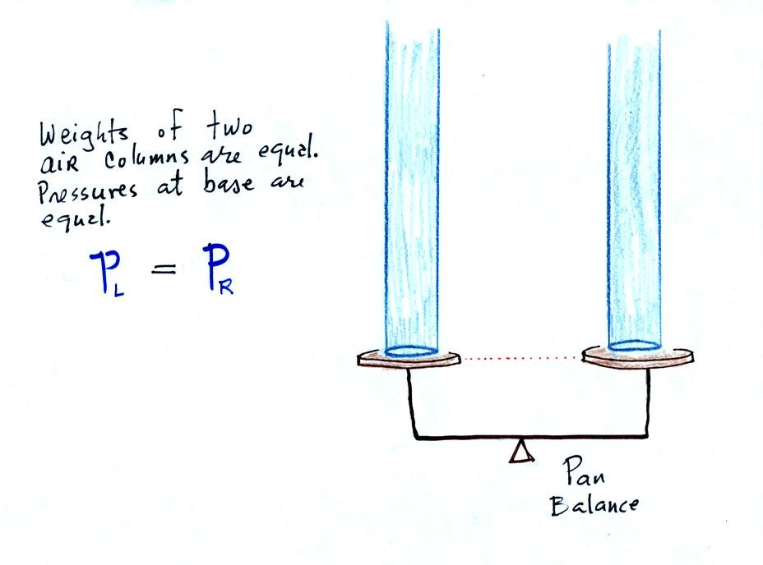
P_{L} and P_{R} are equal (note you don't really know what either pressure is just that they are equal
.
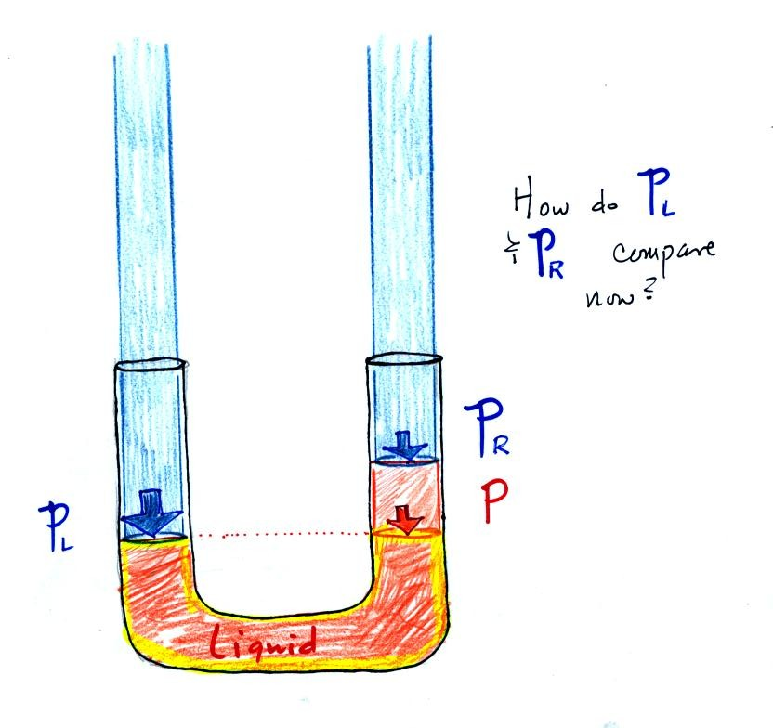
Now the situation is a little different, the liquid levels are no longer equal. You probably realize that the air pressure on the left, P_{L}, is a little higher than the air pressure on the right, P_{R}. P_{L} is now being balanced by P_{R} + P acting together. P is the pressure produced by the weight of the extra fluid on the right hand side of the manometer (the fluid that lies above the dotted line). The height of the column of extra liquid provides a measure of the difference between P_{L} and P_{R}.

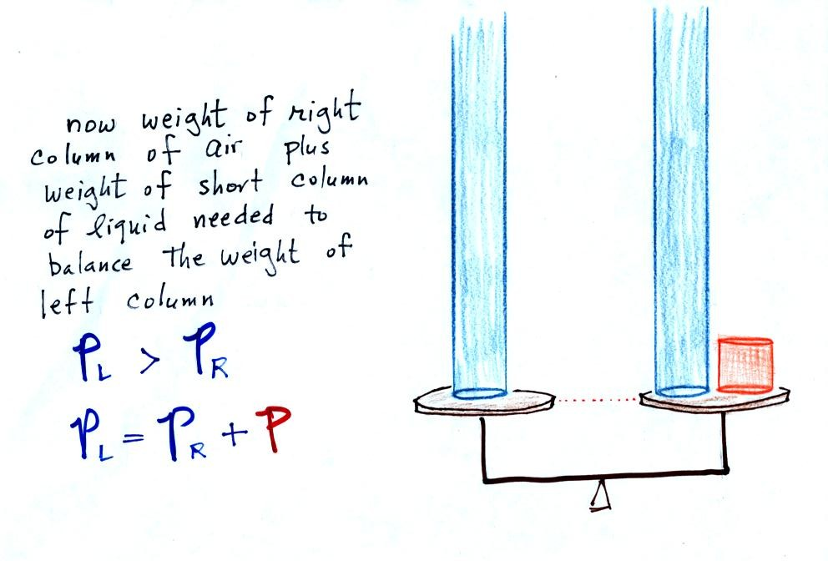
Next we will go an extreme and close off the right hand side of the manometer.
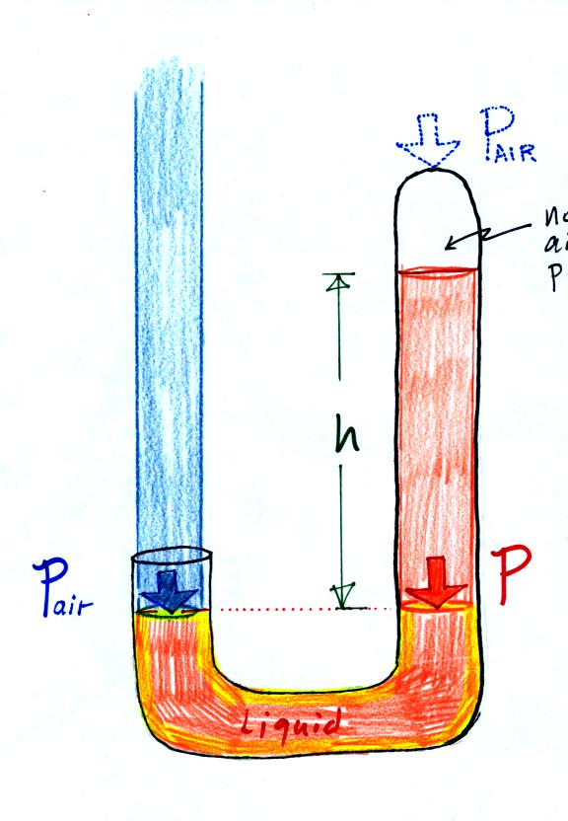

Air pressure can't get into the right tube any more. Now at the level of the dotted line the balance is between P_{air} and P (pressure by the extra liquid on the right). If P_{air} changes, the height of the right column, h, will change. You now have a barometer, an instrument that can measure and monitor the atmospheric pressure. (some of the letters were cut off in the upper right portion of the figure, they should read "no air pressure")
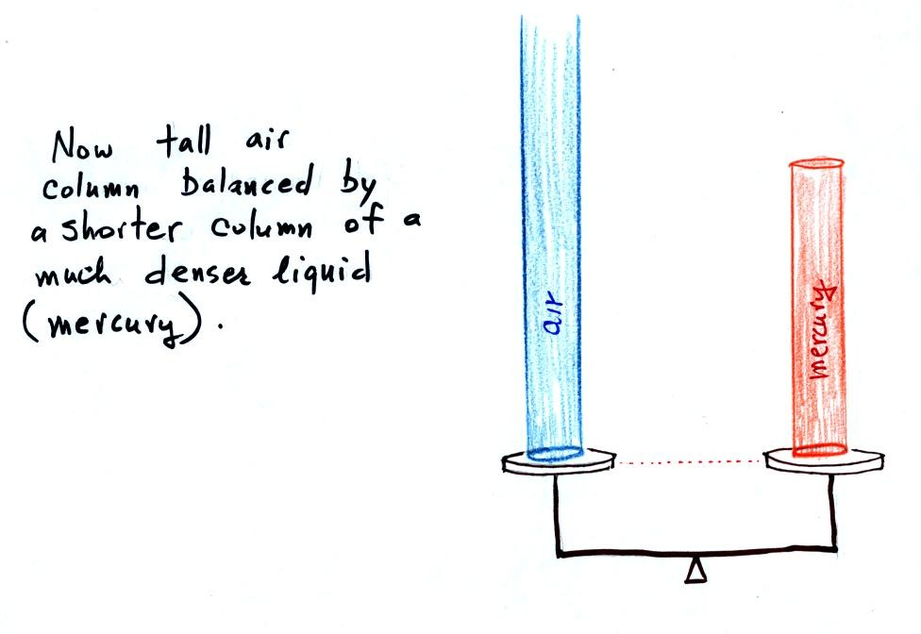

Barometers like this are usually filled with mercury. Mercury is a liquid. You need a liquid that can slosh back and forth in response to changes in air pressure. Mercury is also dense which means the barometer won't need to be as tall as if you used something like water. A water barometer would need to be over 30 feet tall. With mercury you will need only a 30 inch tall column to balance the weight of the atmosphere at sea level under normal conditions (remember the 30 inches of mercury pressure units mentioned earlier). Mercury also has a low rate of evaporation so you don't have much mercury gas at the top of the right tube.

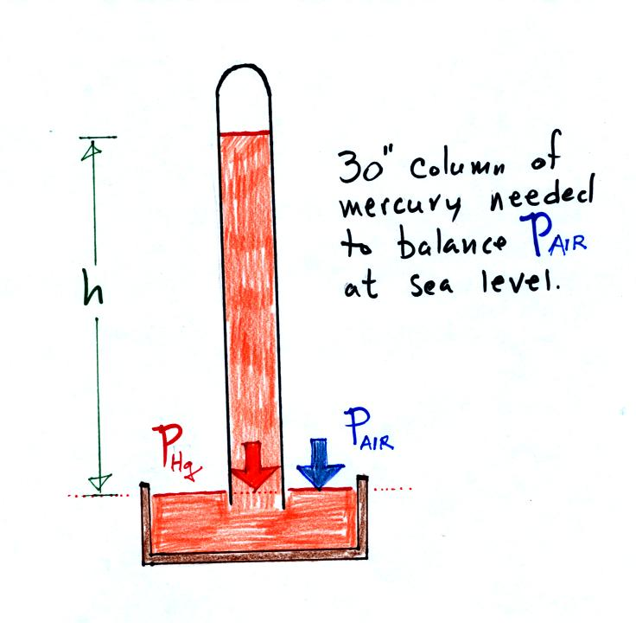
Finally here is a more conventional barometer design. The bowl of mercury is usually covered in such a way that it can sense changes in pressure but not evaporate and fill the room with poisonous mercury vapor.

