Wednesday Sept. 17, 2008
Yesterday (Sept. 16) was Independence Day in Mexico and you heard two more songs "Cancion Del Mariachi" and "Aires Del Mayab" from the Calexico and Mariachi Luz de Luna concert at the Barbican Theater in London.
The 1S1P Bonus Assignment was collected in class today. It will take some time (probably at least one week) to grade these reports and return them to you.
The first Optional homework Assignment is due next Monday You should complete this assignment before coming to class and have it ready to turn in at the beginning of class. 1S1P Assignment #1 reports are due on or before Wednesday, Oct. 1
The Quiz #1 Study Guide now available. Note Quiz #1 next week will cover material on both the Practice Quiz Study Guide and the Quiz #1 Study Guide.
An additional review has been scheduled from 2 - 3 pm in Modern Languages 310 on Tuesday afternoon next week.

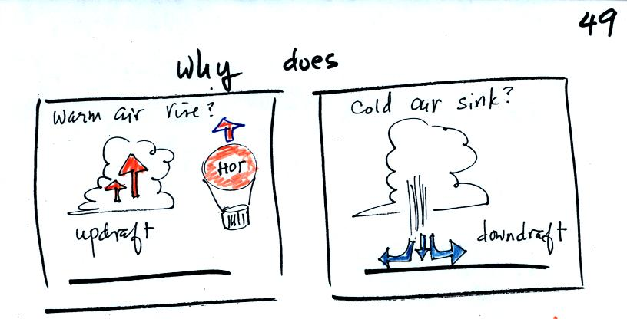
Nobody has told me yet why hot air balloons rise. It isn't just hot air balloons, but the warm air in a thunderstorm updraft also rises. Conversely cold air sinks. A full understanding of why this occurs is a 3-step process. We worked through the first two steps today.
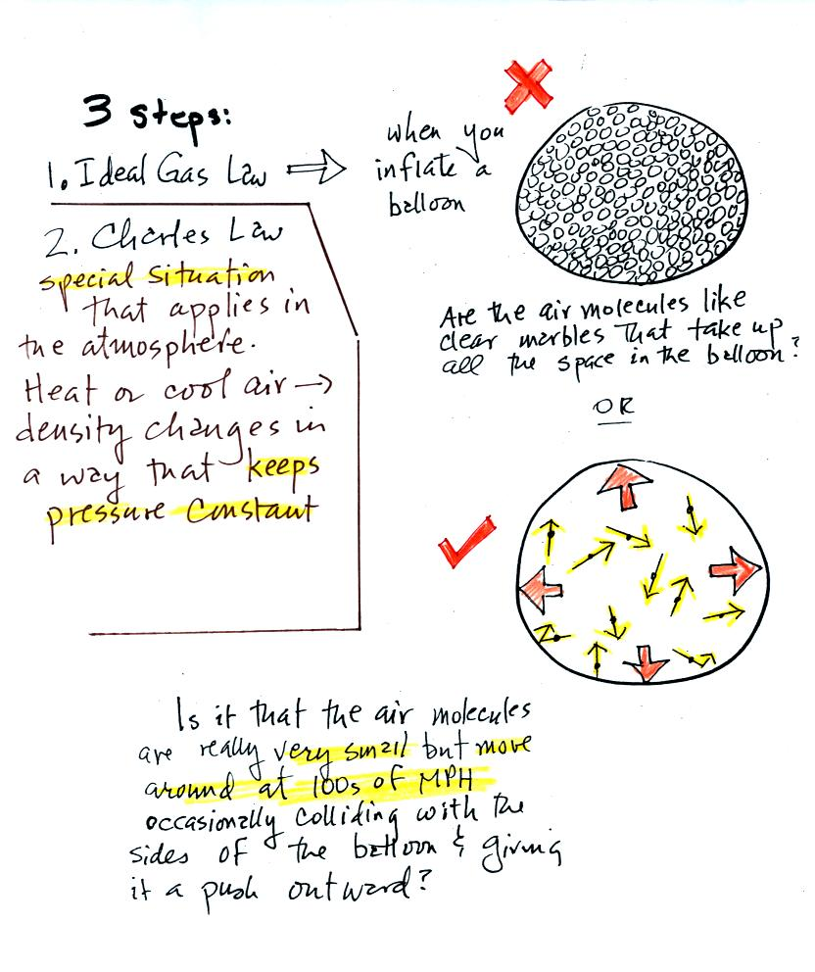
The figure above is the bottom part of p. 49 in the photocopied ClassNotes. We will first learn about the ideal gas law. That is an equation that tells you how properties of the air inside a balloon work to determine the air's pressure. Then we will look at Charles' Law, a special situation involving the ideal gas law.
The figure above makes an important point: the air molecules in a balloon "filled with air" really take up very little space. A balloon filled with air is really mostly empty space. It is the collisions of the air molecules with the inside walls of the balloon that keep it inflated.
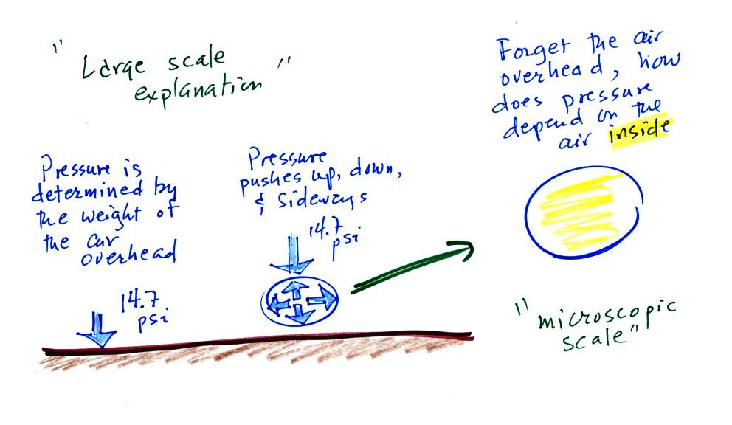
Up to this point in the semester we have been thinking of pressure as being determined by the weight of the air overhead. Air pressure pushes down against the ground at sea level with 14.7 pounds of force per square inch. If you imagine the weight of the atmosphere pushing down on a balloon sitting on the ground you realize that the air in the balloon pushes back with the same force. Air everywhere in the atmosphere pushes upwards, downwards, and sideways.
The ideal gas law equation is another way of thinking about air pressure. We ignore the atmosphere and concentrate on just the air inside the balloon. We are going to "derive" an equation. Pressure (P) will be on the left hand side. Properties of the air inside the balloon will be found on the right side of the equation.
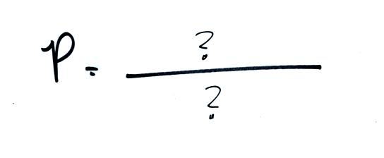

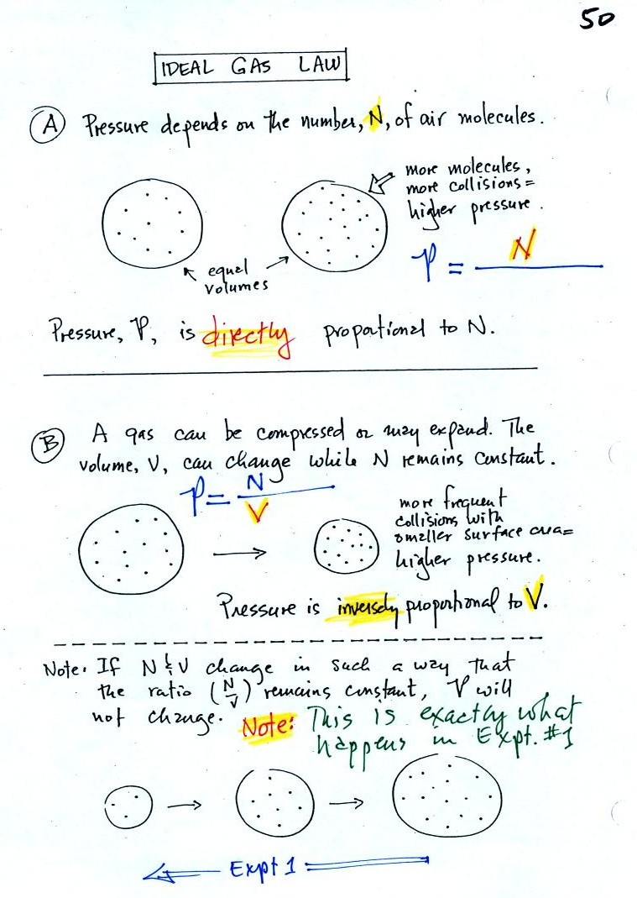
In A
the pressure produced by the air molecules inside a balloon will first depend on how many air molecules are there. If there weren't any air molecules at all there wouldn't be any pressure. As you add more and more add to something like a bicycle tire, the pressure increases. Pressure is directly proportional to N - an increase in N causes an increase in P. If N doubles, P also doubles (as long as the other variables in the equation don't change).
In B
air pressure inside a balloon also depends on the size of the balloon. Pressure is inversely proportional to volume, V . If V were to double, P would drop to 1/2 its original value.
Note
it is possible to keep pressure constant by changing N and V together in just the right kind of way. This is what happens in Experiment #1 that some of you are working on. Oxygen in a graduated cylinder reacts with steel wool to form rust. Oxygen is removed from the air sample which is a decrease in N. As oxygen is removed, water rises up into the cylinder decreasing the air sample volume. N and V both decrease in the same relative amounts and the air sample pressure remains constant. If you were to remove 20% of the air molecules, V would decrease to 20% of its original value and pressure would stay constant.
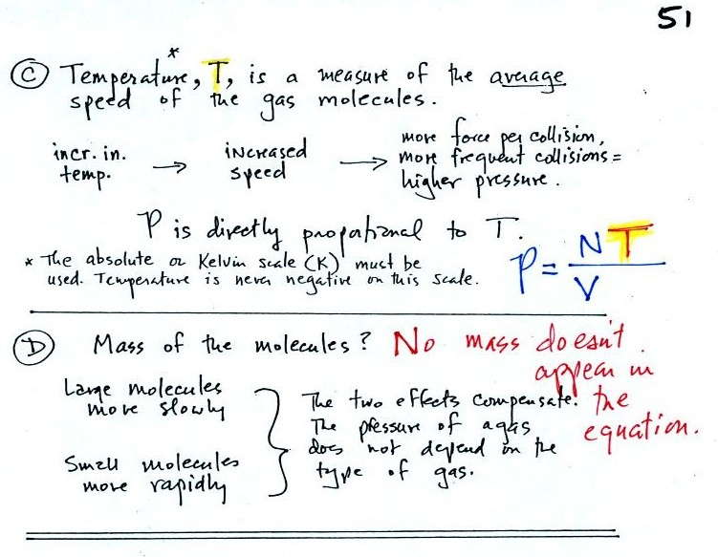
Increasing the temperature of the gas in a balloon will cause the gas molecules to move more quickly. They'll collide with the walls of the balloon more frequently and rebound with greater force. Both will increase the pressure. You shouldn't throw a can of spray paint into a fire because the temperature will cause the pressure inside the can to increase and the can could explode. We'll demonstrate the effect of temperature on pressure in class on Friday.
Surprisingly the pressure does not depend on the mass of the molecules. Pressure doesn't depend on the composition of the gas. Gas molecules with a lot of mass will move slowly, the less massive molecules will move more quickly. They both will collide with the walls of the container with the same force.
The figure below (which replaces the bottom of p. 51 in the photocopied ClassNotes) shows two forms of the ideal gas law. The top equation is the one we just derived and the bottom is a second slightly different version. You can ignore the constants k and R if you are just trying to understand how a change in one of the variables would affect the pressure. You only need the constants when you are doing a calculation involving numbers.

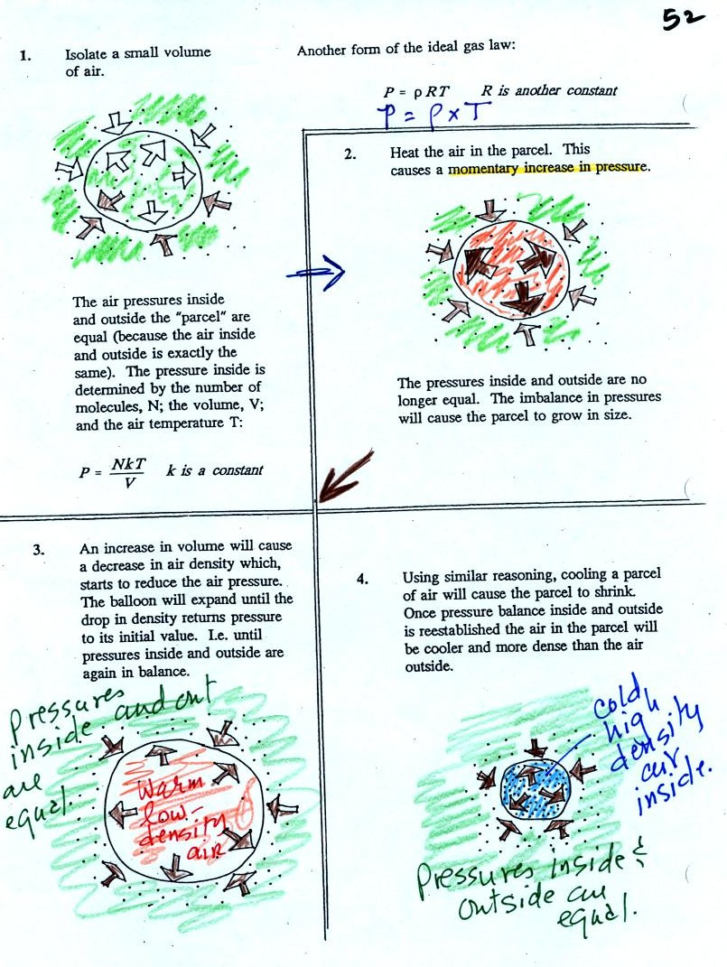
Read through the explanation on p. 52 in the photocopied Classnotes.
These two associations:
(i) warm air = low density air
(ii) cold air = high density air
are important and will come up a lot during the remainder of the semester.
Click here if you would like a little more detailed, more step-by-step, explanation of Charles Law. Otherwise proceed on to the Charles' Law demonstration that we did in class.

Charles Law can be demonstrated by dipping a balloon in liquid nitrogen. You'll find an explanation on the top of p. 54 in the photocopied ClassNotes.
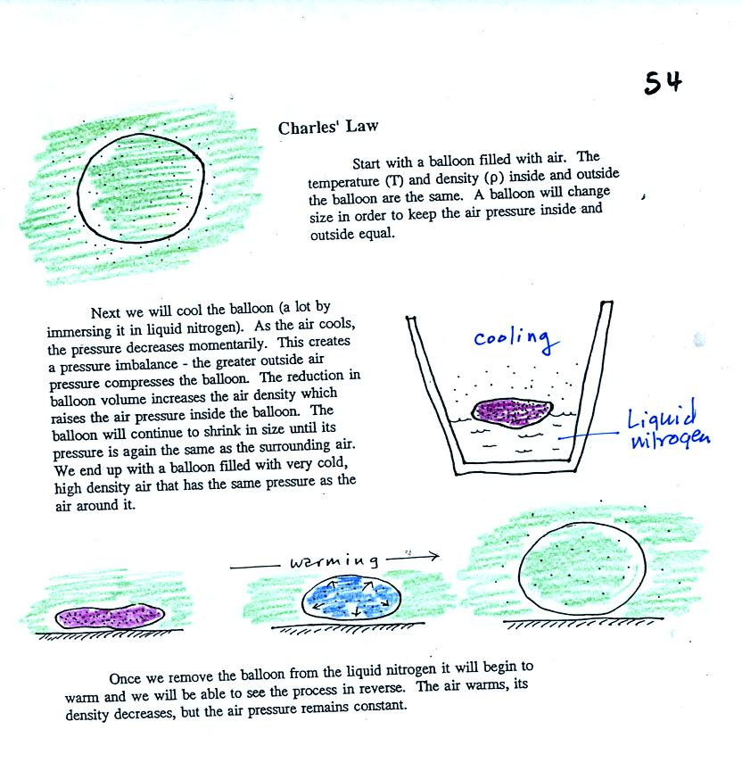
The balloon had shrunk down to practically no volume when pulled from the liquid nitrogen. It was filled with cold high density air. As the balloon warmed the balloon expanded and the density of the air inside the balloon decreased. The volume and temperature kept changing in a way that kept pressure constant.
Here's a summary
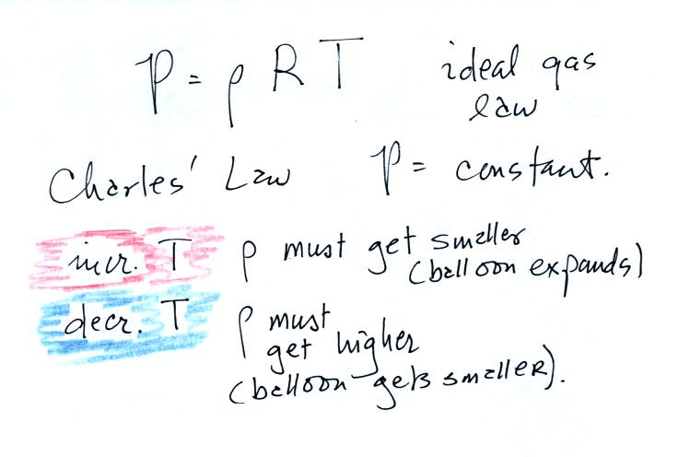

Now for one of those abrupt transitions from one topic to another, completely different, topic that some times occurs in NATS 101. This might be a good time to go outside for a smoke, or a drink, or a stretch, or maybe just a good yell.
We're well into the semester and are now ready to move into the last part of Chapter 1. I hope you aren't too unhappy with the slow progress we're making (if you are you can send me an email and let me know about it).
This week and early next week we'll learn how weather data are entered onto surface weather maps and learn about some of the analyses of the data that are done and what they can tell you about the weather. We will also (time permitting) have a brief look at upper level (higher altitude) weather maps.
Much of our weather is produced by relatively large (synoptic scale) weather systems. To be able to identify and characterize these weather systems you must first collect weather data (temperature, pressure, wind direction and speed, dew point, cloud cover, etc) from stations across the country and plot the data on a map. The large amount of data requires that the information be plotted in a clear and compact way. The station model notation is what meterologists use (you'll find the station model notation discussed in Appendix C, pps 525-529, in the textbook).
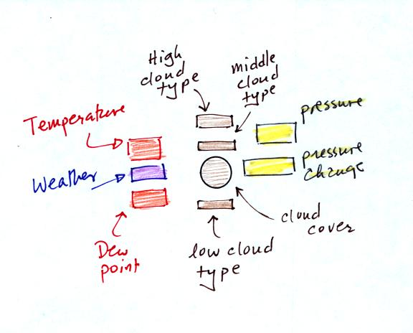
The figure above wasn't shown in class.
A small circle is plotted on the map at the location where the weather measurements were made. The circle can be filled in to indicate the amount of cloud cover. Positions are reserved above and below the center circle for special symbols that represent different types of high, middle, and low altitude clouds (I didn't mention these in class but they are in the textbook). The air temperature and dew point temperature are entered to the upper left and lower left of the circle respectively. A symbol indicating the current weather (if any) is plotted to the left of the circle in between the temperature and the dew point (you can choose from close to 100 different weather symbols included in the textbook ). The pressure is plotted to the upper right of the circle and the pressure change (that has occurred in the past 3 hours) is plotted to the right of the circle.
Here's the actual example we started on in class.
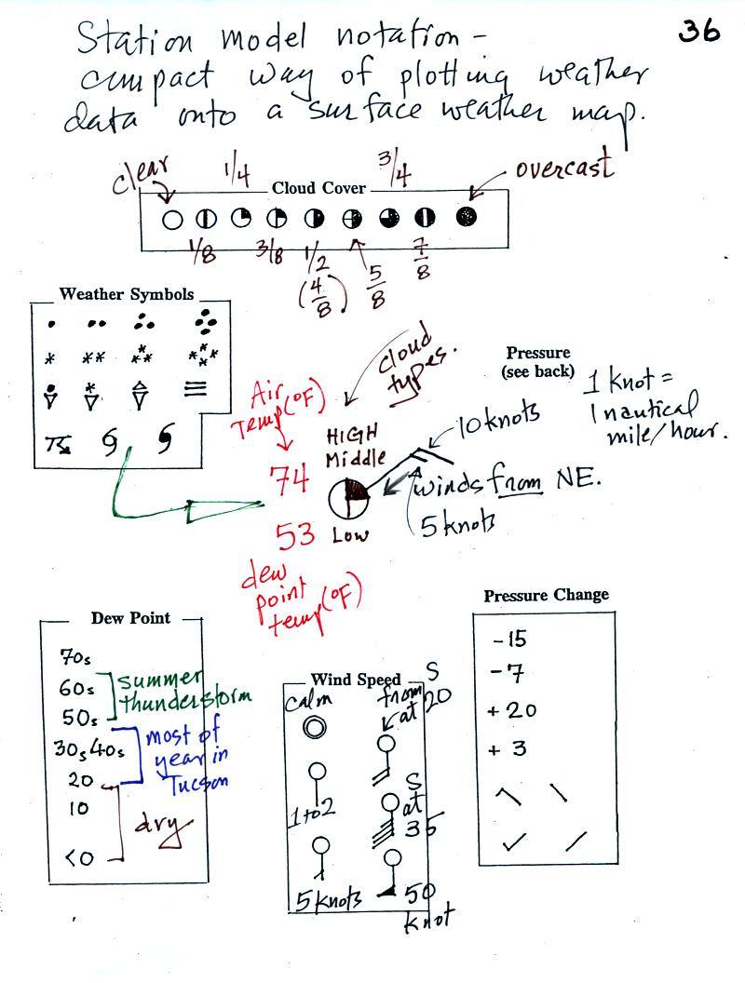
This is frankly a mess and would be very hard to unscramble if you are seeing it for the first time. So we'll work through another example one step at a time.
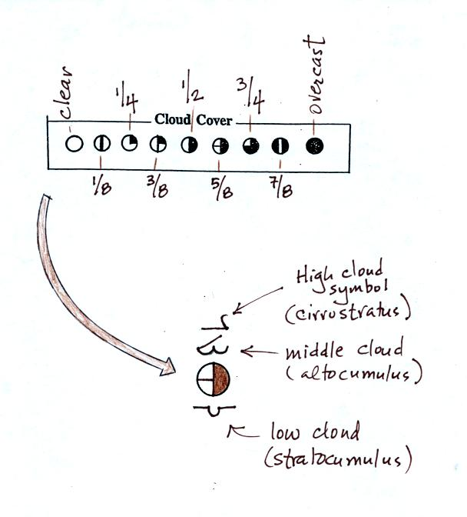
The center circle is filled in to indicate the portion of the sky covered with clouds (estimated to the nearest 1/8th of the sky) using the code at the top of the figure. Then symbols (not drawn in class) are used to identify the actual types of high, middle, and low altitude clouds (the symbols can be found in Appendix C in the textbook).
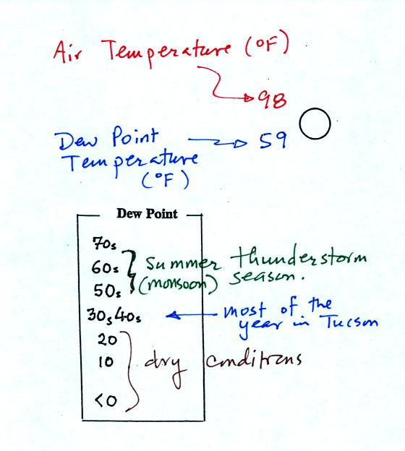
The air temperature in this example was 98º F (this is plotted above and to the left of the center circle). The dew point temperature was 59º F and is plotted below and to the left of the center circle. The box at lower left reminds you that dew points are in the 30s and 40s during much of the year in Tucson. Dew points rise into the upper 50s and 60s during the summer thunderstorm season (dew points are in the 70s in many parts of the country in the summer). Dew points are in the 20s, 10s, and may even drop below 0 during dry periods in Tucson.
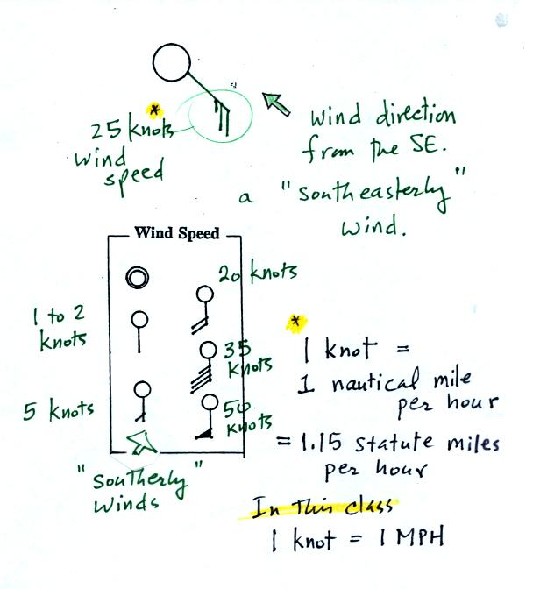
A straight line extending out from the center circle shows the wind direction. Meteorologists always give the direction the wind is coming from. In this example the winds are blowing from the SE toward the NW at a speed of 25 knots. A meteorologist would call these southeasterly winds. Small barbs at the end of the straight line give the wind speed in knots. Each long barb is worth 10 knots, the short barb is 5 knots. Knots are nautical miles per hour. One nautical mile per hour is 1.15 statute miles per hour. We won't worry about the distinction in this class, you can just pretend that one knot is the same as one mile per hour.
Here are some additional wind examples that weren't shown in class:
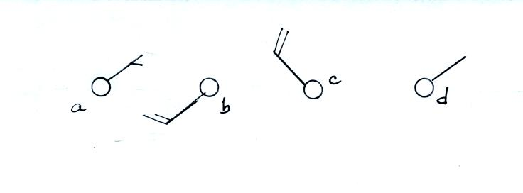
In (a) the winds are from the NE at 5 knots, in (b) from the SW at 15 knots, in (c) from the NW at 20 knots, and in (d) the winds are from the NE at 1 to 2 knots.
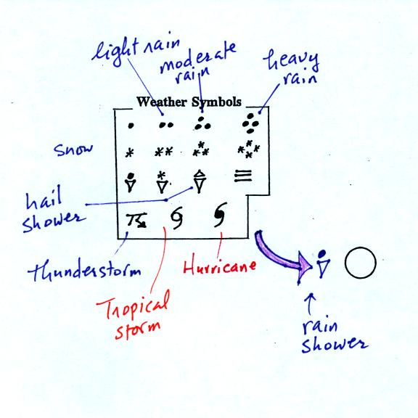
A symbol representing the weather that is currently occurring is plotted to the left of the center circle. Some of the common weather symbols are shown. There are about 100 different weather symbols that you can choose from.
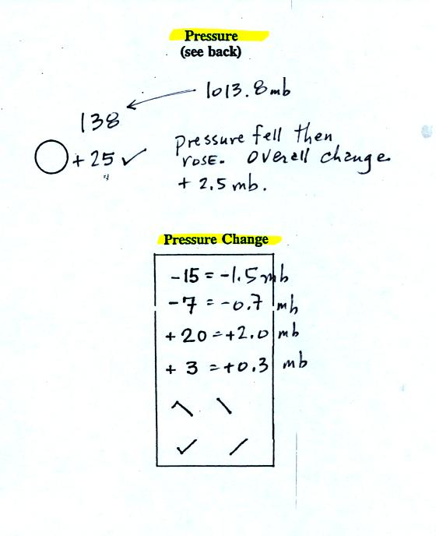
The sea level pressure is shown above and to the right of the center circle. Decoding this data is a little "trickier" because some information is missing. We'll learn about decoding the pressure in class on Friday.
Pressure change data (how the pressure has changed during the preceding 3 hours and not covered in class) is shown to the right of the center circle. You must remember to add a decimal point. Pressure changes are usually pretty small.

Here are some links to surface weather maps with data plotted using the station model notation: UA Atmos. Sci. Dept. Wx page, National Weather Service Hydrometeorological Prediction Center, American Meteorological Society.

