Monday Sept. 22, 2008
I don't know about you, but I enjoyed class today. Instead of the usual music I showed a few minutes from the first episode from Survivor The Australian Outback. It aired in Spring 2001. Survivor Gabon premieres this week at 7 pm on Thursday.
The Experiment #1 reports were collected in class today. It will take about a week to grade your reports. The Experiment #2 materials will be handed out in class on Wednesday or Friday (more and more likely) this week.
Optional Assignment #1 and a short Optional Assignment hidden in last Friday's notes were also collected today. The material in the hidden optional assignment won't be on this weeks quiz. Answers to Optional Assignment #1 questions are now available online.
There is a quiz this week on Wednesday. The quiz will cover material on both the Practice Quiz Study Guide (about 40%) and the Quiz #1 Study Guide (about 60%). You can choose from 3 reviews for the quiz: Monday 4-5 pm in FCS 225, Tuesday 2-3 pm in Modern Languages 310 and Tuesday 4-5 pm in FCS 225. The reviews are in the old FCS building by the way.

We spent the first part of the class learning a little bit about the Fall Equinox. This material won't be on this week's quiz.
The figure below is a quick review of the kinds of wind motions found with surface centers of low and high pressure.
Surface winds spin counterclockwise and spiral inward, converge, toward low pressure. This causes air to rise in the center. Rising air expands and cools. If moist air is cooled enough clouds can form.
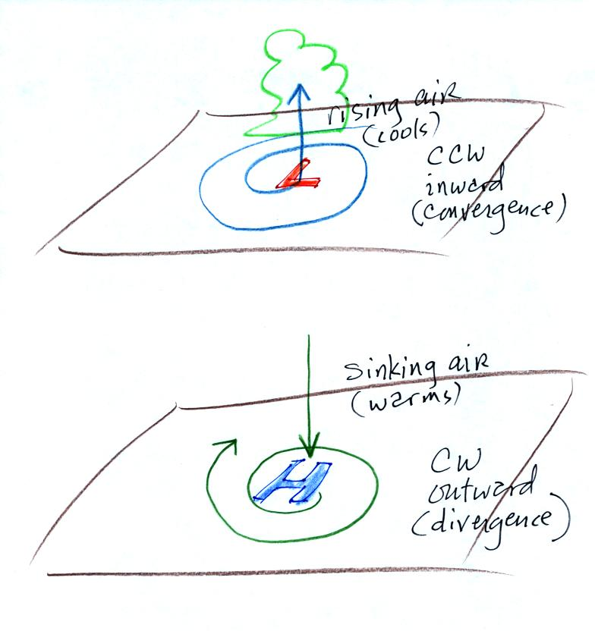
Winds spin clockwise and spiral outward, diverge, from high pressure. Sinking air in the center of the high replaces the outward moving air. Sinking air warms and prevents clouds from forming.
Now some new material.
The pressure pattern will also tell you something about where you might expect to find fast or slow winds. In this case we look for regions where the isobars are either closely spaced together or widely spaced. (I'm using some more carefully drawn pictures from the Spring 2008 class)
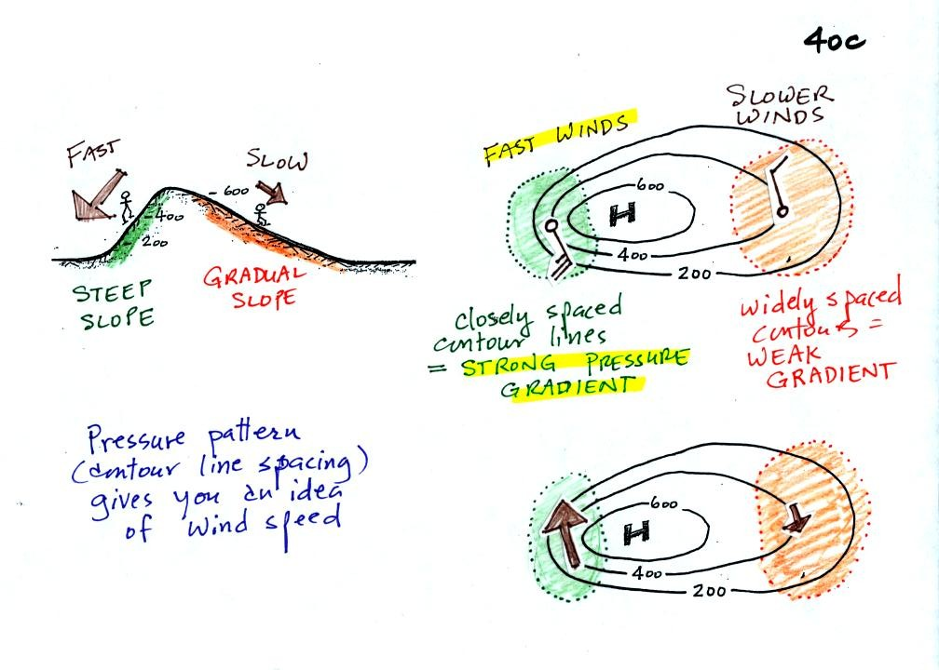
Closely spaced contours means pressure is changing rapidly with distance. This is known as a strong pressure gradient and produces fast winds. It is analogous to a steep slope on a hillside. If you trip, you will tumble rapidly down a steep hillside, more slowly down a gradual slope.
The winds around a high pressure center are shown above using both the station model notation and arrows. The winds are spinning clockwise and spiralling inward slightly.
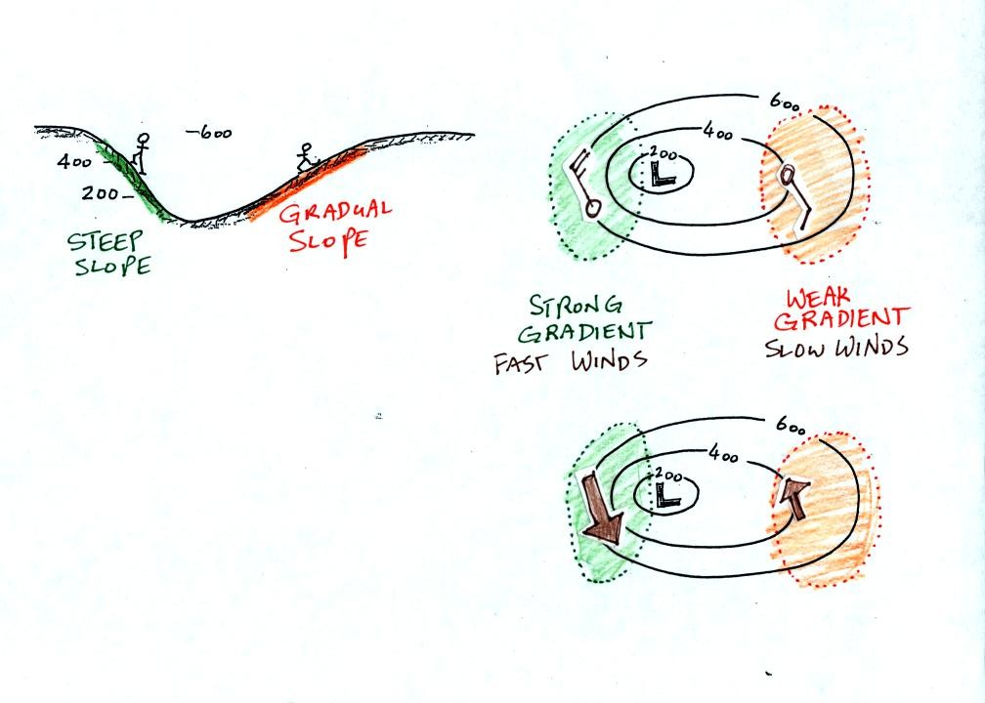
Winds spin counterclockwise and spiral inward around low pressure centers.
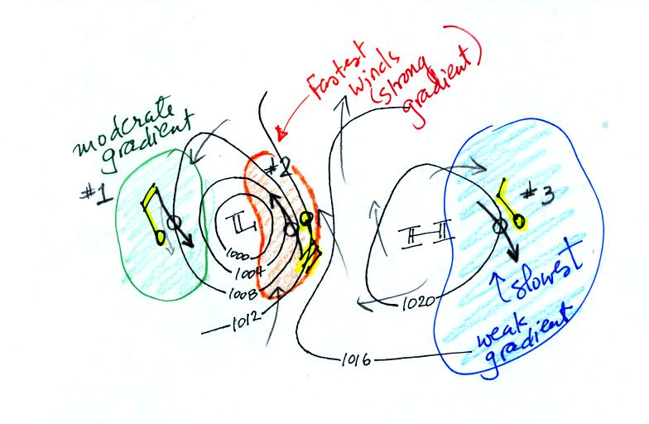
This is the figure from the bottom of p. 40c. The fastest winds (blowing from the SE) are found in the center of the picture. The slowest winds are found on the right side of the figure where the contours are far apart. Note the southerly winds in the middel of the picture would probably be warmer (because they are coming from the south) than the NW winds at the right and left sides of the pictures.

The pressure pattern determines the wind direction and wind speed. Once the winds start to blow they can affect and change the temperature pattern. The figure below shows the temperature pattern you would expect to see if the wind wasn't blowing at all or if the wind was blowing straight from west to east. The bands of different temperature are aligned parallel to the lines of latitude. Temperature changes from south to north but not from west to east.
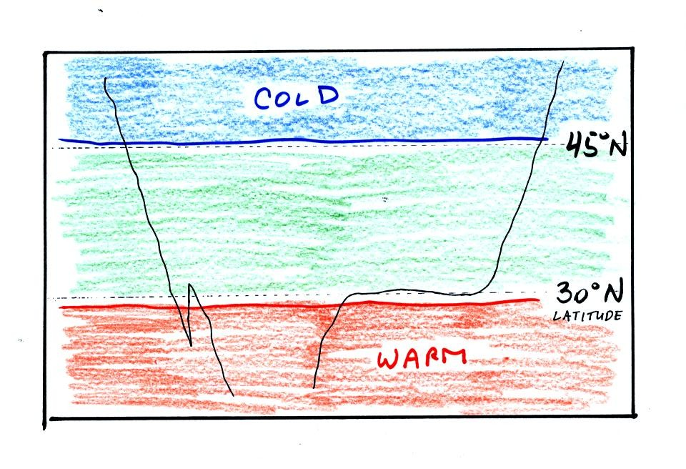
This isn't a very interesting picture. It gets a little more interesting if you put centers of high or low pressure in the middle.
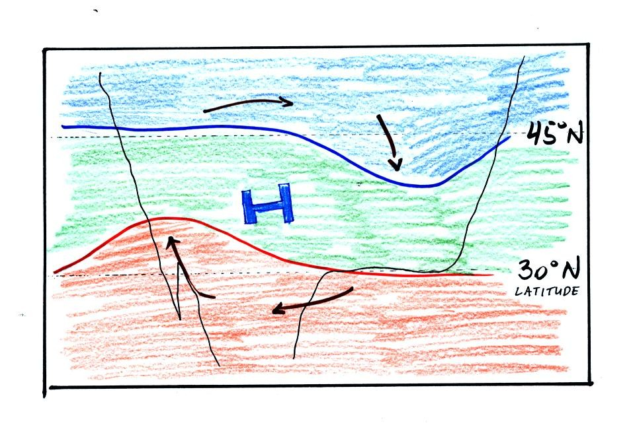
The clockwise spinning winds move warm air to the north on the western side of the High. Cold air moves toward the south on the eastern side of the High. The diverging winds also move the warm and cold air away from the center of the High.
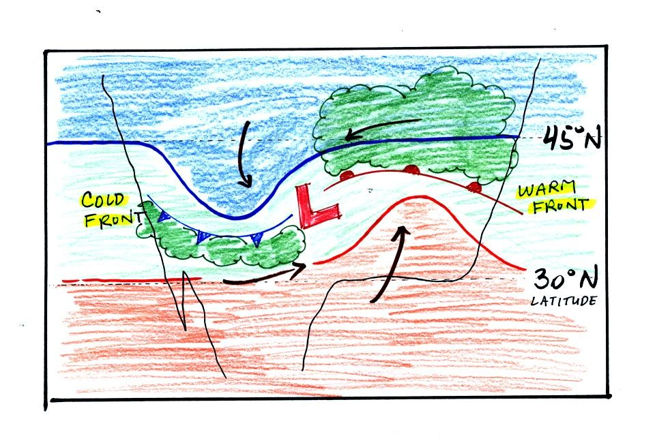
Counterclockwise winds move cold air toward the south on the west side of the Low. Warm air advances toward the north on the eastern side of the low.
The converging winds in the case of low pressure will move the air masses of different temperature in toward the center of low pressure and cause them to collide with each other. The boundaries between these colliding air masses are called fronts. Fronts are a second way of causing rising air motions (rising air expands and cools, if the air is moist clouds can form)
Cold air is moving from north toward the south on the western side of the low. The leading edge of the advancing cold air mass is a cold front. Cold fronts are drawn in blue on weather maps. The small triangular symbols on the side of the front identify it as a cold front and show what direction it is moving. The fronts are like spokes on a wheel. The "spokes" will spin counterclockwise around the low pressure center (the axle).
A warm front (drawn in red with half circle symbols) is shown on the right hand side of the map at the advancing edge of warm air. It is also rotating counterclockwise around the Low.
Clouds can form along fronts (often in a fairly narrow band along a cold front and over a larger area ahead of a warm front). We need to look at the crossectional structure of warm and cold fronts to understand better why this is the case.
This type of storm system is referred to as an extratropical cyclone (extra tropical means outside the tropics, cyclone means winds spinning around low pressure) or a middle latitude storm. Large storms also form in the tropics, they're called tropical cyclones or more commonly hurricanes.
The top picture below shows a crossectional view of a cold front
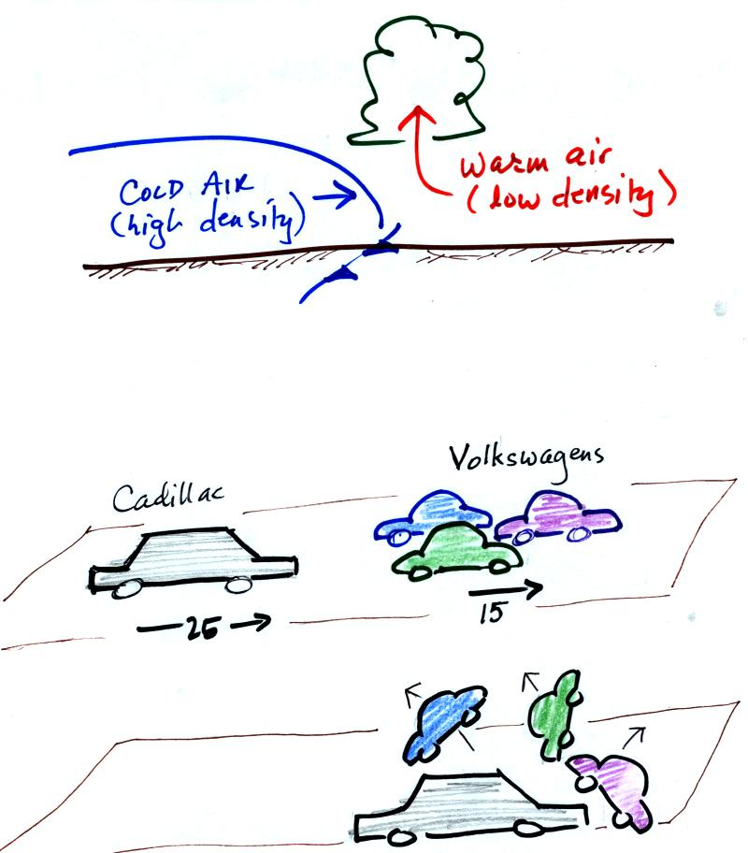
At the top of the figure, cold dense air on the left is advancing into warmer lower density air on the right. We are looking at the front edge of the cold air mass. The warm low density air is lifted out of the way by the cold air.
The lower figure shows an analogous situation, a big heavy Cadillac plowing into a bunch of Volkswagens. The VWs are thrown up into the air by the Cadillac.
Here's a crossectional view of a warm front, the structure is a little different.
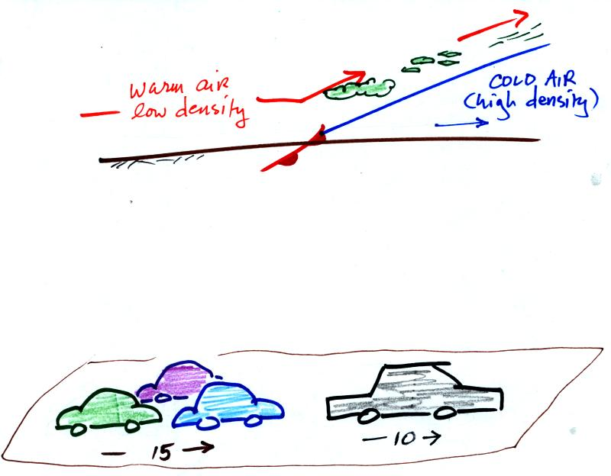
In the case of a warm front we are looking at the back, trailing edge of cold air (moving slowly to the right). Note the ramp like shape of the cold air mass. Warm air overtakes the cold air. The warm air is still less dense than the cold air, it can't wedge its way underneath the cold air. Rather the warm air overruns the cold air. The warm air rises again (more gradually) and clouds form. The clouds generally are spread out over a larger area than with cold fronts.
In the automobile analogy, the VWs are catching a Cadillac. What happens when they overtake the Cadillac?
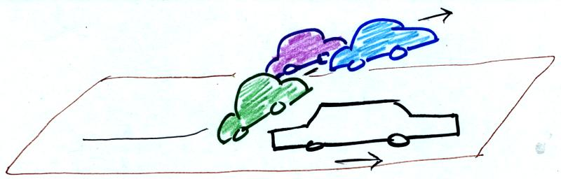
The Volkswagens aren't heavy enough to lift the Cadillac. They run up and over the Cadillac.
Fronts are another way of causing air to rise. Rising air cools and if the warm air is moist, clouds and precipitation can form.
Now we will return to the surface weather map we have been analyzing.
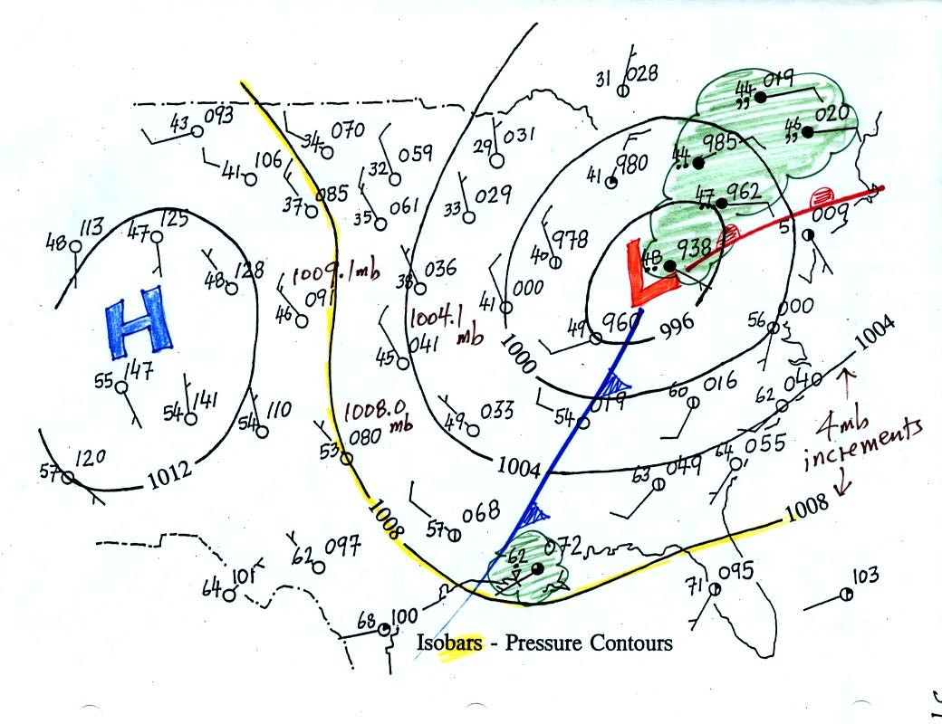
The weather data plotted on the map indicate clearly the presence of cold and a warm fronts (we learn later about some of the criteria used to located fronts). Now we can begin to understand what is causing the rain shower along the Gulf Coast (clouds caused by an approaching cold front) and the cloudy rainy weather in the Northeast (an approaching warm front and also perhaps some convergence into the low pressure center).

Here are the four questions (and answers) that were on the optional in class worksheet (meant to give you a little practice interpreting surface maps). This wasn't an assignment and shouldn't have been turned in at the end of class.
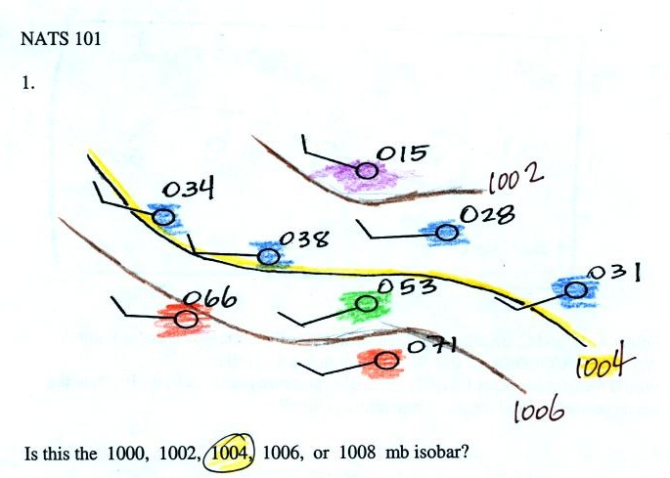
You were supposed to label the isobar in the figure (highlighted in yellow). Pressure values have been color coded. Pressures less the 1002 mb are purple, blue is for pressures between 1002 and 1004, green for pressures between 1004 and 1006, and orange is for pressures between 1006 and 1008. The highlighted isobar separates pressure values less than 1004 from values greater than 1004, it is the 1004 mb isobar. The 1002 and 1006 have been drawn in also.
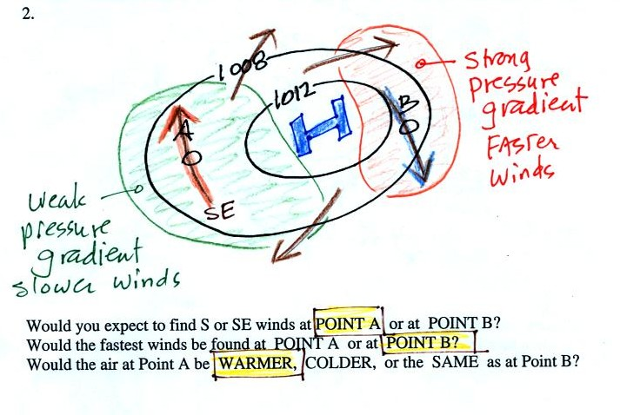
The first thing that you needed to recognize was that this is a center of high pressure. The values on the isobars get larger as you move in toward the center of the picture. Then you can sketch in some winds (clockwise and outward). Once you do that it is clear than Point A has SE winds, winds at Point B are from the NNW. The strongest winds are at Point B. The winds at Point A are coming from the south and are likely to be warmer than the northerly winds at Point B.
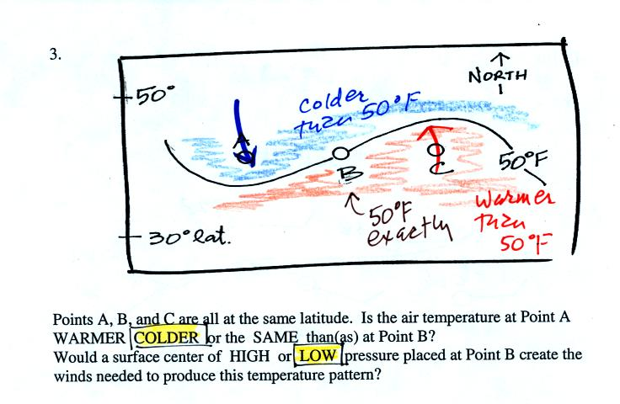
Air north of the 50 F isotherm is colder than 50 F, air to the south is warmer. Point B is on the isotherm so it has a temperature of exactly 50 F. You need a center of low pressure at B to produce the counterclockwise spin needed to produce this temperature pattern.
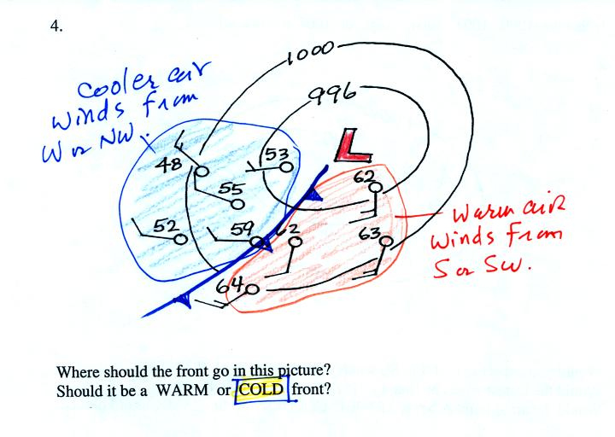
Two different bodies of air (air masses) have been identified on the basis of temperature and wind direction. The boundary between them is a front. The front will spin counterclockwise around the low. Since the air behind the front is cold, this is a cold front.

