NATS 101 In-class Name_______________________________
Optional Assignment

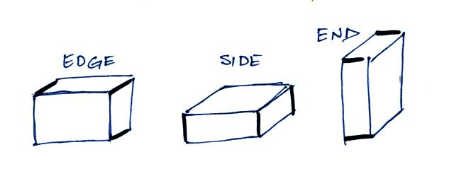
1. A brick could be laid on its EDGE, on its SIDE, or on END. In which case would the pressure on the ground be greatest? Or would the pressure be the SAME in all three cases?

2. It wouldn't be unusual to inflate the tire on a "road bike" to 90 psi. This would be about _______ bars of pressure.

a. 2 b. 3 c. 4 d. 6 e. 8 f. 9

3. Is the rate of pressure decrease in Layer A in the picture below GREATER than LESS than or EQUAL to the rate of decrease in Layer B?
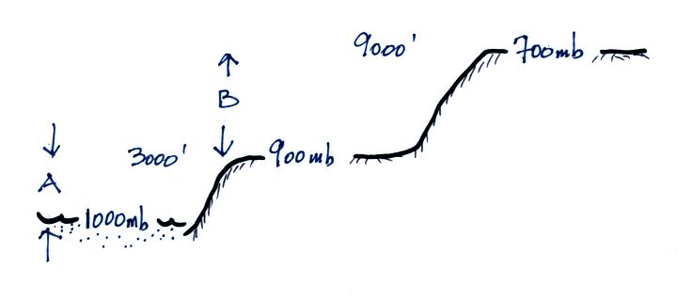

4. If the force of gravity on the earth were to increase but the amount (mass) of air in the atmosphere remained the same, would atmospheric pressure at sea level INCREASE DECREASE or remain the SAME?

5. If you traveled from Tucson (2500' alt.) to the top of Mt. Lemmon (9000' alt.) you would expect to observe a __________ in air temperature, a __________ in air density, and a __________ in air pressure. (fill in each blank with RISE or DROP)
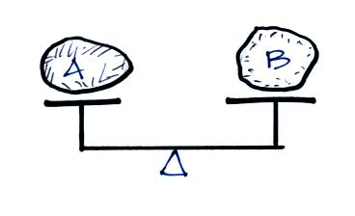
6. The two objects are in balance in the picture
at right. The two objects must have the same
a. mass b. volume
c. density d. composition
e. weight

