Charles Law Step by Step

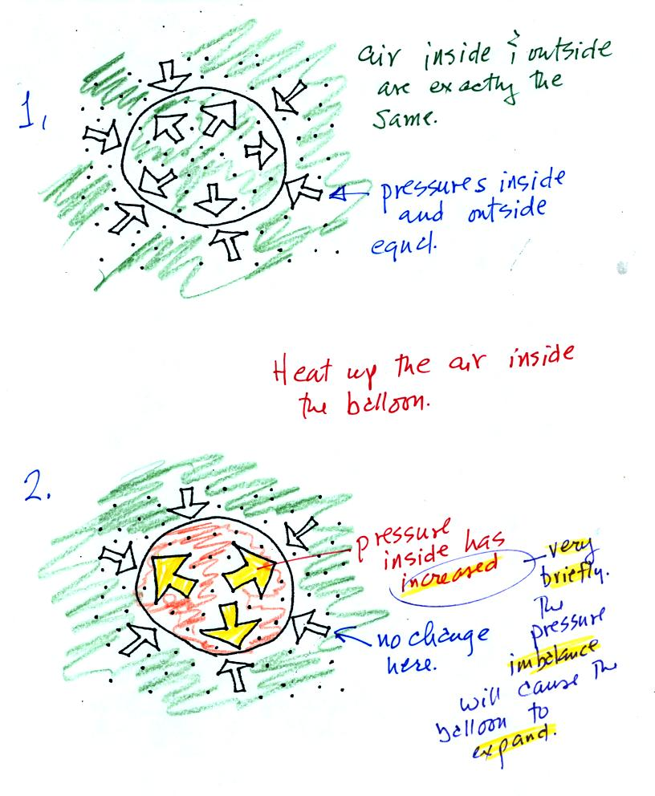
Air in the atmosphere behaves like air in a balloon. A balloon can grow or shrink in size depending on the pressure of the air inside. When a balloon isn't getting bigger or smaller it means the force inside that is pushing out is balanced by the force outside that is pushing in.
We start in the top figure with air inside a balloon that is exactly the same as the air outside. The air inside and outside have been colored green. The arrows show that the pressure of the air inside pushing outward and the pressure of the air surrounding the balloon pushing inward are all the same strength.
Next we warm the air in the balloon (Fig. 2). The ideal gas law equation tells us that the pressure of the air in the balloon will increase. The increase is momentary though.
Because the pressure inside is now greater (the big yellow arrows) than the pressure outside, the balloon will expand. As volume begins to increase, the pressure of the air inside the balloon will decrease. Eventually the balloon will expand just enough that the pressures inside and outside are again in balance. You end up with a balloon of warm low density air that has the same pressure as the air surrounding it (Fig. 3)
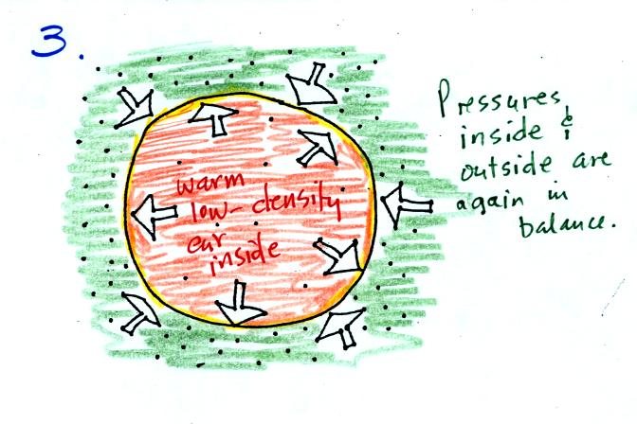

You can use the same reasoning to understand what happens when you cool the air in a balloon.
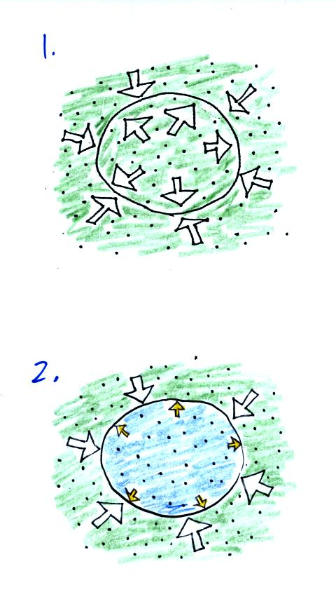
The air inside and outside are the same in Fig. 1. Cooling the air inside the balloon in Fig. 2 causes a momentary drop in the inside pressure (small yellow colored arrows) and creates a pressure imbalance. The stronger outside air pressure compresses the balloon.
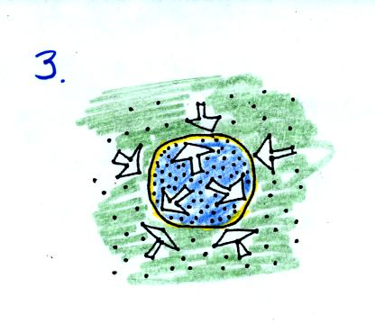
As the balloon volume decreases, pressure inside the balloon increases. It eventually is able to balance the outside air pressure. You end up with a balloon filled with cold high density air.
These two associations:
warm air = low density air and
cold air = high density air
are important and will come up a lot during the remainder of the semester.

