Causes of the Seasons
Any college graduate should be able to answer the following three questions (the picture is on p. 73 in the photocopied ClassNotes)
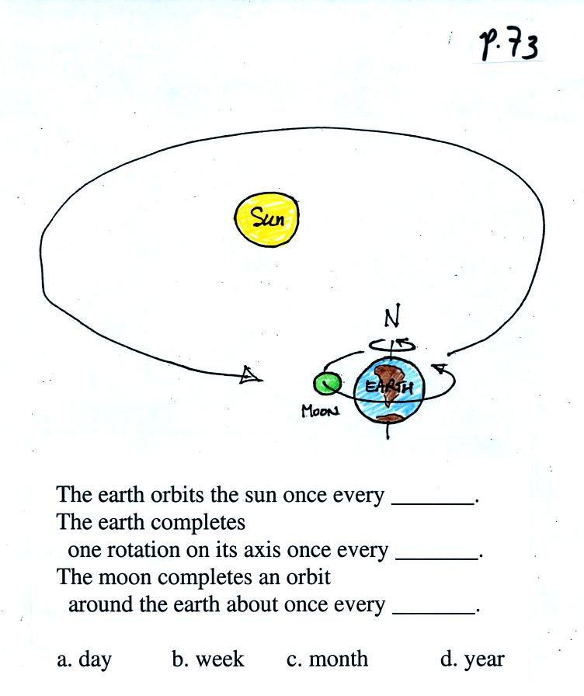
Once you think you know the answer to the question above, click here

The perihelion is the point in the earth's orbit at which it is closest to the sun. This occurs around January 3. The aphelion is the point at which the earth is farthest from the sun. This occurs around July 4.
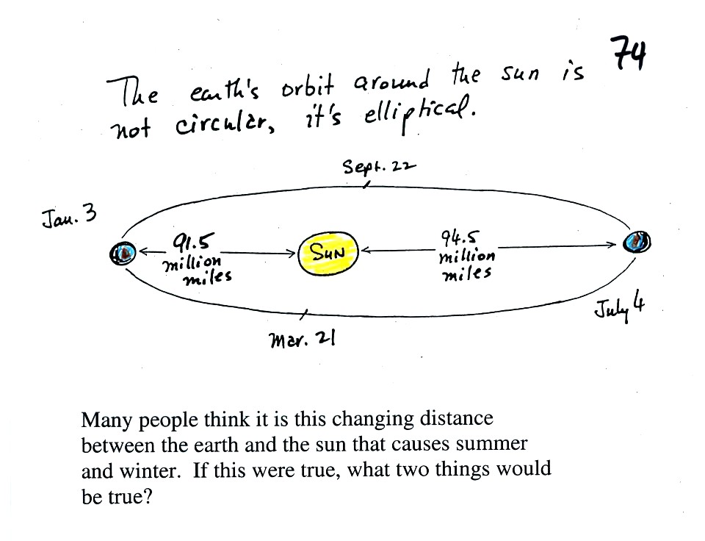
Once you think you can answer the question above, click here
The real cause of the seasons is the tilt of the earth relative to the plane of its orbit around the sun.
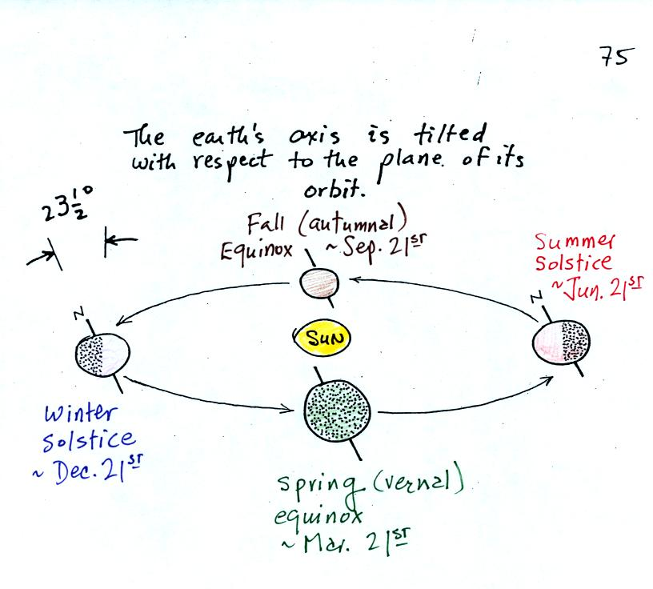
The north pole is tilted away from the sun on the northern hemisphere winter solstice (it is the summer solstice in the southern hemisphere). The north pole is tilted toward the sun on the summer solstice in the northern hemisphere.
If you were on the far side of this picture looking back toward the sun. Here is what you would see
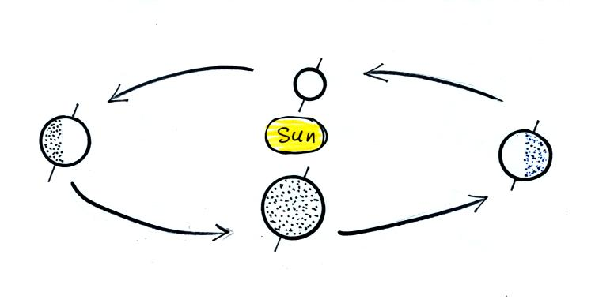
Can you identify the northern hemisphere summer and winter solstices & the spring and fall equinoxes in this picture?
Click here when you think you have the answer.
Because the earth is sometimes tilted toward the sun, sometimes away from the sun, the angle of the sun in the sky varies during the year. This will partly determine how much incoming sunlight makes it to the earth's surface and how effectively it can warm the ground.
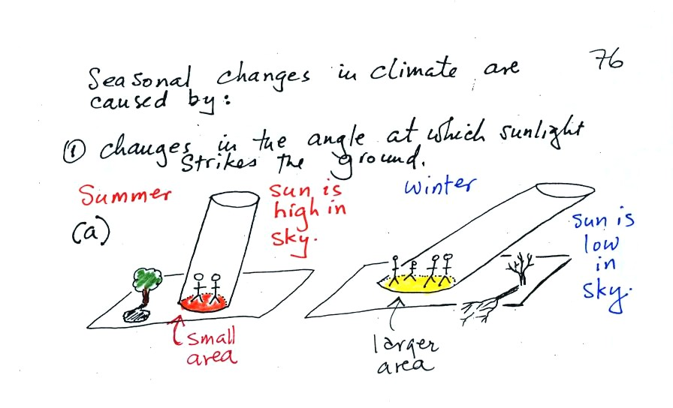
In the summer when the sun reaches a high elevation angle above the horizon, an incoming beam of sunlight will shine on a small area of ground. The ground will get hot. The two people sharing the shaft of summer sunlight will get a sunburn.
In the winter the sun is lower in the sky. The same beam of sunlight gets spread out over a larger area. The energy is being used to try heat a larger amount of ground. The result is the the ground won't get as hot. 4 people are able to share the winter sunlight and won't get burned as quickly.
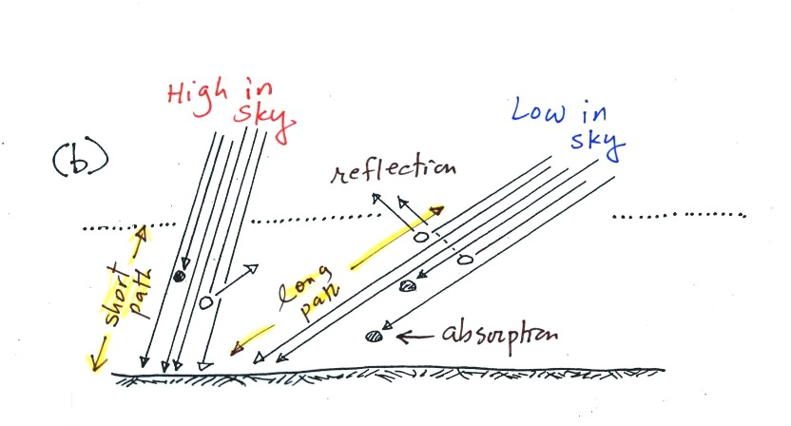
As sunlight passes through the atmosphere it can be absorbed or reflected. Both prevent energy from reaching and warming the ground. On average (over the globe) only about 50% of the sunlight arriving at the top of the atmosphere actually makes it to the ground. A beam of sunlight that travels through the atmosphere at a low angle (right picture above) is less intense than beam that passes through the atmosphere more directly (left picture). 4 out of the 6 arrows taking the short path through the atmosphere make it to the ground in the left figure (67%). In the right figure only 2 of the 6 survive the trip (33%).
There's something else that changes also. The T Th class, especially, should be aware of this.
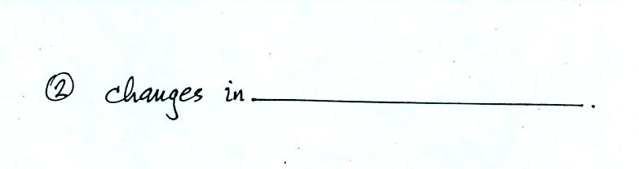
Click here when you think you have the answer.

