Thursday Nov. 17, 2011
The El Tour de Tucson bicycle race/ride is Saturday so some bicycle racing instead of music before class this morning. We saw the last few kilometers up the infamous Mont Ventoux from the 2000 Tour de France. Marco Pantani just edged out Lance Armstrong at the finish line. Here are the last couple of minutes of the race.
Several additional topics have been added to 1S1P Assignment #3. There's also a new 1S1P Bonus Assignment. That will probably be it for this semester.
Please also check to see if your name is on this list of students that don't yet have an experiment (or book or scientific paper) report grade. If I've listed your name by mistake please let me know and accept my apologies. If you're not currently working on something you should check with me right away.
In the time it took to get Thursday's notes online, the Quiz #4 Study Guide Pt. 2 has appeared online.

Here's another picture of the day. Peppers from my vegetable garden, just in time for Thanksgiving.

The Fall 2011 edition of the Toilet Bowl Flushing Experiment turned out just as it was supposed to. The results are shown below. The bottom row shows that clockwise and counterclockwise spinning were equally likely. That's what you would expect when the Coriolis force doesn't play any role at all. If we had performed the experiment in the southern hemisphere we would have obtained the same result.

 | clockwise | counterclockwise
MWF class | 27 | 31
T Th class | 36 | 33
Totals from both classes | 63 | 64

The 3-cell model assumes that the earth is of uniform composition and not tilted toward or away from the sun. It predicts belts of high pressure at 30 N and 30 S latitude as shown above at left. Because the real world has oceans and continents we find centers of high pressure, not belts, located near 30 latitude. They move north and south of 30 degrees during the year as the N. Pole tilts toward and away from the sun.

Here's a little more carefully drawn picture (on one side of a class handout). Winds blowing around these centers of high pressure create some of the world's major ocean currents. The California current is a cold southward flowing current found off the west coast of the US. The Gulf Stream is the warm northward flowing current along the east coast.
The figure above shows the intertropical convergence zone (the dotted dashed line) south of the Equator. This happens during the northern hemisphere winter. A second similar figure was included on the class handout. It showed the ITCZ north of the Equator. That is the situation during the northern hemisphere summer.
The subtropical high pressure centers also move north and south of their nominal locations near 30 latitude. Movement of these features is part of what causes our summer monsoon

Tucson gets about 12 inches of rain in a normal year. About half of this comes during the "summer monsoon" season. The word monsoon refers to a seasonal change in wind direction. During the summer, subtropical high pressure (the Pacific high) moves north of 30 N latitude. Winds on the southhern side of the subtropical high have an easterly component. Moist air originating in Mexico and from over warm water in the Gulf of Mexico blows into Arizona. The sun heats the ground during the day, warm moist air in contact with the ground rises and produces convective thunderstorms.
The close proximity of the Pacific high, with its sinking air motions, is what gives California, Oregon, and Washington dry summers.
In the winter the subtropical high moves south of 30 N latitude. Winds to the north of the high blow from the west. Air originating over the Pacific Ocean is not as moist because the water is colder than the Gulf of Mexico. In addition the air loses much of its moisture as it crosses mountains in California (remember the rain shadow effect). The air is pretty dry by the time it reaches Arizona. Significant winter rains occur in Arizona when storms systems are able to draw moist subtropical air from the southwest Pacific ocean into Arizona.

Here's a little review, just to get you thinking about thunderstorms again. You can determine whether an air mass thunderstorm is in its initial, mature, or final stage just by looking to see whether there are just updrafts, just downdrafts, or both updrafts and downdrafts present inside the cloud. The presence of a tilted updraft indicates a severe thunderstorm. We'll look now at what causes the updraft to tilt.
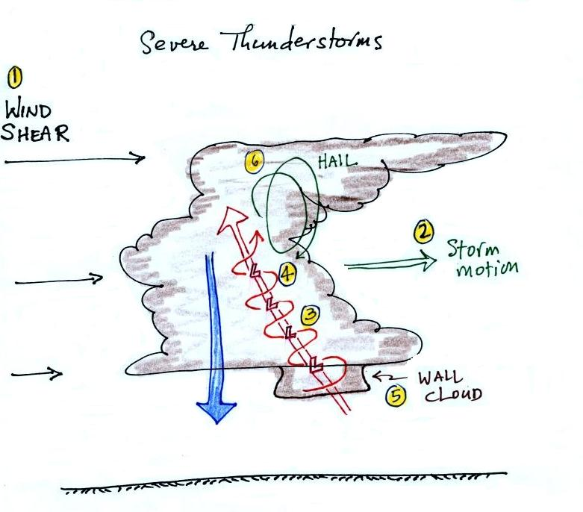
This figure is on p. 154a in the ClassNotes.
Severe storms are more likely to form when there is vertical wind shear. Wind shear (pt 1) is changing wind direction and/or wind speed with distance. In this case, the wind speed is increasing with increasing altitude, this is vertical wind shear.
A thunderstorm that forms in this kind of an environment will move at an average of the speeds at the top and bottom of the cloud (pt. 2). The thunderstorm will move to the right more rapidly than the air at the ground which is where the updraft begins. Rising air that is situated at the front bottom edge of the thunderstorm will find itself at the back edge of the storm when it reaches the top of the cloud.
This produces a tilted updraft (pt. 3). The downdraft is situated at the back of the ground. The updraft is continually moving to the right and staying away from the downdraft. The updraft and downdraft coexist and do not "get in each others way." If you remember in air mass thunderstorms, the downdraft gets in the way of the updraft and leads to dissipation of the storm.
Sometimes the tilted updraft will begin to rotate. A rotating updraft is called a mesocyclone (pt. 4). Meso refers to medium size (thunderstorm size) and cyclone means winds spinning around low pressure. Low pressure in the core of the mesocyclone creates an inward pointing pressure gradient force needed to keep the updraft winds spinning in circular path (low pressure also keeps winds spinning in a tornado).
The cloud that extends below the cloud base and surrounds the mesocyclone is called a wall cloud (pt. 5). The largest and strongest tornadoes will generally come from the wall cloud. You'll see some pretty dramatic videos of wall clouds next week (hopefully with sound).
Note (pt. 6) that a tilted updraft provides a way of keeping growing hailstones inside the cloud. Hailstones get carried up toward the top of the cloud where they begin to fall. But they then fall back into the strong core of the updraft and get carried back up toward the top of the cloud.

The United States has more tornadoes in an average year than any other country in the world (over 1000 per year). The central US has just the right mix of meteorological conditions.

I got a little carried away with the colored pencils on this picture. Without any mountains in the way, cold dry air can move in the spring all the way from Canada to the Gulf Coast. There is collides with warm moist air from the Gulf of Mexico to form strong cold fronts and thunderstorms.

Tornadoes have been observed in every state in the US, but tornadoes are most frequent in the central plains, a region referred to as "Tornado Alley" (highlighted in red, orange, and yellow above). You'll find this map on p. 161 in the photocopied ClassNotes.

Here are some basic tornado characteristics (the figure above is also on p. 161)
1. About 2/3rds of tornadoes are F0 or F1 tornadoes (we'll learn moare about the Fujita scale used to rate tornado intensity later today and next week) and have spinning winds of about 100 MPH or less. Microburst winds can also reach 100 MPH. Microbursts are much more common in Tucson in the summer than tornadoes and can inflict the same level of damage.
2. A very strong inwardly directed pressure gradient force is needed to keep winds spinning in a circular path. The pressure in the center core of a tornado can be 100 mb less than the pressure in the air outside the tornado. This is a very large pressure difference in such a short distance. The PGF is much stronger than the Coriolis Force (CF) and the CF can be neglected.
3. Because the Coriolis force doesn't play a role, tornadoes can spin clockwise or counterclockwise, though counterclockwise rotation is more common. This might be because larger scale motions in the cloud (where the CF is important, might determine the direction of spin in a tornado).
4, 5, 6. Tornadoes usually last only a few minutes, leave a path on the ground that is a few miles long, and move at a few 10s of MPH. There are exceptions, we'll look at one shortly.
7, 8. Most tornadoes move from the SW toward the NE. This is because tornado-producing thunderstorms are often found just ahead of a cold front. Winds ahead of a cold front often blow from the SW. Most tornadoes have diameters of tens to a few hundred yards but tornadoes with diameters over a mile have been observed.
9, 10. Tornadoes are most frequent in the Spring. The strongest tornadoes also occur at that time of year. Tornadoes are most common in the late afternoon when the atmosphere is most unstable.
The two tables above are on p. 161 in the photocopied ClassNotes. At the present time about 75 people are killed every year in the United States. This is about a factor of ten less than a century ago due to improved methods of detecting tornadoes and severe thunderstorms. Modern day communications also make easier to warm people of dangerous weather situations. Lightning and flash floods (floods are the most serious severe weather hazard) kill slightly more people. Hurricanes kill fewer people on average than tornadoes.

This figure traces out the path of the 1925 "Tri-State Tornado" . The tornado path (note the SW to NE orientation) was 219 miles long, the tornado lasted about 3.5 hours and killed 695 people. The tornado was traveling over 60 MPH over much of its path. It is the deadliest single tornado ever in the United States. The Joplin Missouri tornado this past spring (May 22) killed 162 people making it the deadliest since 1947 and the 7th deadliest tornado in US history.

Tornadoes often occur in "outbreaks." The paths of 148 tornadoes during the April 3-4, 1974 "Jumbo Tornado Outbreak" are shown above. Note the first tornadoes were located in the upper left corner of the map. The tornadoes were produced by thunderstorms forming along a cold front (see the weather map below). During this two day period the front moved from the NW part toward the SE part of the figure. Note that all the tornado paths have a SE toward NE orientation.

The April 25-28, 2011 outbreak is now apparently the largest tornado outbreak in US history.

I tried to show a short video at this point. The video was OK but there wasn't any sound. And you really need to hear the sound on something like this. I did find video footage for several of the tornadoes on YouTube. The table below is a little more detailed description of the tornadoes shown on the video tape.
If we were in a room with two screens I would have put this table on one screen and shown the video on the other.

54a | F3 | Grand Isle, NE  (no sound) | Mar. 13, 1990 | tornado cloud is pretty thick and vertical
61f | F3 | McConnell AFB KS | Apr. 26, 1991 | this is about as close to a tornado as you're ever likely to get. Try to judge the diameter of the tornado cloud. What direction are the tornado winds spinning?
52 | F5 | Hesston KS  (no sound) | Mar. 13, 1990 | Watch closely, you may see a tree or two uprooted by the tornado winds
51 | F3 | North Platte NE | Jun. 25, 1989 | Trees uprooted and buildings lifted by the tornado winds
65 | F1 | Brainard MN | Jul. 5, 1991 | It's a good thing this was only an F1 tornado
57 | F2 | Darlington IN | Jun. 1, 1990 | Tornado cloud without much dust
62b | F2 | Kansas Turnpike | Apr. 26, 1991 | It's sometimes hard to run away from a tornado. Watch closely you'll see a van blown off the road and rolled by the tornado. The driver of the van was killed!
47 | F2 | Minneapolis MN | Jul. 18, 1986 | Tornado cloud appears and disappears.
I would encourage you to look at the McConnell AFB video and the Kansas Turnpike tornado. The YouTube videos contain more footage than was on the video tape. The turnpike video also has a warning that a highway underpass is actually a very dangerous place to take shelter from a tornado. Here is some additional information from the Norman OK office of the National Weather Service. Slide 6 lists some of the reasons why underpasses are so dangerous.
The second column in the table above has the Fujita Scale rating of each tornado. An easy to remember version of the Fujita Scale is shown below.

It is very hard to actually measure the speed of the rotating winds in a tornado (though this has been done using mobile Doppler radar). Researchers usually survey the damage caused by the tornado to come up with a Fujita Scale rating. The Fujita Scale has recently been revised. The newer scale is called the Enhanced Fujita Scale to differentiate it from the original scale introduced in 1971.

