Upper Level Charts Pt. 1 – Basic Features

We've been spending some time learning about surface weather maps. Maps showing conditions at various altitudes above the ground are also drawn. Upper level conditions can affect the development and movement of surface features (and vice versa).
In this first section we'll just learn 3 basic facts about upper level charts. First the overall appearance is somewhat different from a surface weather map. The pattern on a surface map can be complex and you generally find circular (more or less) centers of high and low pressure (see the bottom portion of the figure below). You can also find closed high and low pressure centers at upper levels, but mostly you find a relatively simple wavy pattern like is shown on the upper portion of the figure below (sort of a 3-dimensional view).

A simple upper level chart pattern is sketched below (a map view). There are two basic features: wavy lines that dip southward and have a "u-shape" and lines that bend northward and have an "n-shape".

The u-shaped portion of the pattern is called a trough. The n-shaped portion is called a ridge.

Troughs are produced by large volumes of cool or cold air (the cold air is found between the ground and the upper level that the map depicts). The western half of the country in the map above would probably be experiencing colder than average temperatures. Large volumes of warm or hot air produce ridges. We'll see why this is true in "Upper level charts pt. 2".

The winds on upper level charts blow parallel to the contour lines generally from west to east. This is a little different from surface winds which blow across the isobars toward low pressure. An example of surface winds is shown below.
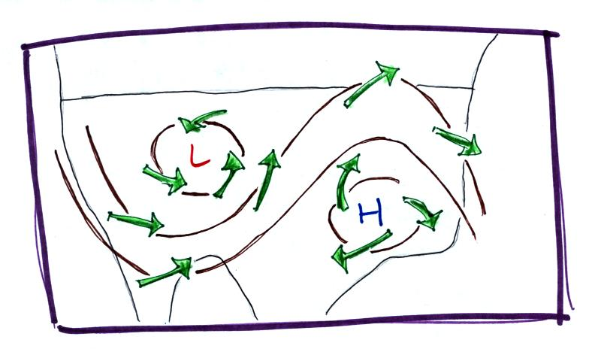
That's it for this first section. Really all you need to be able to do is
1. identify troughs and ridges,
2. remember that troughs are associated with cold air & ridges with warm air, and
3. rember that upper level winds blow parallel to the contour lines from west to east.

