NATS 101 Name_________________________
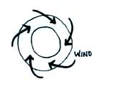
Optional Assignment

1. Does the figure show SURFACE or UPPER-LEVEL
winds? Are they blowing around a center of HIGH
or LOW pressure? Are these SOUTHERN or
NORTHERN hemisphere winds?

2. You observe a large storm system on a satellite photograph that is moving from east to west and spinning in a clockwise direction. This would most likely be a (circle 3 choices below, one from each column)
Northern hemisphere middle latitude anticyclone
Southern hemisphere tropical cyclone
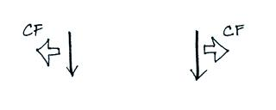
3. Which figure shows winds blowing in the southern
hemisphere? (CF shows the direction of the Coriolis force)

4. What characteristic do the “doldrums” and the “horse latitudes” have in common?
a. high pressure b. fast winds c. clear skies
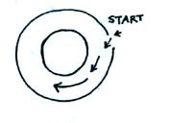
d. low pressure e. calm winds f. cloudy skies

5. The direction of the initial motion in the figure at right
means this is a center of HIGH LOW pressure. Rather
than going straight toward the center of the picture the
wind turns to the left. The direction of this bending
means that this is a NORTHERN SOUTHERN
hemisphere chart.

6. The direction of the ______ force changes when you move from the northern to the southern hemisphere.
a. Coriolis b. frictional c. gravitational d. pressure gradient

7. Would you find wind PATTERN A or wind PATTERN B at the intertropical convergence zone?
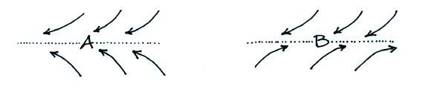

8. The term ______________________________ refers to a seasonal change in the direction of the prevailing winds.
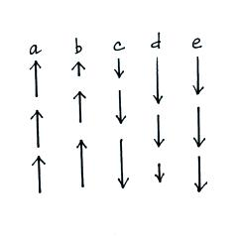
9. The speeds of 5 upward or downward moving
objects are shown at right. From careful study
of the object’s motions and making use of
Newton’s 1st law of motion, you could conclude
that there is no net force acting on the objects in
_______ and _______. An upward force is
being exerted on the object in _______. A
downward force is acting on the object in
_______ and _______.
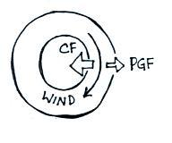

10. The direction of the PGF in the figure at right
tells you that this is a center of HIGH LOW
pressure. The direction of the CF is to the
RIGHT LEFT of the wind which indicates
this is a SOUTHERN NORTHERN hemisphere
chart.

11. In a thermal circulation the pressure gradient force is much STRONGER WEAKER than the Coriolis force.
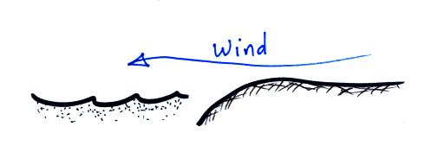

12. The surface wind in the picture at right is blowing offshore.
Would this be called a SEA or LAND breeze? Would the
land be WARMER or COLDER than the ocean? Would
the surface winds blow like this during the DAY or at NIGHT?
Would you expect to see clouds over the LAND or the SEA?

13. At 32º N. latitude, Tucson is closest to which of the following 3-cell model features?
a. doldrums b. ITCZ c. polar front d. horse latitudes

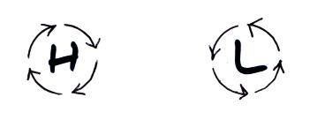
14. The wind is blowing in a circular path at constant
speed in the two figures at right. The direction
of the net force is
a. inward around L, outward around H
b. inward in both figures
c. in the direction of motion in both figures
d. zero in both figures

15. The strength of the _______ force and the _______force depend on wind speed.
a. Coriolis b. frictional c. gravitational d. pressure gradient force

