NATS 101 Name_______________________________
In-class Optional Assignment

1. A mixing ratio of 6 g/kg means there are 6 grams of _____________________________
mixed in
with 1 kilogram of __________________________________.

2. If you know the air's temperature you can look up the value of the _______ in a table.
a. mixing ratio b. saturation mixing ratio c. relative humidity d. dew point

3. Adding water vapor to the air will not increase the _______.
a. mixing ratio b. saturation mixing ratio c. relative humidity d. dew point

4. 90º F air can potentially hold _______ times as much water vapor as 45º F air (consult the table on p. 86 in the photocopied ClassNotes)
a. 2 b. 4 c. 5 d. 10

5. To calculate the relative humidity you need to know the _______ and the _______.
a. mixing ratio b. saturation mixing ratio c. air temperature d. dew point

6. The value of the _______ will tell you whether moist air is saturated or not.
a. mixing ratio b. saturation mixing ratio c. relative humidity d. dew point

7. Based on the data in the figure below, does the parcel of 70º F air have MORE LESS or the SAME amount of water vapor than(as) the 85º F air?

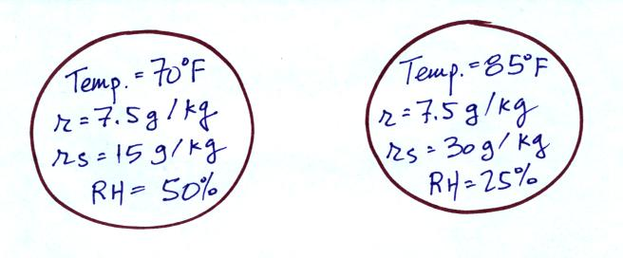

8. Which two of the following have the same job, telling you how much water vapor is actually in the air?
a. mixing ratio b. saturation mixing ratio c. relative humidity d. dew point

