NATS 101 Name_______________________________
In-class Optional Assignment

1. A mixing ratio of 6 g/kg means there are 6 grams of ________water vapor__________
mixed in with 1 kilogram of _____air (dry air)______.

2. If you know the air's temperature you can look up the value of the ___b___ in a table.
a. mixing ratio b. saturation mixing ratio c. relative humidity d. dew point

3. Adding water vapor to the air will not increase the ___b___.
a. mixing ratio b. saturation mixing ratio c. relative humidity d. dew point

4. 90º F air can potentially hold ___c___ times as much water vapor as 45º F air (consult the table on p. 86 in the photocopied ClassNotes)
a. 2 b. 4 c. 5 d. 10

5. To calculate the relative humidity you need to know the ___a___ and the ___b___.
a. mixing ratio b. saturation mixing ratio c. air temperature d. dew point

6. The value of the ___c___ will tell you whether moist air is saturated or not.
a. mixing ratio b. saturation mixing ratio c. relative humidity d. dew point

7. Based on the data in the figure below, does the parcel of 70º F air have MORE LESS or the SAME amount of water vapor than(as) the 85º F air?
Both parcels have the same mixing ratio. Mixing ratio tells you the actual amount of
water vapor in air.

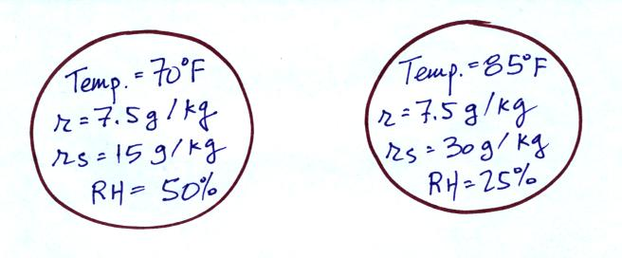

8. Which two of the following have the same job, telling you how much water vapor is actually in the air?
a. mixing ratio b. saturation mixing ratio c. relative humidity d. dew point

