ATMO 170A1 Name_______________________________
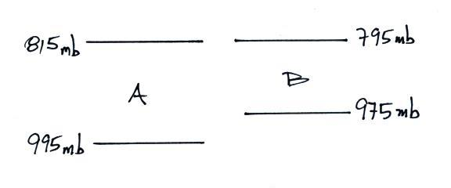
In-class Optional Assignment

1. As you move upward in the figure
at right, is pressure in Layer A
decreasing MORE rapidly,
LESS rapidly, or at the SAME
rate than(as) the pressure in Layer B?

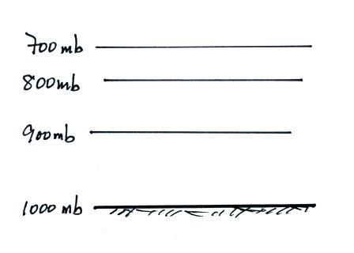
2. Average sea-level pressure is about _______________ millibars (mb). The highest sea level pressure ever recorded is _______________ mb. The record low sea level pressure reading was_______________.

3. What’s wrong with the picture at right?

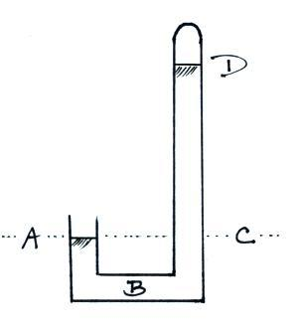
4. Air pressure _______________, air density _______________, and air temperature _______________ with increasing altitude. (fill in each blank with DECReases, INCReases, or can BOTH increase or decrease depending on altitude)

5. The same pressure would be measured at
Points _______ and _______ on the
barometer shown at right. The pressure is
zero at Point _______. The highest
pressure would be found at Point _______.
(each letter in the figure at right should be
used once as an answer)

6. Which one of the following doesn’t belong in the same group as the other three?
a. stable layer b. stratosphere c. temperature inversion d. thunderstorm

