Atmo 170A1 Name_______________________________
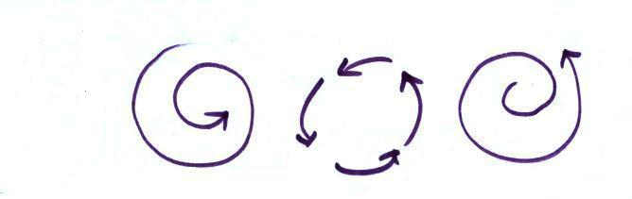
InClass Optional Assignment

1.

For the 3 types of motion shown above indicate whether the net force is Inward, Outward, or Zero.
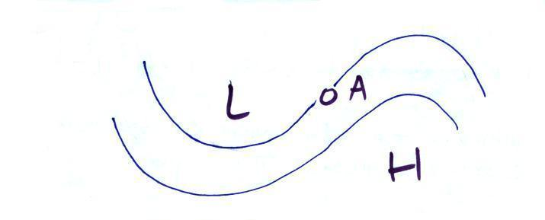
2.

With an arrow show the direction of the PGF at Point A.
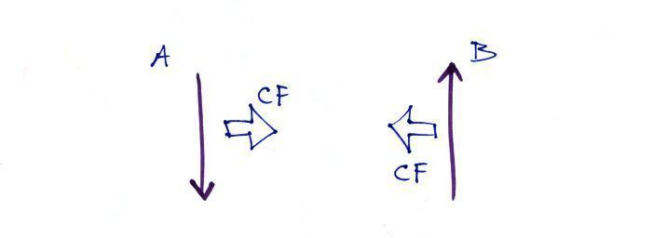
3.

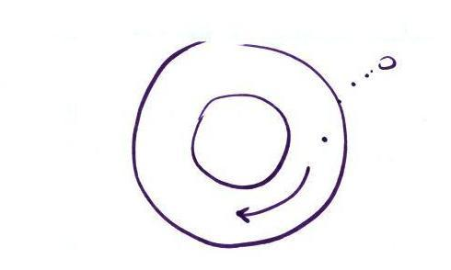
Which of these shows winds blowing in the northern hemisphere? (A, B, Both or Neither)

4.

Based on the direction of the initial motion you can say this is a center of HIGH LOW pressure in the NORTHERN SOUTHERN hemisphere.
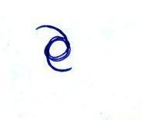
5. Does the symbol at right indicate a NORTHERN or SOUTHERN
hemisphere HURRICANE or TROPICAL STORM. Would you
expect this storm to moving toward the EAST or WEST?

