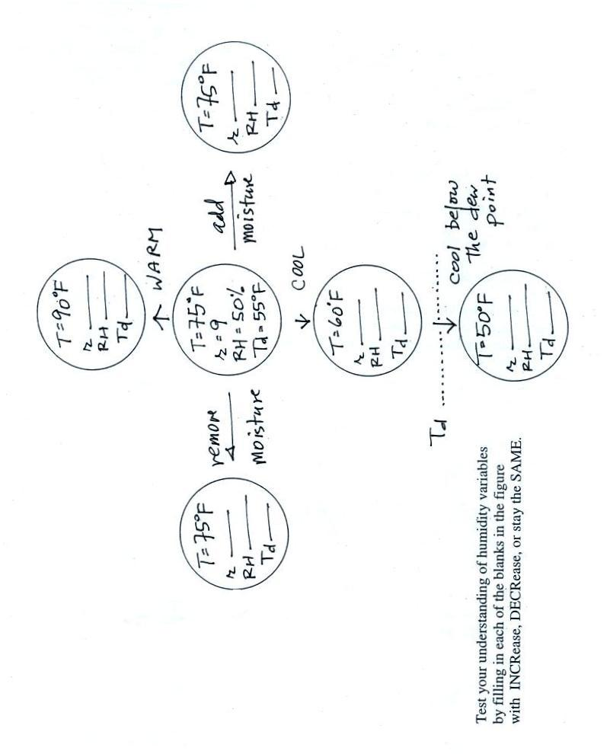
Name__________________________________
Which city at right
would have the highest mixing ratio _______ City A City B
Which city would have Tair = 80º F Tair = 70º F
the highest relative humidity _______ Td = 40º F Td = 50º F
Which city would have
the highest saturation mixing ratio _______

Along which path in the figure below
is the
mixing ratio, r, increasing _______
is the
relative humidity, RH, increasing _______
is the
mixing ratio, r, decreasing _______
is the
relative humidity, RH, decreasing _______
(use the a, b, or c shown on the figure
or use d for nowhere, each answer should be used once)

