Atmo 170 A1 Name___________Answers___________
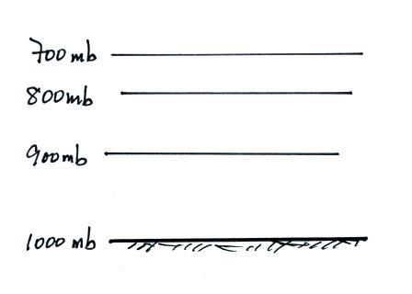
In-class Optional Assignment

1. What’s wrong with the picture at right

Pressure is decreasing with increasing altitude, that is correct. The problem is with the thicknesses of the layers. The thinnest layer should be at the bottom of the picture, not at the top. The bottom layer is thinnest because it is compressed the most by the weight of all of the atmosphere overhead. As you move upward there is less and less air overhead and less and less weight. As you move upward the layers are compressed less and less and should get thicker.

As it’s drawn now the figure shows air density increasing with increasing altitude. Low density air in the thick layer at the bottom of the picture and the highest density air in the thin layer at the top of the picture. Density doesn’t increase with increasing altitude, it decreases with increasing altitude.

2. Temperature decreases with increasing altitude in the ____T_____
The top of Mt. Lemmon (alt. 9000 ft) is in the ____ T _____
Thunderstorms can form in the ____ T ____
A temperature inversion between 20 and 50 km makes the ___S___ a very stable layer.
The ozone layer is found in the ____ S ____ (fill in each blank with a T for troposphere or an S for stratosphere)

3. If you start to add air to a rigid container, the number of air molecules N will __ Incr ___, the container volume V will ___Same__, and the pressure of the air in the container will
__ Incr ___. (fill in each blank with INCRease, DECRease, or remain the SAME; you can assume the air temperature remains constant)
The container is rigid, so its volume doesn’t change.

4. If you warm a parcel (volume) of air in the atmosphere, the ____T_____ and ____V_____ will increase, the _____D____ will decrease, and the ____N____ and _____P____will remain constant. (fill in the blanks with Density, Number of air molecules, Pressure, Temperature, or Volume; each answer should be used once)

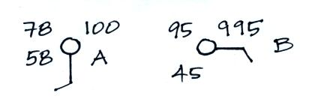
5. The atmosphere can be split into layers according to how air COMPOSITION DENSITY PRESSURE TEMPERATURE changes with altitude.

8. Does CITY A or CITY B have the highest relative humidity?
Does CITY A or CITY B have the highest actual amount of water vapor in the air?
One job of the dew point is to give you an idea of how much water vapor is in the air. The higher the dew point the more water vapor is in the air. So City A with a dew point of 58º F has more water vapor than City B which has a dew point of 45º F.

If you cool the air to the dew point, the relative humidity becomes 100%, the highest it can go. You only need to cool the air 20º F in City A (from 78º F to 58º F) so the relative humidity must be closer to 100% than the air in City B. In City B the air needs to be cooled 50º F (from 95º F to 45º F) before the relative humidity increases to 100%.

6. A parcel of warm air will rise because the DENSITY PRESSURE of the air inside the parcel is HIGHER LOWER than that of the surrounding air.

7. If you double the volume, double the number of air molecules, and double the temperature of the air inside a parcel the pressure will INCREASE DECREASE remain the SAME.
Doubling the number of air molecules would cause pressure to double. Doubling the temperature would double the pressure. If you double both the number of air molecules and the temperature, pressure would increase by a factor of 4.

Doubling the volume would decrease the pressure by a factor of 2.

So doubling N, T, and V increases the pressure by (2 x 2)/2 = 4/2 = 2.

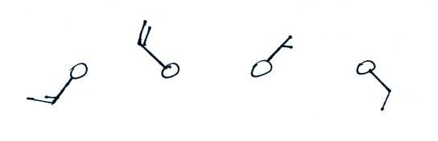
9. Which of the figures shows
northeasterly winds?

The winds in these 4 examples SW NW NE SE
are blowing from the directions noted
at right

