Experiment Report Format
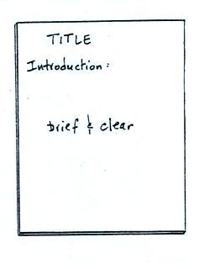
Title (5 pts) Your report should have a descriptive title

Introduction (10 pts) This is perhaps the most difficult
part of the report to write. You must have a good
understanding of the whole experiment to be able to write
a clear and complete introduction.

The introduction should explain in fairly general terms
what kind of measurement you tried to make and how
you made it. Don’t describe the experiment in detail here;
that belongs in the procedure section of your report.
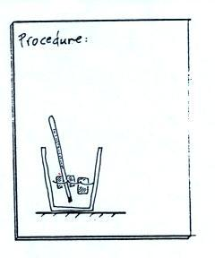
In the latent heat experiment, for example, you are
trying to measure how much energy is needed to melt
ice. You need to add energy to ice to cause it to melt.
What is the source of the energy in this experiment?
Energy is often invisible. In your introduction you should
explain how you were able to measure how much energy
was added to the ice to cause it to melt.

Procedure (10 pts) Here you explain exactly how you
carried out the experiment. Someone unfamiliar with the
experiment should be able to perform it using just your
description of the procedure.
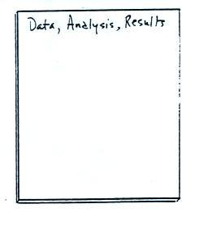
The procedure should be written in a narrative style rather
than a numbered list of steps or instructions. Pictures can be
very helpful and often save a lot of written description.

Data, Analysis, and Results (10-15 pts) Include your
original data collection sheet, not a copy. If you draw a graph,
use graph paper, make the graph large, and label the axes. You
should include an example of all but the simplest calculations.
Be sure to include units where appropriate.

