Apparatus No. _________ Mass of aluminum block___________________

Solar Irradiance Experiment
(Don’t let the title scare you, solar irradiance is just a fancy term for the amount of energy in sunlight)

Become familiar with the apparatus before you
take it outside and place it in the sunlight. The aluminum
block will start to warm rather quickly once it’s placed
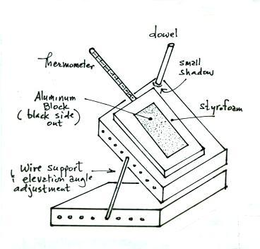
in the sun and you will need to be ready to align it and begin taking time and temperature measurements.
The picture at right shows how the apparatus
should be assembled. Be careful when pushing the
thermometer through the Styrofoam and into the edge
of the aluminum block. Don’t force the thermometer,
but be sure that it is fully inserted into the block.
Be sure the thermometer is turned so that you can easily
read the scale without getting in front of the apparatus
and casting a shadow on the aluminum block. The
elevation can be adjusted by removing the wire
support and placing the two ends in different sets of
holes. Practice removing and inserting the wire
support and adjusting the elevation of the wooden
stand. Your measurements should be taken on a clear
sunny day with calm or light winds. Measurements
should be made in the late morning or early afternoon
when the sun is relatively high in the sky.

When you are ready to begin the experiment move the apparatus to a shady location outdoors and let it sit there for a few minutes to allow the aluminum block to come to the same temperature as the outside air. You can remove the thermometer and use it to make a measurement of the outside air temperature. You might even take the aluminum block out of the styrofoam and place it on the ground so that it equilibrates more quickly.
When you are ready to begin your measurements move the apparatus out into the sun. Quickly turn the wooden stand and adjust the elevation angle until the wooden dowel casts very little shadow (remove the wire while adjusting the elevation, reinsert it in appropriate holes when you are close to the necessary elevation angle). The elevation angle adjustment is somewhat coarse and you will probably not be able to obtain perfect alignment. Get as close as you can.

Try to align the apparatus in less than 1 minute so that you can make your first temperature measurement 1 minute after beginning the experiment. Continue making temperature measurements every minute for a few minutes so that you can get an idea how quickly the block is warming up. You might be able to decrease the interval to 2 or 3 minutes if the block is warming slowly. You should continue making measurements until you see a clear indication in your data that the rate of warming is beginning to decrease. You will probably need to make measurements for a total of 20 to 30 minutes. Periodically check the alignment of the apparatus during the time and make any adjustments that are needed.

