ATMO 170A1 Sects. 2 & 3 Name__________________________________
Practice Quiz Sep. 12, 2013 (please also put your name on the back)

1. (5 pts) If you carry an object from the earth to the moon, the object's _______ will change.
a. composition b. density c. mass d. volume e. weight

2. (5 pts) High concentrations of _______ is part of what made the Great London Smog of 1952 so deadly (4000 people died in a one week period).
a. carbon dioxide b. chlorofluorocarbons c. ozone d. sulfur dioxide

3. (10 pts) The earth is about 4.5 BILLION MILLION TRILLION years old. Our present atmosphere is very DIFFERENT SIMILAR from(to) the earth's original atmosphere. (circle one word in each group)

4. (10 pts) _______ can react with water in clouds to make acid rain. In a class demonstration _______ from dry ice bubbled through Tucson tap water turned the water slightly acidic.
a. carbon dioxide b. carbon monoxide c. nitrogen d. ozone e. sulfur dioxide

5. (10 pts) During compete combustion fuels react with oxygen to form _______. During incomplete combustion _______ is produced. (fill in each blank with one of the choices below)
a. carbon monoxide b. ozone c. carbon dioxide d. hydrogen

6. (5 pts) Chlorofluorocarbons (CFCs) in the atmosphere are of concern because they are greenhouse gases and also because they _______.
a. react in clouds to make acid rain b. are colorless, odorless, toxic gases
c. destroy stratospheric ozone d. react with ozone to make photochemical smog

7. (5 pts) The atmospheric concentration of _______ can range from near 0% up to 3% or 4%.
a. nitrogen b. oxygen c. water vapor d. argon e. carbon dioxide

8. (10 pts) Atmospheric pressure at sea level is normally about 14.7 pounds per square inch (psi). This value is determined by which two of the following?
a. amount (mass) of air in the atmosphere b. thickness of the atmosphere
c. composition of the atmosphere d. strength of the earth's gravity

9. (5 pts) Most of the oxygen in today's atmosphere is thought to have come from
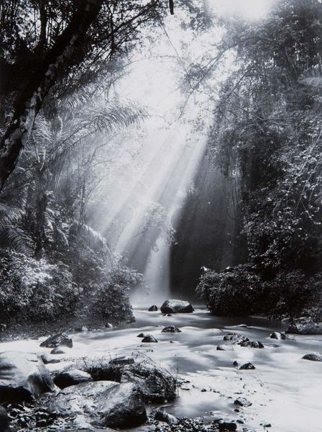
a. volcanoes & earthquakes b. meteors & comets
c. thunderstorms & lightning d. plants & photosynthesis

10. (5 pts) A low air quality index (AQI) means the air is CLEAN DIRTY.

11. (5 pts) The rays or beams of sunlight in the photograph are a pretty
good illustration or example of what phenomenon?
Name_____________________________________

12. (15 pts) The two most abundant gases in the atmosphere are _______. _______ are the two main summertime and wintertime pollutants in Tucson. The two best known greenhouse gases are _______. (fill in each blank with one of the letters below)
a. carbon dioxide (CO₂) & water vapor (H₂O) b. ozone (O₃) & carbon monoxide (CO)
c. argon (Ar) & water vapor (H₂O) d. nitrogen (N₂) & oxygen (O₂)
e. hydrogen (H) & helium (He) f. ozone (O₃) & sulfur dioxide (SO₂)

13. (5 pts) _______ is(are) the best way of cleaning particulates and pollutants from the air.
a. Low humidity b. Clouds c. High pressure d. Wind

14. (5 pts) On sunny summer days ______________________ can react with a hydrocarbon to produce photochemical smog.

15. (5 pts) Why might small particles suspended in the air be more of a health hazard than larger particles?

16. (10 pts) Is ethanol added to gasoline in Tucson during the WINTER or SUMMER months? Are these "oxygenated fuels" used to reduce OZONE (O₃) or CARBON MONOXIDE (CO) emissions?

17. (5 pts) Which of the four pollutants discussed in class has the biggest effect on visibility?

18. (15 pts) Do strong vertical air motions mean the atmosphere is STABLE or UNSTABLE? The formation of surface inversion layers is more likely on winter MORNINGS AFTERNOONS. In an inversion layer, air PRESSURE TEMPERATURE increases with increasing altitude.

19. (10 pts) Despite being considered a pollutant when found in air at ground level, ARGON OZONE found in the STRATOSPHERE TROPOSPHERE is beneficial because it absorbs high-energy, potentially deadly forms of ultraviolet light.

Extra credit (you can earn up to 10 pts)
1. (6 pts) The term smog referred, originally, to a mixture of ____________ and ____________.

2. (5 pts) In Tucson a dew point temperature of 65º F would be AVERAGE HIGH LOW.

3. (5 pts) Which of the following is the smallest or shortest distance?
a. centimeter b. kilometer c. micrometer d. millimeter

