Week #8 Assignment

1. Which one of the following pairs of clouds would be most similar in appearance?
a. cumulus & cirrus b. cumulonimbus & cirrocumulus
c. cirrostratus & stratus d. cirrocumulus & altocumulus

2. Which three cloud types are altostratus cirrostratus cumulonimbus
missing from the list at right? nimbostratus cirrocumulus cumulus
stratocumulus

3. The sun is visible through _________________________, a grey layer cloud, but objects on the ground don’t cast shadows.

4. The flat top of a thunderstorm is referred to as a(n) _________________________ cloud.
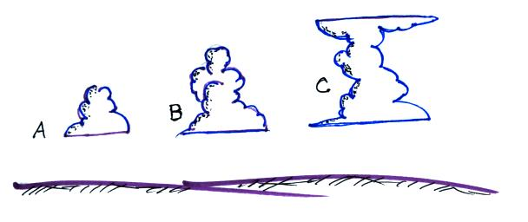
5, Towering cumulus (cumulus congestus)
would refer to which of the clouds
sketched at right?

6. _________________________ is a low-level layer cloud.

7. The cloud name given to a thunderstorm is _______. Occurrence of a halo is a pretty sure indication of _______, a high altitude layer cloud. _______ is a middle level cloud with thumbnail size patches of cloud. A high altitude cloud with a filamentary appearance is _______.
a. altocumulus b. stratocumulus c. altostratus d. cirrostratus
e. cumulonimbus f. nimbostratus g. cirrus h. cirrocumulus

8. Which two of the following tell you something about cloud altitude?
a. cirro b. nimbo c. strato d. cumulo e. alto
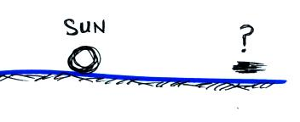
9. The patch of colored light sometimes seen to the right
or left of the setting sun is called a(n)
a. mirage b. solar flare c. sun pillar d. sundog

10. Cold high altitude cloud emit MORE LESS radiation than low clouds and appear GREY WHITE on an infrared satellite photograph.

11. A thin, high altitude, layer cloud would appear WHITE GREY on a visible satellite photograph and WHITE GREY on an infrared image.
12. Satellites are able to photograph clouds at night by detecting INFRARED ULTRAVIOLET VISIBLE radiation that is ABSORBED EMITTED REFLECTED by the clouds (circle one choice from each group)

13. Stratiform clouds form in a STABLE UNSTABLE atmosphere and grow mainly in a HORIZONTAL VERTICAL direction.

14. Does the collision-coalescence process work best when the cloud droplets are all the SAME size or DIFFERENT sizes, when the cloud is THICK or THIN, when the cloud has a STRONG or WEAK updraft?

15. If Droplet A has a diameter that is 2 times greater than Droplet B, then Droplet A will have a volume that is _______ times larger than Droplet B.
a. 2 b. 4 c. 8 d. 10 e. 16 f. 48 g. 96 h. 100

16. Is most of the rain here in the hot dry desert southwest produced by the COLLISION-COALESCENCE or the ICE-CRYSTAL process?

17. Which of the following is not found in a cold cloud?
a. water droplets only at temperature above freezing
b. water droplets and ice crystals at temperatures above freezing
c. water droplets and ice crystals at temperatures below freezing
d. ice crystals only at temperatures below freezing

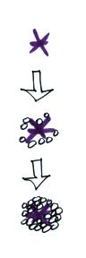
18. When found together in a cloud at the same temperature an ice crystal will evaporate
at a(the) HIGHER SAME LOWER rate than(as) a supercooled water droplet.

19. The picture at right is illustrating the formation of _______
a. hail b. sleet c. snow d. graupel

20. Does riming occur during the ICE CRYSTAL or the COLLISION COALESCENCE process? Does riming make a precipitation particle LARGER or SMALLER?

21. A raindrop that freezes before reaching the ground is
a. snow b. graupel c. sleet d. hail

22. By measuring changes in signal frequency a Doppler radar provides information about
a. particle composition b. particle motion toward or away from the radar
c. buildup of electrical charge d. particle shape

