ATMO 170A1 Sects. 2 & 3 Name____________Answers_______________
Practice Quiz Sep. 12, 2013 (please also put your name on the back)

1. (5 pts) If you carry an object from the earth to the moon, the object's ___e___ will change.
a. composition b. density c. mass d. volume e. weight
In a question like this you can either circle the answer or fill in the blank with the letter of the answer.
2. (5 pts) High concentrations of ___d___ is part of what made the Great London Smog of 1952 so deadly (4000 people died in a one week period).
a. carbon dioxide b. chlorofluorocarbons c. ozone d. sulfur dioxide

3. (10 pts) The earth is about 4.5 BILLION MILLION TRILLION years old. Our present atmosphere is very DIFFERENT SIMILAR from(to) the earth's original atmosphere. (circle one word in each group)

4. (10 pts) ___e___ can react with water in clouds to make acid rain. In a class demonstration ___a___ from dry ice bubbled through Tucson tap water turned the water slightly acidic.
a. carbon dioxide b. carbon monoxide c. nitrogen d. ozone e. sulfur dioxide
In a question like this the order of the answers is important. You need to fill in the blanks with your answer. You would lose credit if you just circled answers a and e because it wouldn't be clear which answer went with which question.

5. (10 pts) During compete combustion fuels react with oxygen to form ___c___. During incomplete combustion ___a___ is produced. (fill in each blank with one of the choices below)
a. carbon monoxide b. ozone c. carbon dioxide d. hydrogen

6. (5 pts) Chlorofluorocarbons (CFCs) in the atmosphere are of concern because they are greenhouse gases and also because they ___c___.
a. react in clouds to make acid rain b. are colorless, odorless, toxic gases
c. destroy stratospheric ozone d. react with ozone to make photochemical smog

7. (5 pts) The atmospheric concentration of ___c___ can range from near 0% up to 3% or 4%.
a. nitrogen b. oxygen c. water vapor d. argon e. carbon dioxide

8. (10 pts) Atmospheric pressure at sea level is normally about 14.7 pounds per square inch (psi). This value is determined by which two of the following?
a. amount (mass) of air in the atmosphere b. thickness of the atmosphere
c. composition of the atmosphere d. strength of the earth's gravity
Pressure is determined by the weight of the air overhead. Weight depends on both mass and gravity.

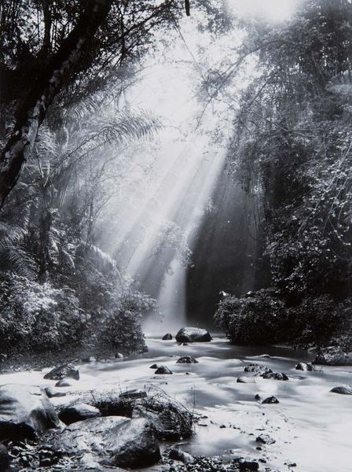
9. (5 pts) Most of the oxygen in today's atmosphere is thought to have come from
a. volcanoes & earthquakes b. meteors & comets
c. thunderstorms & lightning d. plants & photosynthesis

10. (5 pts) A low air quality index (AQI) means the air is CLEAN DIRTY.

11. (5 pts) The rays or beams of sunlight in the photograph are a pretty
good illustration or example of what phenomenon?
scattering of light

12. (15 pts) The two most abundant gases in the atmosphere are __d__. __b__ are the two main summertime and wintertime pollutants in Tucson. The two best known greenhouse gases are ___a___. (fill in each blank with one of the letters below)
a. carbon dioxide (CO₂) & water vapor (H₂O) b. ozone (O₃) & carbon monoxide (CO)
c. argon (Ar) & water vapor (H₂O) d. nitrogen (N₂) & oxygen (O₂)
e. hydrogen (H) & helium (He) f. ozone (O₃) & sulfur dioxide (SO₂)

13. (5 pts) ___b___ is(are) the best way of cleaning particulates and pollutants from the air.
a. Low humidity b. Clouds c. High pressure d. Wind

14. (5 pts) On sunny summer days ________ozone_________ can react with a hydrocarbon to produce photochemical smog.

15. (5 pts) Why might small particles suspended in the air be more of a health hazard than larger particles? Smaller particles can be inhaled deeper into your lungs (and may even pass through the lungs into the blood stream).

16. (10 pts) Is ethanol added to gasoline in Tucson during the WINTER or SUMMER months? Are these "oxygenated fuels" used to reduce OZONE (O₃) or CARBON MONOXIDE (CO) emissions?

17. (5 pts) Which of the four pollutants discussed in class has the biggest effect on visibility?
Particulate matter

18. (15 pts) Do strong vertical air motions mean the atmosphere is STABLE or UNSTABLE? The formation of surface inversion layers is more likely on winter MORNINGS AFTERNOONS. In an inversion layer, air PRESSURE TEMPERATURE increases with increasing altitude.

19. (10 pts) Despite being considered a pollutant when found in air at ground level, ARGON OZONE found in the STRATOSPHERE TROPOSPHERE is beneficial because it absorbs high-energy, potentially deadly forms of ultraviolet light.

Extra credit (you can earn up to 10 pts)
1. (6 pts) The term smog referred, originally, to a mixture of ___smoke____ and ____fog_____.

2. (5 pts) In Tucson a dew point temperature of 65º F would be AVERAGE HIGH LOW.

3. (5 pts) Which of the following is the smallest or shortest distance?
a. centimeter b. kilometer c. micrometer d. millimeter
a kilometer is 1000 meters, a centimeter is 1/100 th of a meter, a millimeter is 1/1000 th of a meter, and a micrometer is one-millionth of a meter (10⁻⁶ meters)

