NATS 101 Sect. 17
Practice Quiz Sept. 13, 2000 Name______________________________

1. Are oxygenated fuels used in Tucson and other cities in the WINTER or SUMMER months? Are they used to reduce OZONE (O₃) or CARBON MONOXIDE (CO) concentrations? (choose one word from each pair)

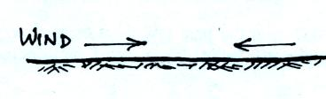
2. Are the surface winds at right CONVERGING into
or DIVERGING out from the center of the picture?
Would the surface winds cause the air in the center
of the picture to RISE or SINK?

3. Laughing gas [nitrous oxide (N₂O)] is a greenhouse gas, so is natural gas [methane (CH₄)]. What are the two most abundant and most important greenhouse gases?

4. Which of the following are involved in the formation of Los Angeles type smog? (more than one correct answer, circle all the correct answers)
a. photochemical reactions b. high sulfur dioxide levels c. high humidity, clouds, and fog
d. reactions involving ozone e. winds and blowing dust f. salt particles from the ocean
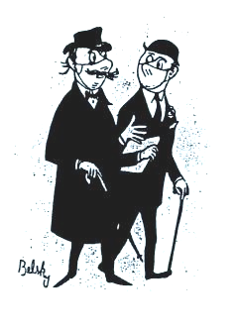

5. High sulfur dioxide (SO₂) levels and high humidity during the
Great London smog of 1952 created fog that was ACIDIC BASIC.
People wore masks over their nose and mouth to try and neutralize
the fog and reduce the health effects of exposure to the fog. Would
it have made sense to soak the masks in VINEGAR or AMMONIA?

6. Ground level ozone is an example of a PRIMARY SECONDARY pollutant. In Tucson ozone concentrations peak in the SUMMER WINTER during the MORNING AFTERNOON.

7. During complete combustion, fuels react with oxygen to form _______. During incomplete combustion _______ is produced.
a. carbon monoxide b. ozone c. carbon dioxide e. hydrogen

8. Which of the following does not usually decrease as you move up from the bottom to the top of the troposphere?
a. air pressure b. air density c. air temperature d. wind speed

9. A surface radiation inversion is a STABLE UNSTABLE layer that forms EARLY LATE in the day and is able to CONCENTRATE DISPERSE air pollutants such as carbon monoxide.

10. The first analysis that is usually done on a surface weather map is to draw contour lines that reveal small horizontal changes in _______ that cause the wind to blow.
a. pressure b. density c. altitude d. temperature

11. Fill in each blank below to indicate whether you would expect to find each of the following characteristics to be associated with a surface center of HIGH or LOW pressure.
clockwise winds __________ rising air __________ clear skies __________

Name____________________________________

12. What important constituent of today's atmosphere was not present in the earth's first atmosphere or early in the second atmosphere? [hint: concentrations of this constituent began to slowly increase as UV radiation was able to dissociate (split apart) water vapor and carbon dioxide molecules. Photosynthesis is now a more important source of this gas]

13. During the past few days or so dew point temperatures have dropped from values in the low 60s into the 40s indicating a significant decrease in the concentration of what atmospheric constituent?
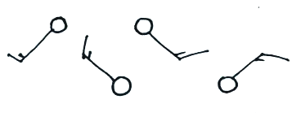

14. A wind blowing from the NW toward the SE would be
indicated with which of the symbols at right?

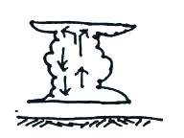
15. An object with a LARGE SMALL mass has a lot of inertia.

16. Thunderstorms develop when the atmosphere is STABLE
UNSTABLE. A thunderstorm will grow until it reaches the
top of the STRATOSPHERE TROPOSPHERE, and will
then begin to flatten out.

17. HFC compounds do not contain _______________ and therefore do not present any risk ot the earth's ozone layer. They do still act as greenhouse gases, however.

18. Reservoir compounds INCREASE DECREASE the rate of destruction of ozone by free chlorine. Polar stratospheric clouds INCREASE DECREASE reservoir molecule concentrations.

19. You would find surface weather observations made in Tucson at 11:00 am plotted on the _______ surface weather map. (Z is the same as GMT or UT; there is a 7 hour difference between Tucson and GMT time)

20. Emissions of which of the following have seen the greatest reduction since enaction of the Clean Air Act of 1970?
a. sulfur dioxide (SO₂) b. carbon monoxide (CO) c. volatile organic compounds (VOCs)
d. particulate matter (PM) e. lead (Pb)

EXTRA CREDIT (up to 10 pts)
1. The air we breath contains molecular oxygen (O₂). Electrical discharges such as lightning are capable of splitting some of the oxygen molecules producing atomic oxygen (O). Once atomic oxygen is produced what other gas might you expect to find near lightning?

2. If the earth's gravity were to increase but the amount of air in the atmosphere did not change, the weight of the atmosphere and sea level atmospheric pressure would both INCREASE. How would you explain the fact that the reading on a mercury barometer would remain the SAME?

3. Fill in one of the blanks with
average sea level pressure. 14.7 psi = __________ millibars = __________inches of mercury

