ATMO 170 Sect. 2 Name______________________________________
Quiz #2 Oct. 19, 2017 (please also put your name on the back)

1. (10 pts) Everything else being equal, the coldest winter temperatures would be found at a location surrounded by LAND OCEAN. The smallest annual range of temperatures would be found at a location surrounded by LAND OCEAN.

2. (5 pts) The formation of frost is an example of deposition. Most people don’t know what deposition is. What is deposition?

3. (5 pts) The earth and sun have different wavelengths of peak emission because they have different
a. temperatures b. volumes c. compositions d. masses

4. (5 pts) The earth’s surface is warm enough that it emits more EM radiation than it receives from the sun. Which of the following supplies most of the energy needed to bring the surface into energy balance?
a. absorption of UV radiation by the ozone layer b. heat stored in the earth’s oceans
c. emission of IR radiation by the atmosphere d. heat from the hot molten core of the earth

5. (5 pts) On a day with a temperature of 40º F with 15 MPH winds, a thermometer would measure a temperature EQUAL GREATER LESS to(than) 40º F.

6. (10 pts) Compared to visible light, infrared light has LONGER SHORTER wavelength and is a LESS MORE energetic form of electromagnetic (EM) radiation.

7. (5 pts) If the amount of sunlight arriving at the earth that is reflected were to decrease would you expect the earth to WARM COOL or remain the SAME temperature?

8. (5 pts) A measurement of air temperature would give you a pretty good idea of the air molecule's
a. average kinetic energy b. thermal conductivity c. latent heat d. specific heat

9. (5 pts) Wien’s Law says that if an object warms the _______ will decrease.
a. wavelength of peak emission b. speed of propagation
c. intensity of emitted radiation d. radiative equilibrium temperature

10. (15 pts) Because of _______ the atmosphere pretty nearly absorbs all of the _______ in incoming sunlight. Greenhouse gases selectively absorb and also emit _______ light. (fill in the blanks)
a. N₂ & O₂ b. UV light c. O₂ & O₃
d. IR light e. CO₂ & H₂O f. visible light

11. (5 pts) The Stefan-Boltzmann law σT⁴ allows you to calculate the _______ of EM radiation
a. wavelength of peak emission b. speed of propagation
c. frequency d. intensity

12. (15 pts) _______ in the list below is the melting point of ice. _______ is a reasonable average temperature for the earth. _______ is the hottest temperature in the list. (fill in the blanks).
a. 0º C b. 0º F c. 100º C d. 100 º F e. 200º F f. 300º K

Name______________________________________

13. (5 pts) In order for air to transport “hidden” latent heat energy the air must contain
a. electric charge b. kinetic energy c. greenhouse gases d. water vapor

14. (5 pts) The atmospheric greenhouse effect is caused by the
a. high specific heat of water and the fact that 2/3rds of the earth’s surface is ocean
b. absorption and emission of EM radiation by gases in the air
c. absorption of UV light by the ozone layer in the stratosphere
d. release of latent heat when water vapor condenses to make clouds

15. (10 pts) Energy is released into the air during which two of the following phase changes?
a. dry ice subliming b. evaporating water c. condensation of water vapor d. formation of frost

16. (5 pts) An object at room temperature that feels cold to the touch probably has high
a. specific heat b. density c. latent heat d. thermal conductivity

17. (5 pts) Kinetic energy has units of
a. degrees Kelvin (ºK) b. micrometers (µm) c. calories (cal) d. cycles per second (Hz)

18. (5 pts) Because of ______ the average surface temperature on the earth is about 60º F instead of 0º F.
a. free convection b. the tilt of the earth relative to its orbit around the sun
c. latent heat energy d. the greenhouse effect e. the high specific heat of water

19. (10 pts) In air, convection is a MORE LESS important energy transport process than conduction. In water conduction would transport MORE LESS energy than in air

20. (5 pts) Energy can be transported through empty space by
a. conduction b. convection c. latent heat d. all of these e. none of these

21. (15 pts) It will generally be COLDER WARMER on a cloudy night than on a night with clear skies. This is because clouds are GOOD POOR absorbers of INFRARED VISIBLE ULTRAVIOLET light.

22. (5 pts) Energy transport by CONVECTION CONVERGENCE DIVERGENCE CONDUCTION can only take place in liquids and gases, not in solids

Extra Credit (you can earn up to 10 pts)
1. (5 pts) The atmosphere is emitting radiant energy downward toward the ground
a. during the day b. at night c. both day and night d. neither day nor night

2. (5 pts) The wavelength of peak emission from an ordinary tungsten bulb is 1.0 micrometers (µm). Is this ULTRAVIOLET, VISIBLE, or INFRARED light?

3. (5 pts) The largest percentage of the sunlight arriving at the top of the atmosphere
a. passes through the air and gets absorbed by the ground b. is absorbed by ozone
c. is absorbed by greenhouse gases d. is reflected back into space
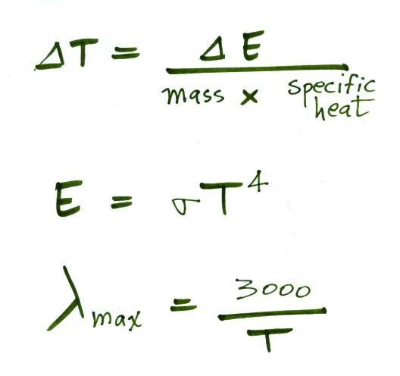
Here are some equations that might help with some of the questions on the quiz

