ATMO 170a1 Sect. 2 Name_______________________________
Final Exam Thu., Dec. 15, 2016

You may refuse to answer one question on this exam. Simply write refuse next to the question of your choice and you will receive full credit for that question. Choose wisely. Each answer on this exam is worth 1 pt. A question with two parts is worth 2 pts, a question with 3 parts is worth 3 pts., etc.

1. At the summit of Mt. Lemmon (9000 ft.altitude) the air pressure is HIGHER LOWER, the air density is HIGHER LOWER, and the air temperature is HIGHER LOWER than in Tucson (2500 ft.)

2. The hottest temperature in the list below is _______. Ice melts and water freezes at a temperature of _______. The earth's surface has an average temperature of about _______. (fill in the blanks)
a. 0º C b. 0º F c. 100º C d. 100º F e. 200º F f. 300º K

3. The air will often turn a deep blue the day after a rain storm. This probably means the air is
a. cold b. moist c. hot d. polluted e. dry f. clean

4. An object immersed in a fluid experiences an upward buoyant force equal to the weight of the fluid displaced is a statement of a principle discovered by
a. Aristotle b. Archimedes c. Galileo d. Newton e. Piccard

5. What is the name given to an unusually strong and narrow thunderstorm downdraft?

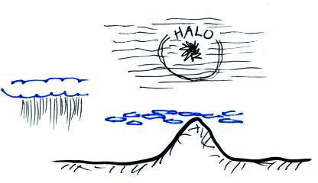

6. Which three of the following cloud types are
shown in the picture at right
a. cumulonimbus b. altocumulus
c. nimbostratus d. cirrostratus
e. stratocumulus f. cirrus

7. The lowest layer in the atmosphere is the _______. The _______ is always a very stable layer. Cruising altitude for commercial aircraft is between 30,000 and 40,000 feet which is near the top of the _______. (fill in the blanks with Troposphere) or Stratosphere)

8. Atoms in a hot object have a lot of _______. Metals such as copper have high _______. Cold air sinks because it has high _______. Water vapor contains hidden _______. (fill in the blanks, each answer should be used once)
a. conductivity b. density c. kinetic energy d. latent heat energy

9. Which of the following does Newton's first law of motion say could be true if there was no net force (no total force) applied to an object? (more than one answer)
a. the object could be stationary (not moving)
b. the object could be moving in a straight line at constant speed
c. the object could be moving in a straight line but changing speed
d. the object could be moving at constant speed but changing direction

10. If you warm moist air, the _______ will increase, the _______ and _______ will remain the same, and the _______ will decrease. (fill in the blanks, each answer below should be used once)
a. r (mixing ratio) b. r_{S} (saturation mixing ratio)
c. RH (relative humidity) d. T_{D} (dew point temperature)

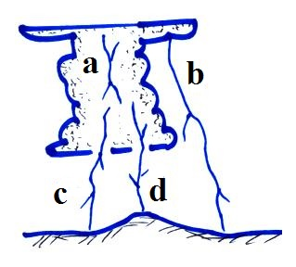
11. Discharge _______ in the figure at right is the most common
type of lightning. _______ is the rarest lightning discharge.

12. Incomplete combustion is a source of _______ a winter morning pollutant. Hydrocarbons react with _______ to produce photochemical or Los Angeles type smog. High levels of _______ is partly what made the Great London Smog of 1952 so deadly. (fill in the blanks)
a. carbon dioxide b. carbon monoxide c. ozone d. sulfur dioxide e. radon

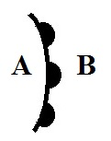
13. Oxygen and ozone make the atmosphere a good TRANSMITTER ABSORBER EMITTER of ultraviolet light. A window refers to wavelengths of light that are TRANSMITTED ABSORBED EMITTED by the atmosphere. The atmosphere absorbs, emits, and transmits INFRARED ULTRAVIOLET VISIBLE light

14. Is the front shown at right moving toward POINT A or POINT B?
Is the warmest air found at POINT A or POINT B?

15. _______ is a high altitude cloud with a filamentary appearance. _______ is another name for a thunderstorm. A lumpy layer cloud found at low altitude would be called _______. (fill in the blanks)
a. cumulonimbus b. altocumulus c. nimbostratus
d. cumulus e. stratocumulus f. cirrus
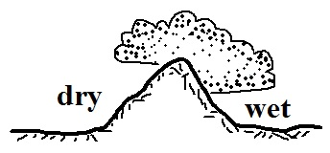
16. The term rain shadow refers to the conditions on the DRY WET
side of the mountain in the picture at right. Winds blowing from the LEFT RIGHT would produce the precipitation pattern shown at right.

17. To get a name, a tropical cyclone must increase to _______ strength. A tropical cyclone
with winds between 75 and 95 MPH would be considered a _______. (fill in the blanks)
a. tropical disturbance b. tropical depression c. tropical storm d. hurricane
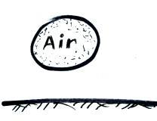
18. If the air in the parcel at right is warmer than the surrounding air, the parcel will RISE SINK because the DENSITY PRESSURE of the air inside the parcel is HIGHER LOWER than that of the surrounding air.

19. An air mass thunderstorm will begin to weaken and dissipate when
a. lightning neutralizes all of the electrical charge in the cloud
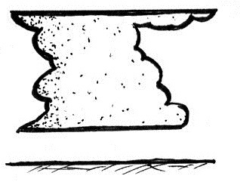
b. all the cloud particles turn to ice
c. the downdraft grows and cuts off the updraft
d. the cloud becomes taller than it is wide

20. The flat top on the thunderstorm at right is called a(n) ANVIL SHELF
cloud and often marks the top of the TROPOSPHERE STRATOSPHERE.

21. The _________________________ is the temperature to which you must cool
moist air in order to increase the relative humidity to 100%.

22. The direction of the _______ force is always perpendicular to the wind. The _______ is always inward when wind blows in a circular path. The _______ is always perpendicular to the height or pressure contours on a weather map. (fill in the blanks)
a. Coriolis force b. net force c. pressure gradient force d. frictional force

23. The air in the eye of a hurricane is clear because
a. the air is dry b. the winds are calm c. the pressure is low d. the air is sinking
24. _______ blow parallel to the contours on a weather map.
a. Neither surface or upper level winds b. Only surface winds
c. Both upper level and surface winds d. Only upper level winds

25. The main benefit of the greenhouse effect is to
a. absorb harmful ultraviolet radiation
b. provide nutrients needed by growing plants
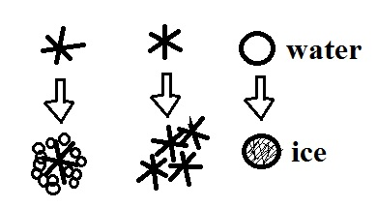
c. increase global average surface temperatures
d. transport water from the oceans to the land

26. The formation of _______ is not shown in the figure at right.
a. graupel b. snow c. hail d. sleet

27. Dry ice changes directly from a solid to a gas. Is this called DEPOSITION or SUBLIMATION? Does this change RELEASE or TAKE energy from(into) the air?

28. Is cloud formation more likely when air COOLS or WARMS? Rising air expands and WARMS COOLS. Are rising air motions produced by surface centers of HIGH or LOW pressure?

29. Most tornadoes form in the SPRING FALL. Tornado winds spin around a core of LOW HIGH pressure. Most tornadoes have spinning winds of 100 MPH or LESS MORE. The number of tornado deaths every year is now HIGHER LOWER than it was 50 to 100 years ago

30. Which of the following are true? (more than one answer)
a. Intracloud lightning is more common than cloud-to-ground lightning
b. Collisions between precipitation particles in a cloud produce the charge needed for lightning
c. A metal car is a safe place to be during a lightning storm
d. Lightning striking the ground without rain is called dry lightning

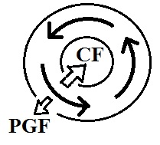
31. There is less and less air left overhead as you move upward through the atmosphere. This explains why PRESSURE TEMPERATURE always DECREASES INCREASES with increasing altitude.

32. The figure at right shows upper level winds blowing around
HIGH LOW pressure in the NORTHERN SOUTHERN
hemisphere.

33. Precipitation would be most likely in a _______ and a _______.
a. cloud with large and small water droplets b. cloud with just ice crystals
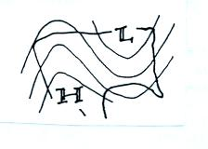
c. cloud with just large water droplets d. cloud with ice crystals and water droplets

34. A RIDGE TROUGH covers the western United States
on the upper level chart at right. You would expect to find
WARMER COLDER than normal conditions in the west.

35. Because the earth is fairly cool it emits LONG SHORT wavelength ULTRAVIOLET INFRARED MICROWAVE radiation.

36. 3. The deadliest disaster in US history was _______. The costliest natural disaster in US history was _______.
a. Hurricane Camille in 1969 b. The Labor Day hurricane of 1935
c. The Galveston hurricane of 1900 d. Hurricane Katrina in 2005

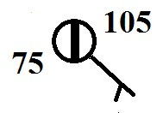
37. Which three of the following are shown at right?
a. temperature b . dew point c. mostly clear skies
d. pressure e. mostly cloudy skies f. relative humidity

38. A(n) INCREASE DECREASE of air DENSITY PRESSURE TEMPERATURE with increasing altitude is called an inversion and produces stable atmospheric conditions.
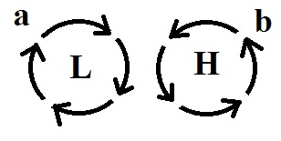
38. The winds are blowing in a circular path at constant speed in
the two figures at right. The net force is in Fig. (a) is _______. The
net force in Fig. (b) is _______. (fill in the blanks)
a. inward b. outward c. zero d. in the direction of motion

40. Because water has a HIGHER LOWER specific heat that land, a city on a coast will usually be WARMER COLDER in the summer and WARMER COLDER in the winter than a city located further inland.

41. Most of the year the winds in southern Arizona blow from the west. For 2 or 3 months in the summer the winds change direction and blow from the east. What is the name given to a seasonal shift like this in the direction of the prevailing winds?
a. cyclone b. monsoon c. thermal circulation d. haboob

42. A thin layer of air in contact with hot ground will warm by _______. Once the air becomes warm it will start to rise and transport energy upward by _______. (fill in the blanks)
a. conduction b. convergence c. convection d. latent heat

43 The Coriolis force is cause by
a. temperature differences between the equator and pole b. the rotation of the earth
c. the gravitational force of the moon d. the tilt of the earth

44. The Fujita Scale is used to rate tornado intensity. The _______ scale is used for hurricanes.
a. Beaufort b. Kelvin c. Richter d. Saffir-Simpson

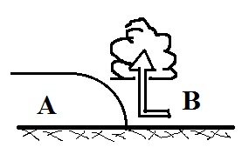
45. The figure at right is a cross sectional view of a WARM COLD front.
Air mass A is moving toward the RIGHT LEFT. Air mass B is WARMER COLDER than air mass A.

46. Photosynthesis is the source of most of the ______ in the atmosphere. ______ is the most abundant gas in the atmosphere. ______and ______are greenhouse gases. (fill in the blanks)
a. argon b. carbon dioxide c. hydrogen
d. nitrogen e. oxygen f. water vapor

47. Virga is rain that MELTS EVAPORATES CONDENSES FREEZES before reaching the ground.

48. Closely spaced contours on a weather map would indicate a STRONG WEAK pressure gradient and would produce FAST SLOW winds.

49. A mesocyclone will produce which of the following thunderstorm features?
a. anvil cloud b. mammatus clouds c. wall cloud d. gust front

50. Red light has LONGER SHORTER wavelength and is a MORE LESS energetic form of electromagnetic radiation than blue light.

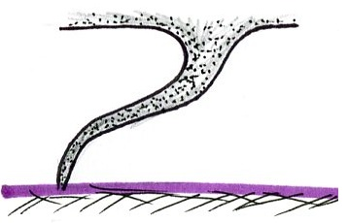
51. Based on its appearance the tornado at right is relatively
STRONG WEAK and is EARLY LATE in its life cycle.

52. Determine the relative humidity for air with a dew point temperature of 55º F, a mixing ratio of 8 g/kg, a saturation mixing ratio of 16 g/kg, and an air temperature of 70º F.

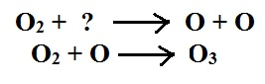
53. The two equations at right show that when ____________________
is absorbed by a molecule of oxygen (O₂) the molecule can be split
into two oxygen atoms (O). One of the oxygen atoms can then
react with molecular oxygen to form O₃ which is ____________________.

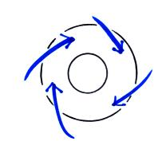
54. A rise in ocean levels along a coastline caused by an approaching hurricane.
a. storm surge b. rip tide c. easterly wave d. tsunami

55. The figure at right shows SURFACE UPPER-LEVEL winds
blowing around a center of HIGH LOW pressure in the
NORTHERN SOUTHERN hemisphere.

56. Which of the following doesn't belong in the same group as the other three?
a. mesocyclone b. downdraft c. gust front d. haboob
___________________________________________________________________________________

Every semester there are a few students that end up just below the threshold between two grades. I find that some of these students didn’t complete all of the required coursework. If it looks like making up the missing work would raise a student’s overall average enough for me to be able to bump them up a letter grade, I would like to be able to give them an incomplete so that they have the opportunity to make up the missing work. But I can’t really do that without checking with you first.

__________ Check here to give me permission to give you an incomplete if the circumstances
warrant.

__________ Check here if you DO NOT WANT, under any circumstances, to be given an
incomplete.

An incomplete means that you don’t immediately receive a grade for this class (an I will appear on your transcripts). Once you’ve completed the missing work you’ll receive a grade. You have up to one year to make up an incomplete (though I would suggest you finish the work as soon as you can).
The following equations may be used on this exam if needed:

