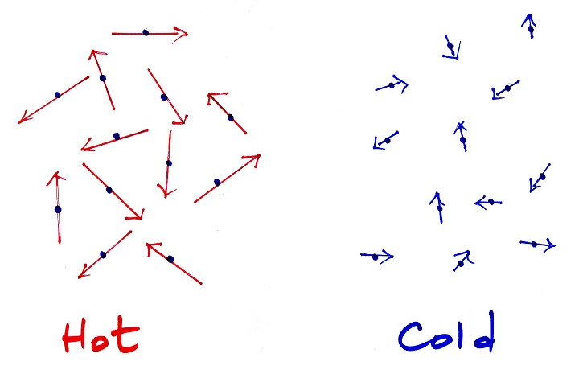
Temperature and temperature scales

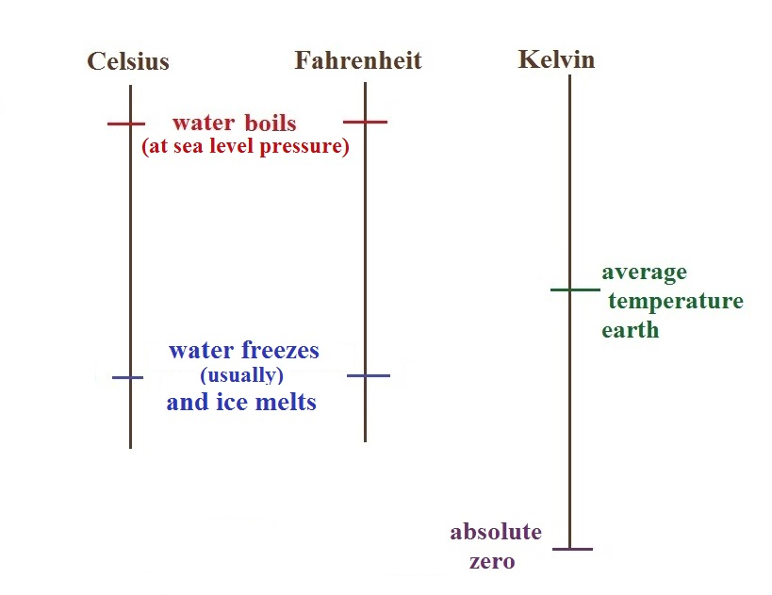
_________________________________________________________________________________

Hot temperature records Cold temperatures
129º F (Death Valley in 2013 & - 70º F (Montana, 1954)
Mitribah, Kuwait in 2016) - 80º F (Alaska, 1971)
-109º F dry ice
-129º F (Antarctica, 1983)
-320º F liquid nitrogen

