Energy and temperature relationship
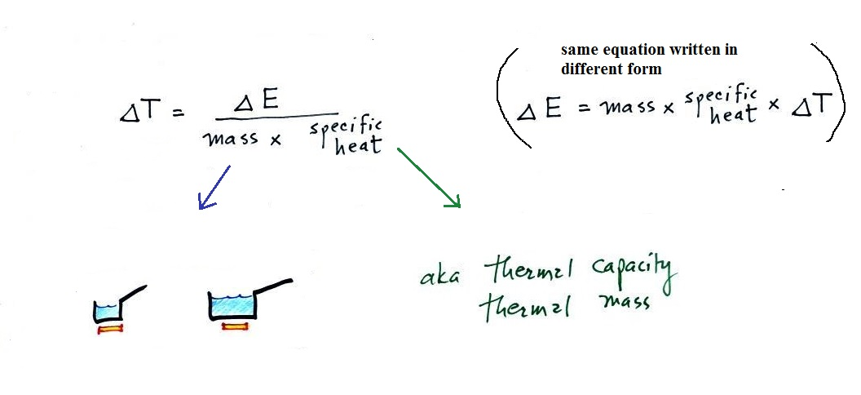
Adding energy to (or removing energy from) an object will usually* cause the object's _________________________ to increase (decrease).

* What else might happen?
