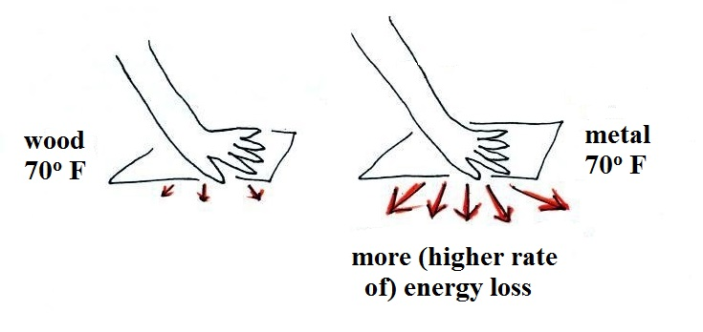
If you touch a piece of wood and a piece of metal, the metal feels
colder even when both objects have the same temperature. This is because the metal is a much better conductor than wood and will carry energy away from you hand much more quickly than the wood.

Our perception of cold
is more an indication of how quickly our body or hand
is losing energy
than a reliable measurement of temperature
__________________________________________________________________
