Quiz #3 Fall 2011

1. (10 pts) _______ would be used to name a layer cloud. _______ wouid be used in a middle altitude cloud's name. (fill in the blanks)
a. nimbo b. strato c. alto d. cirro e. cumulo
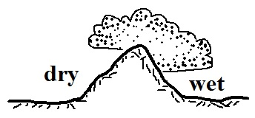
2. (10 pts) The term rainshadow refers to conditions on the WET DRY
side of the mountain in the picture at right. Would rising air motions
be found on the WET or DRY side of the mountain?

3. (5 pts) Which of the following is not a feature found on cumulonimbus clouds?
a. shelf cloud b. lenticular cloud c. anvil cloud d. mammatus cloud

4. (10 pts) Which two of the following are true?
a. ice crystals and water droplets at the same temperature evaporate at the same rate
b. clouds can be composed of ice crystals or water droplets but not a mixture of both
c. condensation nuclei are abundant, ice crystal nuclei are scarce
d. water droplets cooled to below freezing don't always freeze

5. (5 pts) The _______ will tell you how much water vapor is actually in the air.
a. relative humidity b. mixing ratio c. wet bulb temperature d. saturation mixing ratio

6. (10 pts) Adding particles (condensation nuclei) to the air should WORSEN IMPROVE the visibility and make any clouds that form MORE LESS reflective than they would be otherwise.
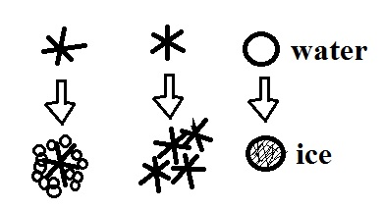
7. (5 pts) The formation of _______ is not shown in the figure at right.
a. graupel b. snow c. hail d. sleet

8. (5 pts) If you COOL WARM air enough you can remove moisture from it.

9. (5 pts) Use the table of saturation mixing ratio values at right to determine Tair r_{S}
the relative humidity of air with a temperature of 90º F, a mixing ratio of 90 F 30 g/kg
6 g/kg, and a dew point temperature of 60º F. 80 20
70 12
60 6
50 4

10. (10 pts) Haloes are produced by THIN THICK layer clouds that are composed of ICE crystals WATER droplets.

11. (5 pts) _______ is more likely when cloud bases are high and the air below the cloud is dry.
a. hail b. virga c. sleet d. snow e. graupel

12. (5 pts) The maximum amount of water vapor that can be found in air depends on the _______.
a. air temperature b. air density c. dew point d. air pressure
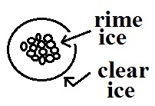
13. (5 pts) The precipitation particle shown at right is _______
a. graupel b. snow c. hail d. sleet

14. (5 pts) Which of the following doesn't belong in the same group as the other three?
a. graupel b. rime ice c. sleet d. milky white appearance

15. (10 pts) If you were to warm some moist air but didn't add or remove any water vapor, the _______ and the _______ would both remain constant.
a. saturation mixing ratio b. dew point c. relative humidity d. mixing ratio

16. (10 pts) Cirrostratus clouds are THINNER THICKER than altostratus clouds. Rain falling from nimbostratus clouds is usually HEAVIER LIGHTER than rain falling from cumulonimbus clouds.
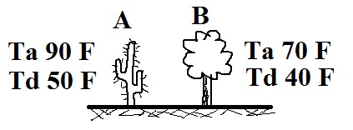
17. (10 pts) Based on the air and dew point temperature information
at right, City _______ has the highest relative humidity. The air
in _______ has the highest actual amount of water vapor.

18 (10 pts) Which two of the following are true of the collision-coalescence process?
a. works best shen the cloud droplets have different sizes
b. produces larger raindrops when the updrafts are strong
c. produces the electrical charge needed for lightning
d. produces most of the summer rain in Tucson

19. (5 pts) _______ is another name for a thunderstorm
a. Cumulonimbus b. Cumulus congestus c. Cirrocumulus d. Stratocumulus

20. (5 pts) What do meteorologists call the colored spots of light
sometimes seen to the right and left of the setting sun?

Extra Credit
1. (5 pts) One 200 µm diameter drop of drizzle has a volume that is _______ times larger than a 20 µm diameter cloud droplet.
a. 1,000,000 b. 100,000 c. 10,000 d. 1000 e. 100 f. 10

