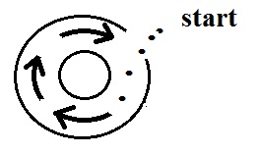
1. (10 pts) The direction of the initial motion in the figure at right (shown with dots) means this is a center of LOW HIGH pressure. The bending that occurs after
the wind starts to blow indicates this is a SOUTHERN NORTHERN hemisphere weather map.

2. (10 pts) Which of the following are true when there is no net force being exerted on an object.
a. the object could be changing direct but the speed of motion would be constant
b. the object could be stationary
c. the object could be moving in a straight line at constant speed
d. the object could be changing speed but would be moving in a straight line

3. (10 pts) You can ignore the _______ force when considering upper level winds. There is no _______ force at the equator. (fill in the blanks)
a. net b. pressure gradient c. Coriolis d. frictional

4. (10 pts) The top of a thunderstorm is normally POSITIVELY NEGATIVELY charged. Is it the COLLISIONS between precipitation particles or the FREEZING & MELTING of precipitation particles that produces electrical charge in thunderstorms?

5. (10 pts) The direction of the _______ force is always perpendicular to the wind. The _______ force is always perpendicular to the contours on a surface weather map. (fill in the blanks)
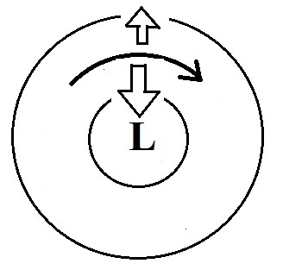
a. net b. pressure gradient c. Coriolis d. frictional

6. (10 pts) Is the inward pointing force in the figure at right
the PRESSURE GRADIENT or the CORIOLIS force?
Is this a NORTHERN or a SOUTHERN hemisphere map?

7. (10 pts) You will find clockwise surface winds blowing around _______. You would find rising air motions associated with surface winds blowing around _______. (fill in the blanks. L and H below stand for low and high pressure, NH and SH are northern & southern hemisphere respectively)

8. (5 pts) The _________________________ scale is used to rate tornado intensity.

9. (10 pts) Which two of the following statements are false?
a. the core of a tornado is always low pressure
b. a thin tilted tornado is usually stronger than a thick, vertically oriented
c. most tornadoes have spinning wind of 100 MPH or less
d. tornadoes are most frequent in the spring, the strongest occur in the fall

10. (5 pts) The leading edge of the cold downdraft air moving outward at the ground below a thunderstorm is called a _______.
a. squall line b. thermal circulation c. dry line d. gust front
11. (10 pts) Would a metal car be a SAFE or a DANGEROUS place to be during a lightning storm. Is it SAFE or DANGEROUS to use a cell phone during a thunderstorm?

12. (5 pts) Which of the following doesn't belong in the same group as the other three?
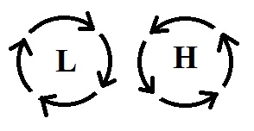
a. wall cloud b. hook echo c. gust front d. mesocyclone

13. (5 pts) The winds are blowing in a circular path at constant speed in
the two figures at right. The net force is _______.
a. inward with L, outward with H b. inward in both cases
c. zero in both cases d. in the direction of motion in both cases

14. (5 pts) The _______ is the first process in a negative cloud-to-ground lightning discharge.
a. dart leader b. upward discharge c. return stroke d. stepped leader

15. (5 pts) Generally the strongest and longest lived thunderstorm is one with a VERTICAL TILTED updraft.

16. (5 pts) _______ blow parallel to the contour lines.
a. Both surface and upper level winds b. Neither surface or upper level winds
c. Surface winds only d. Upper level winds only

EXTRA CREDIT
16. (5 pts) Increasing wind speed with increasing altitude is known as
a. a mesocyclone b. a microburst c an inversion d. wind shear

x. (5 pts) When winds blow from the ocean onto land you might expect an increase in the _______.
a. Coriolis force b. frictional force c. net force d. pressure gradient force

