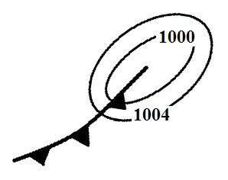
Quiz #2 Sect. 2

surface maps
x. (10 pts) The front shown in the figure is rotating
in a CLOCKWISE COUNTERCLOCKWISE direction
around a surface center of LOW HIGH pressure.

x. (5 pts) Isobars are contours of ALTITUDE PRESSURE TEMPERATURE.

x. (10 pts) Winds spin in a CLOCKWISE COUNTERCLOCKWISE direction spiral INWARD OUTWARD around surface centers of low pressure in the northern hemisphere.

x. (5 pts) Contour spacing on a surface weather map tells you whether the winds will be
a. rising or sinking b. hot or cold c. dry or moist d. fast or slow e. stable or unstable
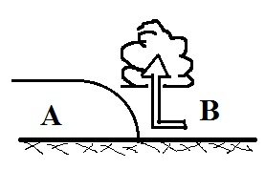
fronts
x. (15 pts) The figure at right is a cross sectional view of a WARM COLD
front. Air mass A is moving toward the RIGHT LEFT. Air mass B is
WARMER COLDER than air mass A.
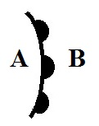
x. (10 pts) Is the front shown at right moving toward
POINT A or POINT B? Is the warmest air found
at POINT A or POINT B?

energy, temp, heat
7. (5 pts) The rapid motions of the atoms or molecules in a substance is
a. kinetic energy b. convection c. static electricity d. specific heat
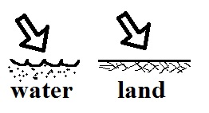
13. (5 pts) Equal amounts of energy are being added to equal amounts
\ of water and land in the figure at right. Will the water warm MORE LESS or about the SAME as the land?

19. (10 pts) Everything else being equal, the coldest winter temperatures would be found at a location surrounded by OCEAN LAND. The smallest annual range of temperatures would be found at a location surrounded by OCEAN LAND.

temperature scales
10. (10 pts) _____ in the list below is the hottest temperature and _____ is the coldest. (fill in the blanks)
a. 100º C b. 200º F c. 300º K

18. (5 pts) Temperatures never go below zero on the ____________________ scale.

conduction & convection
10. (5 pts) Metals often feel cold to the touch because metals have high
a. latent heat b. specific heat c. density d. thermal conductivity

14. (10 pts) A thin layer of air in contact with the ground will warm by _______. Once the air becomes warm it will start of rise and transport energy upward by _______. (fill in the blanks)
a. conduction b. convergence c. convection d. latent heat

latent heat
4. (5 pts) Water vapor carries _______ that is released when the water vapor condenses.
a. latent heat energy b. static electricity c. kinetic energy d. specific heat

21. (10 pts) Which two of the following phase changes would release energy.
a. water boiling b. water vapor condensing c. water freezing
d. dry ice subliming e. ice melting

x. (5 pts) The formation of frost is an example of a _______ phase change.
a. gas to solid b. solid to gas c. liquid to solid d. gas to liquid

EM radiation
2. (5 pts) The wavelength of peak emission (λ_{MAX}) for a tungsten bulb is 1 μm. Is this INFRARED VISIBLE or ULTRAVIOLET light.

2. (10 pts) Compared to visible light, infrared light has LONGER SHORTER wavelength and HIGHER LOWER energy.

rules
2. (5 pts) Wien's Law says that if an object warms the _______ will decrease.
a. wavelength of peak emission b. speed of propagation
c. intensity of emitted radiation d. radiative equilibrium temperature

9. (5 pts) The wavelength of peak emission (λ_{MAX} ) for _______ falls in the visible part of the spectrum.
a. the sun b. the earth c. both the earth and sun d. neither the earth nor sun

rad. equil.
5. (5 pts) The earth reflects about 30% of the sunlight striking it. If this increased to 40% would the earth's temperature of radiative equilbrium INCREASE DECREASE or remain the SAME.

filtering effect atmosphere
8. (15 pts) Most of the _________ in sunlight arriving at the earth never makes it to the ground because it is absorbed by gases in the atmosphere. The atmosphere absorbs and emits _________ light. Greenhouse gases absorb certain wavelengths of _________ light. (fill in each blank with UV for ultraviolet, VIS for visible, or IR for infrared)

greenhouse effect
20. (5 pts) Because of _______ the global annual average surface temperature on the earth is about 60º F instead of about 0º F.
a. free convection b. the tilt of the earth relative to its orbit around the sun
c. latent heat energy d. the greenhouse effect e. the high specific heat of water

3. (5 pts) Which of the following plays the most important role in the greenhouse effect?
a. reflection of incoming sunlight by clouds
b. absorption of ultraviolet light by gases in the stratosphere
c. absorption & emission of infrared light by the atmosphere
d. different rates of warming and cooling of land and water

Extra Credit (you can earn up to 10 pts)
21. (5 pts) _______ is(are) in energy balance in the figure at right.
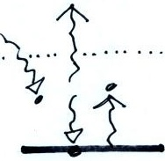
a. The atmosphere but not the ground b. Both the ground and atmosphere
c. The ground but not the atmosphere d. Neither the ground nor the atmosphere

x. (6 pts) Air expands when it RISES SINKS. Expanding air COOLS WARMS.

x. (6 pts) weather changes cold front

6. (5 pts) A thermometer outdoors reads 35º F on a day when the winds are calm. If the wind starts to blow will the temperature reading INCREASE DECREASE or remain the SAME

