Sect. 2
1. (5 pts) The maximum amount of water vapor that can be found in air depends on the _______.
a. air temperature b. air density c. dew point d. air pressure

2. (10 pts) Mixing ratio and _____ provide an idea of the actual amount of water vapor in the air. If you warm the air but don't add or remove any water vapor the _______ will decrease.
a. relative humidity b. saturation mixing ratio c. dew point d. air temperature

3. (5 pts) Foggy conditions mean the _______ is high.
a. dew point b. mixing ratio c. relative humidity
d. saturation mixing ratio e. air temperature f. air pressure

4. (5 pts) Determine the relative humidity for air with a dew point temperature of 55º F, a mixing ratio of 8 g/kg, a saturation mixing ratio of 16 g/kg, and an air temperature of 70º F.

5. (5 pts) If you COOL WARM air enough you can remove moisture from it
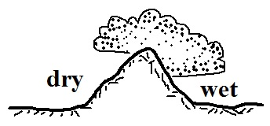
6. (10 pts) The term rain shadow refers to conditions on the WET DRY
side of the mountain in the picture at right. Would rising air motions
be found on the WET or DRY side of the mountain?

7. (5 pts) A combination of hot temperatures and ______________________________ makes it feel hotter than it really is.

8. (10 pts) During the cloud-in-a-bottle demonstration, the cloud formed when EXPANSION COMPRESSION caused the air in the flask to suddenly COOL WARM.

9. (15 pts) _______ is a high altitude cloud with a filamentary appearance. _______ is another name for a thunderstorm. A lumpy layer cloud found at low altitude would be called _______. (fill in the blanks)
a. cumulonimbus b. altocumulus c. nimbostratus
d. cumulus e. stratocumulus f. cirrus

10. (10 pts) _______ would be used to name a cloud producing precipitation. _______ would be used in a middle altitude cloud's name. (fill in the blanks)
a. nimbo b. strato c. alto d. cirro e. cumulo

11. (5 pts) Which of the following is not a feature found on cumulonimbus clouds?
a. shelf cloud b. lenticular cloud c. anvil cloud d. mammatus cloud
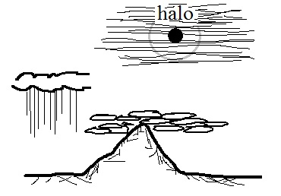
12. (10 pts) Which two of the following cloud types are shown
in the picture at right?
a. cumulonimbus b. altocumulus c. nimbostratus
d. cumulus e. stratus f. cirrostratus

13. (5 pts) Haloes are produced by thin layer clouds that are composed of ICE crystals WATER droplets.

14. (10 pts) Cirrostratus clouds are THINNER THICKER than altostratus clouds. The little patches of cloud in ALTOCUMULUS STRATOCUMULUS clouds are about the size of your thumbnail.

15. (10 pts) Which two of the following are true?
a. ice crystals and water droplets at the same temperature evaporate at the same rate
b. clouds can be composed of ice crystals or water droplets but not a mixture of both
c. condensation nuclei are abundant, ice crystal nuclei are scarce
d. water droplets cooled to below freezing don't always freeze

16. (10 pts) Which two of the following are true of the collision-coalescence process?
a. works best shen the cloud droplets have different sizes
b. produces larger raindrops when the updrafts are strong
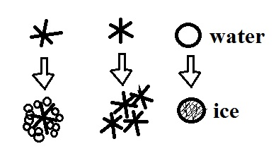
c. produces the electrical charge needed for lightning
d. produces most of the summer rain in Tucson

17. (5 pts) The formation of _______ is not shown in the figure at right.
a. graupel b. snow c. hail d. sleet

18. (5 pts) _______ is more likely when cloud bases are high and the air below the cloud is dry.
a. hail b. virga c. sleet d. snow e. graupel
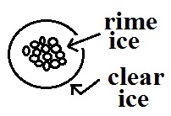
19. (5 pts) The precipitation particle shown at right is _______
a. graupel b. snow c. hail d. sleet

20. (5 pts) Which of the following doesn't belong in the same group as the other three?
a. graupel b. rime ice c. sleet d. milky white appearance

21. (5 pts) Virga is rain that MELTS EVAPORATES CONDENSES FREEZES before reaching the ground.

Extra credit (you can earn up to 10 pts)
1. (5 pts) One 200 µm diameter drop of drizzle has a volume that is _______ times larger than a 20 µm diameter cloud droplet.
a. 1,000,000 b. 100,000 c. 10,000 d. 1000 e. 100 f. 10
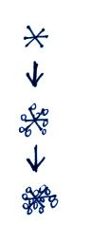
2. (5 pts) An ice storm is generally associated with which of the following types of precipitation?
a. hail b. sleet c. snow d. graupel e. freezing rain

3. (5 pts) An ice crystal falling through a cloud is colliding with supercooled
water droplets. They stick and freeze to the crystal. This process is called
a. riming or accretion b. collision and coalescence
c. condensation and deposition d. convection and convergence

