ATMO 170 Sect. 3 Name______________________________________
Quiz #1 Sep. 28, 2017 (please also put your name on the back)

1. (10 pts) Which two of the following react to form Los Angeles-type (photochemical) smog?
a. ozone b. hydrocarbons c. carbon monoxide d. acid rain
e. water vapor f. carbon dioxide g. argon h. nitrogen

2. (5 pts) On the earth two objects that have the same weight must have the same _______.
a. density b. volume c. composition d. mass

3. (5 pts) Pressure from the air surrounding an air parcel pushes against the top, bottom and sides of the parcel. Is the overall effect of this a net UPWARD force, a net DOWNWARD force or ZERO net force?

4. (5 pts) Low visibility would most likely indicate high _______ concentration in the air.
a. greenhouse gas b. carbon monoxide c. chlorofluorocarbon d. particulate matter

5. (10 pts) An increase of air DENSITY PRESSURE TEMPERATURE HUMIDITY with increasing altitude is called an inversion and produces STABLE UNSTABLE atmospheric conditions. (circle one word in each group)
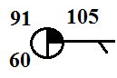
6. (15 pts) According to the data shown at right the temperature is WARMER COLDER than 100º F. Is 60 the value of the DEW POINT or the RELATIVE HUMIDITY?
Is MORE or LESS than half of the sky covered with clouds?

7. (10 pts) Air expands when it RISES SINKS. Expanding air COOLS WARMS

8. (10 pts) _______ is found in London-type smog. _______ can react with water in clouds to form acid rain [fill in each blank with O₃(ozone), SO₂(sulfur dioxide) or CO(carbon monoxide)

9. (10 pts) Carbon dioxide and _______ are the two main greenhouse gases. About 20% of air is _______. (fill in the blanks)
a. ozone (O₃) b. carbon dioxide (CO₂) c. water vapor (H₂O)
d. nitrogen (N₂) e. oxygen (O₂) f. argon (Ar)

10. (10 pts) In which two of the following cases would it be possible for the pressure in a balloon to remain constant? (N = number of air molecules, T = temperature, V = volume, ρ = density)
a. increasing N & increasing T b. decreasing T & decreasing ρ
c. increasing T & increasing V d. decreasing N & decreasing V

11. (15 pts) Isobars are contours of PRESSURE ALTITUDE TEMPERATURE. Winds spin in a COUNTERCLOCKWISE CLOCKWISE direction and spiral INWARD OUTWARD around surface centers of low pressure.

12. (5 pts) Air _______ with increasing altitude.
a. pressure & density both decrease b. pressure decreases & density increases
c. pressure increases & density decreases d. pressure & density both increase
Name______________________________________

13. (5 pts) If you warm or cool a parcel of air in the atmosphere the
DENSITY PRESSURE TEMPERATURE VOLUME will remain the same.

14. (5 pts) Closely spaced isobars on a surface weather map would probably indicate
a. fast winds b. convergence c. a weak pressure gradient d. rising air and clouds

15. (5 pts) Chlorofluorocarbons (CFCs) are involved in the
a. production of acid rain b. production of London type smog
c. production of Los Angeles type smog d. destruction of stratospheric ozone

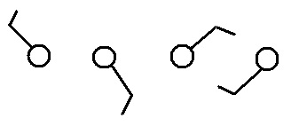
16. (20 pts) The TROPOSPHERE STRATOSPHERE is the lowest layer in the atmosphere. The flat top of a thunderstorm (the anvil) often marks the top of the TROPOSPHERE STRATOSPHERE. Air temperature increases with increasing altitude in the TROPOSPHERE STRATOSPHERE. The ozone layer is found in the TROPOSPHERE STRATOSPHERE.

17. (5 pts) Circle the figure at right that shows winds blowing from
the northwest.

18. (5 pts) Inches of mercury are units of
a. pressure b. volume c. density d. temperature e. concentration f. weight

19. (5 pts) A malfunctioning hot water heater or gas furnace in your home could lead to a deadly buildup of ___________________________________ a colorless, odorless, toxic gas.
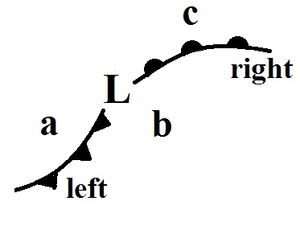
20. (15 pts) The front shown at left in the figure is a WARM COLD front.
Is the front on the right moving TOWARD or AWAY from point c? The
air at point b is probably the WARMEST COLDEST in the picture.

21. (5 pts) Photosynthesis is the source of most of the _______ in our present day atmosphere.
a. carbon dioxide b. hydrogen c. oxygen d. nitrogen e. water vapor

22. (10 pts) A parcel of warm air will rise because the DENSITY PRESSURE of the air inside the parcel is HIGHER LOWER than that of the surrounding air.

Extra Credit (you can earn up to 10 pts)
1. (5 pts) The atmospheric concentration of _______ can range from near 0% up to 3 or 4%.
a. water vapor b. carbon dioxide c. ozone d. oxygen e. argon

2. (5 pts) For clouds to form you must cool moist air to ______________________________

3. (5 pts) Sea level pressure normally falls in the range
a. 900 to 1000 mb b. 950 to 1050 mb c. 750 to 950 mb d. 500 to 1500 mb

4. (5 pts) The concentration of ozone the pollutant peaks in SUMMER SPRING WINTER FALL.

Students may use the following two equations on this quiz

P = N k T / V & P = ρ R T

