ATMO 170 Sect. 3 Name______________________________________
Quiz #2 Oct. 19, 2017 (please also put your name on the back)

1. (15 pts) 212º is the boiling point of water on the ______ scale. 0º is the freezing point of water (also the melting point of ice) on the _______ scale. 300º is a good global average temperature value for the earth on the _______ scale. (fill in each blank with Celsius, Fahrenheit, Kelvin or Richter)

2. (10 pts) Energy is released into the surroundings when which two of the following occur?
a. water evaporate b. frost forms c. ice melts d. water vapor condenses

3. (5 pts) The earth and sun have different wavelengths of peak emission because they have different
a. temperatures b. volumes c. compositions d. masses

4. (5 pts) Which of the following plays the most important role in the greenhouse effect?
a. reflection of sunlight by clouds b. absorption & emission of infrared light by the atmosphere
c. rates of warming and cooling of land and water d. absorption of UV light by gases in the stratosphere

5. (5 pts) An object that feels cold to the touch probably has _______.
a. low specific heat b. low thermal conductivity
c. high specific heat d. high thermal conductivity

6. (15 pts) Greenhouse gases absorb and emit _________ light. Ozone and oxygen make the atmosphere pretty nearly completely opaque to _________ light. The atmosphere is pretty nearly completely transparent to _________ light. [fill in each blank with VIS(visible), UV (ultraviolet) or IR(infrared)]

7. (5 pts) The earth reflects about 30% of the sunlight that strikes it. If this increased to 40% would the earth's temperature of radiative equilibrium INCREASE DECREASE or remain the SAME?

8. (10 pts) You could measure the amount of energy flowing into or out of an object by measuring the temperature change that occurs and knowing the _______ and the _______ of the object.
a. mass b. volume c. conductivity d. specific heat e. density

9. (5 pts) Wien’s Law says that if an object warms the _______ will decrease.
a. wavelength of peak emission b. speed of propagation
c. intensity of emitted radiation d. radiative equilibrium temperature

10. (5 pts) Because of _______the average surface temperature on the earth is about 60º F instead of 0º F.
a. free convection b. latent heat energy c. the greenhouse effect
d. high specific heat of water e. the tilt of the earth relative to its orbit around the sun

11. (5 pts) In order for air to transport "hidden" latent heat energy the air must contain
a. electric charge b. kinetic energy c. greenhouse gases d. water vapor

12. (10 pts) Energy transport by convection can occur in which two of the following?
a. solids b. gases c. empty space d. liquids
Name_________________________________________

13. (15 pts) Clouds are good ABSORBERS REFLECTORS of far-infrared light and good ABSORBERS REFLECTORS of visible light. The difference between daytime high and nighttime low temperatures on a cloudy day will be GREATER LESS EQUAL than(to) the difference on a clear day.

14. (5 pts) _______ of radiant energy emitted by an object depends on the object's temperature.
a. The amount b. The kind c. Both the kind & amount d. Neither the kind nor the amount

15. (10 pts) Green light has LONGER SHORTER wavelength and is a MORE LESS energetic form of radiation than orange light.
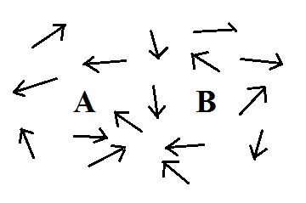
16. (5 pts) Energy transported from A to B in the figure at right
by the random motions of the atoms or molecules is
a. convection b. conduction c. convergence
d. EM radiation e. buoyancy f. latent heat

17. (10 pts) A coastal city will have a more moderate climate than a city located further inland. By moderate we mean the coastal city will have COLDER WARMER winters and COOLER HOTTER summers.

18. (5 pts) How is it possible for the surface of the earth to emit more energy than it gets from the sun and still be in energy balance?

19. (5 pts) If you place a cup of liquid nitrogen in a room it will CONDENSE FREEZE SUBLIME EVAPORATE.

20. (5 pts) A thermometer outdoors reads 35º F on a day when the winds are calm. If the wind starts to blow will the temperature reading DECREASE remain the SAME or INCREASE.

21. (5 pts) The wavelength of peak emission (λ_{MAX}) for a tungsten bulb is 1 µm. Is this INFRARED VISIBLE or ULTRAVIOLET light?

Extra credit (you can earn up to 10 pts)
1. (6 pts) Sunlight is _______. EM radiation emitted by the earth is _______. (fill in the blanks)
a. essentially all IR radiation b. mostly VIS & IR with a little UV radiation
c. mostly UV & VIS with a little IR radiation d. essentially all VIS radiation
2. (5 pts) Most of the sunlight arriving at the top of the atmosphere
a. passes through the air and gets absorbed by the ground b. is absorbed by ozone
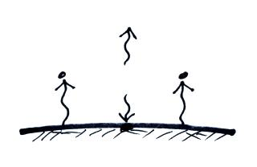
c. is absorbed by greenhouse gases d. is reflected back into space

3. (5 pts) Which is(are) in energy balance in the picture at right?
a. the atmosphere but not the ground b. the ground but not the atmosphere
c. neither the ground not the atmosphere d. both the ground and the atmosphere
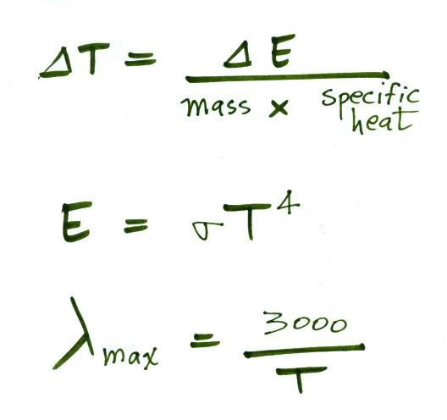
Here are some equations that might help with some of the questions on this quiz

