ATMO 170A1 Sect. 3 Name_______________________________
Final Exam Tue., Dec. 13, 2016

You may refuse to answer one question on this exam. Simply write refuse next to the question of your choice and you will receive full credit for that question. Choose wisely. Each answer on this exam is worth 1 pt. A question with two parts is worth 2 pts, a question with 3 parts is worth 3 pts., etc.

1. The atmosphere mostly absorbs __________ radiation, transmits __________ radiation and emits __________ radiation. [fill in each blank with UV(ultraviolet), VIS(visible) or IR(infrared); each answer should be used once]

Q2_14 Which of the temperatures at right is the a. 100º F b. 100º C c. 0º F
coldest _______, the hottest ______, the d. 0º C e. 200º F f. 300º K
melting point of ice ______. (fill in the blanks)

Q1_1 Nitrogen and _______ are the most abundant gases in air. Carbon dioxide and _______ are greenhouse gases. (fill in the blanks)
a. nitrogen b. oxygen c. water vapor d. argon e. carbon dioxide f. hydrogen

4. The terms millibars, barometer, and isobar all have something to do with _________.
a. air pressure b. air density c. air temperature d. water vapor concentration

H15. The strong ring of thunderstorms surrounding the eye of a hurricane is called the
a. wall cloud b. eye wall c. mesocyclone d. ring cloud
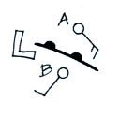
Q2_10 Would the coldest air be found at POINT A or POINT B?
Is the front moving toward POINT A or POINT B? Does the figure
show a WARM or COLD front?

Q1_12 The lowest layer in the atmosphere is the _______. The _______ is always a very stable layer. Temperature increases with increasing altitude in the _______ between 20 and 50 km altitude. Most of the water vapor, clouds, and weather are found in the _______. (fill in the blanks with Troposphere or Stratosphere)
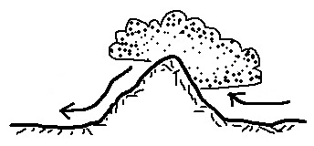
Q3_8 Water vapor is being removed from the air on the
LEFT RIGHT side of the mountain in the picture at right.
The rain shadow is on the LEFT RIGHT side of the mountain.

9. High concentrations of _______ is part of what made the Great London Smog of 1952 so deadly (4000 people died in a one week period)
a. carbon dioxide b. chlorofluorocarbons c. ozone d. sulfur dioxide

10. A city on a sea coast will usually have COLDER WARMER winters and COLDER WARMER summers than a city that is located further inland and surrounded by land.

H9. Which of the following doesn’t belong in the same group as the other three?
a. hurricane b. tsunami c. typhoon d. cyclone

12. Four processes that cause rising air motions were mentioned in class. Name two of them
13. The sky is often a deep blue color after a rain storm. This is because the clouds and rain did a good job of removing _______ from the air.
a. ozone b. carbon monoxide c. sulfur dioxide d. particulate matter

Q4_14 A cloud of dust moving outward from underneath a thunderstorm is a
a. gust front b. wall cloud c. squall line d. dry line

15. Clouds are good absorbers and emitters of infrared (IR) radiation. This explains why DAYTIME NIGHTTIME temperatures on a cloudy day will usually be COOLER WARMER than on a clear day.

PQ4. A(n) INCREASE DECREASE of air DENSITY PRESSURE TEMPERATURE with increasing altitude is called an inversion and produces stable atmospheric conditions.

H7. The air in the eye of a hurricane is clear because
a. the air is dry b. the winds are calm c. the pressure is low d. the air is sinking

18. Air in the atmosphere obeys Charles' Law which means that if you warm a volume of air the DENSITY PRESSURE VOLUME will increase in order for the DENSITY PRESSURE VOLUME to stay constant.

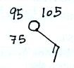
19. A combination of cold and ____________________ can make it feel colder than it really is. A combination of heat and ____________________ can make it feel hotter than it really is

F52. A temperature of 75 95 105 degrees
Fahrenheit is plotted at right.
The wind is blowing from the SE SW NW NE

21. Infrared (IR) light is a HIGHER LOWER energy form of radiation and has LONGER SHORTER wavelength than visible light.

22. Incomplete combustion of fossil fuels produces _______, a colorless, odorless, toxic gas. In clouds _______ reacts with water to make acid rain. (fill in the blanks)
a. ozone b. sulfur dioxide c. radon d. carbon monoxide e. argon

F33. The _______ scale is used to rate tornado strength or damage potential. The _______ scale is used to rate hurricane intensity. (fill in the blanks)
a. Beaufort b. Fujita c. Kelvin d. Richter e. Saffir Simpson

F4. A mesocyclone will produce which of the following thunderstorm features?
a. anvil cloud b. mammatus clouds c. wall cloud d. gust front
F11. The _______ of an object depends on the object's mass and on gravity. The density of an object depends on the object's mass and on its _______. (fill in the blanks)
a. area b. density c. gravity d. volume e. weight f. pressure

26. It feels colder on a windy day than on a day without wind because of energy transport
by _______. 70º F water feels colder than 70º air because of energy transport by _______. In hot dry weather the cooling that your body is able to produce by perspiration is energy transport by _______. (fill in the blanks)
a. conduction b. convection c. latent heat d. electromagnetic radiation

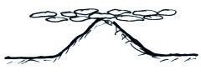
27. Is the cloud sketched at right a HIGH or LOW altitude
CUMULUS, STRATOCUMULUS, or STRATUS cloud

F25. The main benefit of the greenhouse effect is to
a. absorb harmful ultraviolet radiation
b. provide nutrients needed by growing plants
c. increase global average surface temperatures
d. transport water from the oceans to the land

Q4_16 When an object is moving in a circular path at constant speed, the net force _______.
a. points inward b. points outward c. is zero d. points in the direction of motion

x. The flat top of a thunderstorm is called a(n) ____________________ cloud.

Q4_3 Would an automobile with a METAL or a PLASTIC body provide the best protection from lightning? Is it SAFE or DANGEROUS to use a cell phone during a lightning storm?

H5. Moving over colder water would WEAKEN STRENGTHEN a hurricane. When a hurricane moves over land the strength of the frictional force will INCREASE DECREASE and the hurricane winds will blow FASTER SLOWER.

31. “An object immersed in a fluid will experience an upward buoyant force equal to the weight of the displaced fluid” is a law postulated by
a. Coriolis b. Newton c. Archimedes d. Galileo e. Fujita

32. The _______ force causes winds to spin in opposite directions around low pressure in the northern and southern hemispheres.
a. Coriolis b. frictional c. gravitational d. pressure gradient

PQ19 The dew point temperature tells you whether the air is _______.
a. dry or moist b. stable or unstable c. clean or polluted d. hot or cold
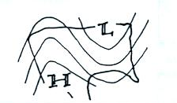
f17. A RIDGE TROUGH covers the western United States
on the upper level chart at right. You would expect to find
WARMER COLDER than normal conditions in the west.

35. A seasonal shift in the direction of the prevailing winds is a(n) _____________________.
36. Chlorofluorocarbons (CFCs) are of concern in the atmosphere because they
a. react in clouds to make acid rain b. are colorless, odorless, and toxic
c. destroy stratospheric ozone d. react with ozone to make photochemical smog

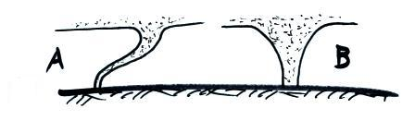
37. What comes earlier in a tornado life cycle, a tornado
like that shown in FIG. A or in FIG. B? The tornado
in Fig. A would probably be STRONGER WEAKER
than the tornado in Fig. B.

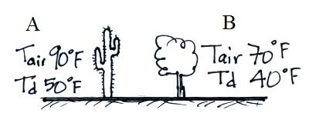
38. A piece of dry ice placed in a warm room will slowly disappear because of DEPOSITION MELTING EVAPORATION SUBLIMATION. The formation of frost is an example of FREEZING DEPOSITION CONDENSATION EVAPORATION. When a piece of ice melts does it TAKE energy from or RELEASE energy into the surrounding air.

39. Based on the information shown in the figure at right,
City _______ has the highest relative humidity. City _______
has the highest actual amount of water vapor in the air

40. Which of the precipitation particles below has alternating layers of clear ice and rime ice?
a. hail b. sleet c. snow d. graupel e. freezing rain
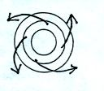

F10. The surface winds at right are CONVERGING DIVERGING.
These winds are produced by a center of HIGH LOW pressure
in the NORTHERN SOUTHERN hemisphere. Would these
winds produce RISING or SINKING air motions?

F8. _______ below tells you a cloud is producing precipitation. _______ and _______ tell you something about a cloud's altitude. (fill in the blanks)
a. alto b. cirro c. cumulo d. nimbo e. strato

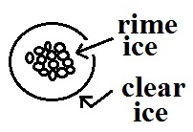
Q3_12 The precipitation particle sketch at right is
a. snow b. graupel c. sleet d. hail

43. Which one of the following does not belong together in the same ground as the other three?
a. rising air b. clear skies c. converging winds d. surface low pressure
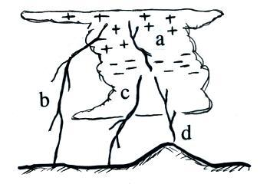

44. _______ lightning shown in the figure at right is the most
common type of lightning. The rarest type of lightning
discharge is _______ lightning. (fill in the blanks)
a. intracloud b. positive cloud to ground
c. negative cloud to ground d. upward

45. Water vapor carries _______ energy that is released when a cloud forms.
a. infrared b. kinetic c. latent heat d. electrostatic

Q2_20 Calories are units of _________________________.

H8. A rise in ocean levels along a coastline caused by an approaching hurricane
a. rip tide b. easterly wave c. storm surge d. tsunami

Q3_16 _______ is a high altitude cloud with a filamentary appearance. _______ is another name for a thunderstorm. A middle level layer cloud with patches of cloud about the size of your thumb nail would be called _______. (fill in the blanks)
a. cumulonimbus b. altocumulus c. nimbostratus
d. cumulus e. stratocumulus f. cirrus

48. Both the kind (wavelength) and amount of electromagnetic radiation emitted by an object depend mainly on the object’s
a. mass b. temperature c. volume d. density e. composition
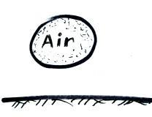
F41. If the air in the parcel at right is warmer than the surrounding air, the parcel will RISE SINK because the DENSITY PRESSURE of the air
inside the parcel is HIGHER LOWER than that of the surrounding air.

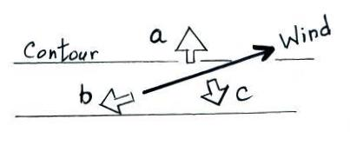
50. Tornado winds always spin around a core of LOW HIGH pressure. The spinning winds in most tornadoes are MORE LESS than 100 MPH. The strongest tornadoes form in the SUMMER SPRING WINTER FALL.

51. Identify the three forces shown in the figure at right.
Frictional force _______ Coriolis force_______
Pressure gradient force_______

PQ1. Most of the _______ in our atmosphere is thought to have come from photosynthesis.
a. nitrogen b. carbon dioxide c. water vapor d. oxygen e. argon

F40. Match each of the four processes below with a a. rain b. graupel
particle or type of precipitation from the list at right. c. sleet d. virga
evaporation_______ melting_______
riming_______ freezing _______

Q1_21 Air _______ always decrease with increasing altitude.
a. density and temperature b. pressure and density c. pressure and temperature

55. Isobars are contours of PRESSURE TEMPERATURE. Counterclockwise spinning winds are found around surface HIGH LOW pressure centers in the northern hemisphere. Rising air expands and COOLS WARMS.
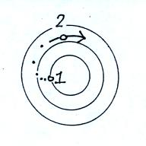

F27. Use the initial (pt. 1) and final (pt. 2) wind motions in
the figure at right to answers the following questions.
Is this a surface of HIGH or LOW pressure? Is this
a SURFACE or UPPER LEVEL chart? Is this a
NORTHERN or SOUTHERN hemisphere map?

_____________________________________________________________________________

Every semester there are a few students that end up just below the threshold between two grades. I find that a subset of these students didn’t complete all the required coursework. If it looks like making up the missing work would raise a student’s overall average enough for me to be able to bump them up a letter grade, I would like to be able to give them an incomplete so that they have the opportunity and extra time to make up the missing work. But I can’t really do that without checking with them first.

_______ Check here to give me permission to give you an incomplete if circumstances warrant

_______ Check here is you DO NOT WANT under any circumstances to be given an incomplete.

An incomplete means that you don’t immediately receive a grade for this class (an I appears on your transcripts). Once you’ve completed the missing work you receive a grade. You have up to one year to make up an incomplete (though I would suggest you get it done as soon as possible)

Equations that might be of help on this exam

