ATMO 170A1 Sect. 3 Name_______________________________
Final Exam Tue., Dec. 13, 2016

You may refuse to answer one question on this exam. Simply write refuse next to the question of your choice and you will receive full credit for that question. Choose wisely. Each answer on this exam is worth 1 pt. A question with two parts is worth 2 pts, a question with 3 parts is worth 3 pts., etc.

1. The atmosphere transmits __________ radiation, emits __________ radiation and mostly absorbs __________ radiation. [fill in each blank with UV(ultraviolet), VIS(visible) or IR(infrared); each answer should be used once]

2. Which of the temperatures at right is the a. 0º F b. 0º C c. 100º F
coldest _______, the hottest ______, the melting d. 100º C e. 200º F f. 300º K
point of ice ______. (fill in the blanks)

3. The _______ of an object depends on the object's mass and on gravity. The density of an object depends on the object's mass and on its _______. (fill in the blanks)
a. area b. gravity c. volume d. weight e. pressure f. density

4. When an object is moving in a circular path at constant speed, the net force _______.
a. points outward b. points inward c. is zero d. points in the direction of motion

5. A mesocyclone will produce which of the following thunderstorm features?
a. wall cloud b. mammatus clouds c. anvil cloud d. gust front
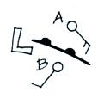
6. Would the warmest air be found at POINT A or POINT B?
Is the front moving toward POINT A or POINT B? Does the figure
show a COLD or WARM front?

7. The _______ is always a very stable layer. Temperature increases with increasing altitude in the _______ between 20 and 50 km altitude. Most of the water vapor, clouds, and weather are found in the _______. The lowest layer in the atmosphere is the _______. (fill in the blanks with Troposphere or Stratosphere)
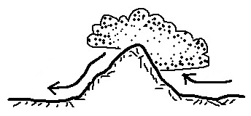
8. Water vapor is being removed from the air on the
RIGHT LEFT side of the mountain in the picture at right.
The rain shadow is on the RIGHT LEFT side of the mountain.

9. The _______ force causes winds to spin in opposite directions around low pressure in the northern and southern hemispheres.
a. Coriolis b. frictional c. gravitational d. pressure gradient

10. Is it DANGEROUS or SAFE to use a cell phone during a lightning storm? Would an automobile with a METAL or a PLASTIC body provide the best protection from lightning?

11. A cloud of dust moving outward from underneath a thunderstorm is a
a. wall cloud b. gust front c. squall line d. dry line

12. Four processes that cause rising air motions were mentioned in class. Name two of them

13. _______ below tells you a cloud is producing precipitation. _______ and _______ tell you something about a cloud's altitude. (fill in the blanks)
a. cumulo b. nimbo c. strato d. alto e. cirro

14. Which of the following doesn’t belong in the same group as the other three?
a. hurricane b. cyclone c. typhoon d. tsunami

15. Visible light is a HIGHER LOWER energy form of radiation and has LONGER SHORTER wavelength than Infrared (IR) light.

16. A rise in ocean levels along a coastline caused by an approaching hurricane
a. rip tide b. storm surge c. tsunami d. easterly wave

17. Air in the atmosphere obeys Charles' Law which means that if you warm a volume of air the PRESSURE VOLUME DENSITY will increase in order for the PRESSURE VOLUME DENSITY to stay constant.

18. A combination of cold and ____________________ can make it feel colder than it really is. A combination of heat and ____________________ can make it feel hotter than it really is
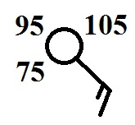
19. A temperature of 75 95 105 degrees
Fahrenheit is plotted at right.
The wind is blowing from the NE NW SW SE

20. A(n) DECREASE INCREASE of air TEMPERATURE PRESSURE DENSITY with increasing altitude is called an inversion and produces stable atmospheric conditions.

21. The dew point temperature tells you whether the air is _______.
a. hot or cold b. stable or unstable c. clean or polluted d. dry or moist

22. Incomplete combustion of fossil fuels produces _______, a colorless, odorless, toxic gas. In clouds _______ reacts with water to make acid rain. (fill in the blanks)
a. ozone b. carbon monoxide c. radon d. sulfur dioxide e. argon

23. The _______ scale is used to rate hurricane intensity. The _______ scale is used to rate tornado strength or damage potential. (fill in the blanks)
a. Beaufort b. Fujita c. Kelvin d. Richter e. Saffir Simpson

24. The strong ring of thunderstorms surrounding the eye of a hurricane is called the
a. ring cloud b. wall cloud c. mesocyclone d. eye wall

25. Nitrogen and _______ are the most abundant gases in air. Carbon dioxide and _______ are greenhouse gases. (fill in the blanks)
a. nitrogen b. hydrogen c. carbon dioxide d. argon e. water vapor f. oxygen

26. _______ is a high altitude cloud with a filamentary appearance. _______ is another name for a thunderstorm. A middle level layer cloud with patches of cloud about the size of your thumb nail would be called _______. (fill in the blanks)
a. cumulus b. stratocumulus c. cirrus
d. cumulonimbus e. altocumulus f. nimbostratus

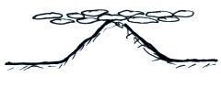
27. Is the cloud sketched at right a LOW or HIGH altitude
STRATUS, STRATOCUMULUS, or CUMULUS cloud.

28. The main benefit of the greenhouse effect is to
a. absorb harmful ultraviolet radiation
b. transport water from the oceans to the land
c. provide nutrients needed by growing plants
d. increase global average surface temperatures

29. The terms millibars, barometer, and isobar all have something to do with _________.
a. air temperature b. air density c. air pressure d. water vapor concentration

30. A seasonal shift in the direction of the prevailing winds is a(n) _____________________.

31. A city on a sea coast will usually have COOLER WARMER summers and COLDER WARMER winters than a city that is located further inland and surrounded by land.

32. Tornado winds always spin around a core of HIGH LOW pressure. The spinning winds in most tornadoes are LESS MORE than 100 MPH. The strongest tornadoes form in the SPRING SUMMER FALL WINTER.

33. Both the kind (wavelength) and amount of electromagnetic radiation emitted by an object depend mainly on the object’s
a. mass b. composition c. volume d. density e. temperature

34. High concentrations of _______ is part of what made the Great London Smog of 1952 so deadly (4000 people died in a one week period)
a. sulfur dioxide b. ozone c. chlorofluorocarbons d. carbon dioxide

35. Air _______ always decrease with increasing altitude.
a. pressure and density b. pressure and temperature c. density and temperature

36. Chlorofluorocarbons (CFCs) are of concern in the atmosphere because they
a. are colorless, odorless, and toxic b. destroy stratospheric ozone
c. react with ozone to make photochemical smog d. react in clouds to make acid rain
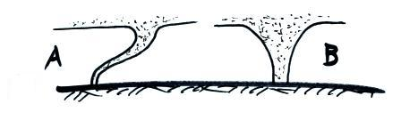
37. What comes earlier in a tornado life cycle, a tornado
like that shown in FIG. A or in FIG. B? The tornado
in Fig. A would probably be STRONGER WEAKER
than the tornado in Fig. B.

38. A piece of dry ice placed in a warm room will slowly disappear because of DEPOSITION SUBLIMATION MELTING EVAPORATION . The formation of frost is an example of CONDENSATION EVAPORATION FREEZING DEPOSITION. When a piece of ice melts does it TAKE energy from or RELEASE energy into the surrounding air.

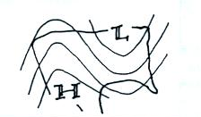
39. Calories are units of _________________________.

40. A RIDGE TROUGH covers the western United States
on the upper level chart at right. You would expect to find
WARMER COLDER than normal conditions in the west.
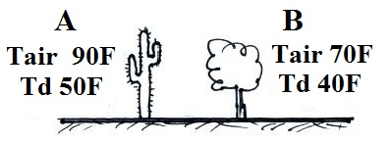
41. Based on the information shown in the figure at right,
City _______ has the highest actual amount of water vapor
in the air. City _______ has the highest relative humidity.

42. The surface winds at right are CONVERGING DIVERGING.
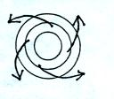
These winds are produced by a center of HIGH LOW pressure
in the NORTHERN SOUTHERN hemisphere. Would these
winds produce RISING or SINKING air motions?

43. The sky is often a deep blue color after a rain storm. This is because the clouds and rain did a good job of removing _______ from the air.
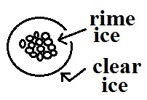
a. ozone b. carbon monoxide c. sulfur dioxide d. particulate matter

44. The precipitation particle sketch at right is
a. graupel b. hail c. sleet d. snow

45. Which one of the following does not belong together in the same ground as the other three?
a. rising air b. converging winds c. surface low pressure d. clear skies
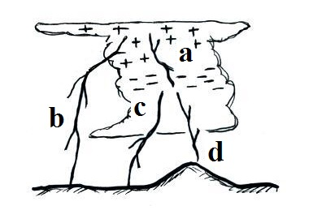

46. The rarest type of lightning shown in the figure at right is _______ lightning. _______ lightning is the most common
type of lightning. (fill in the blanks)
a. intracloud b. positive cloud to ground
c. negative cloud to ground d. upward

47. Water vapor carries _______ energy that is released when a cloud forms.
a. latent heat b. kinetic c. infrared d. electrostatic

48. The flat top of a thunderstorm is called a(n) ____________________ cloud.

49. The air in the eye of a hurricane is clear because
a. the air is dry b. the air is sinking c. the winds are calm d. the pressure is low

50. It feels colder on a windy day than on a day without wind because of energy transport
by _______. 70º F water feels colder than 70º air because of energy transport by _______. In hot dry weather the cooling that your body is able to produce by perspiration is an example of _______energy transport. (fill in the blanks)
a. convection b. latent heat c. conduction d. electromagnetic radiation

51. “An object immersed in a fluid will experience an upward buoyant force equal to the weight of the displaced fluid” is a law postulated by
a. Archimedes b. Coriolis c. Fujita d. Galileo e. Newton
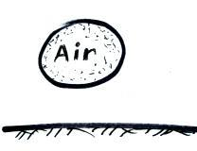
52. If the air in the parcel at right is warmer than the surrounding air, the parcel will RISE SINK because the DENSITY PRESSURE of the air
inside the parcel is HIGHER LOWER than that of the surrounding air.
.
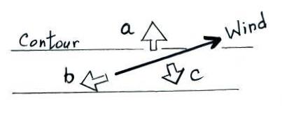
53. Identify the three forces shown in the figure at right.
Coriolis force _______ Frictional force_______
Pressure gradient force_______

54. Moving over colder water would WEAKEN STRENGTHEN a hurricane. When a hurricane moves over land the strength of the frictional force will INCREASE DECREASE and the hurricane winds will blow FASTER SLOWER.

55. Most of the _______ in our atmosphere is thought to have come from photosynthesis.
a. oxygen b. carbon dioxide c. water vapor d. nitrogen e. argon

56. Match each of the four processes below with a a. rain b. graupel
particle or type of precipitation from the list at right. c. sleet d. virga
riming_______ freezing _______
evaporation_______ melting_______

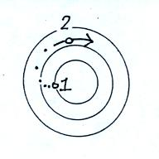
57. Isobars are contours of PRESSURE TEMPERATURE. Counterclockwise spinning winds are found around surface HIGH LOW pressure centers in the northern hemisphere. Rising air expands and COOLS WARMS.

58. Use the initial (pt. 1) and final (pt. 2) wind motions in
the figure at right to answers the following questions.
Is this a surface of HIGH or LOW pressure? Is this a
NORTHERN or SOUTHERN hemisphere map?

_____________________________________________________________________________________

Every semester there are a few students that end up just below the threshold between two grades. I find that a subset of these students didn’t complete all the required coursework. If it looks like making up the missing work would raise a student’s overall average enough for me to be able to bump them up a letter grade, I would like to be able to give them an incomplete so that they have the opportunity and extra time to make up the missing work. But I can’t really do that without checking with them first.

_______ Check here to give me permission to give you an incomplete if circumstances warrant

_______ Check here is you DO NOT WANT under any circumstances to be given an incomplete.

An incomplete means that you don’t immediately receive a grade for this class (an I appears on your transcripts). Once you’ve completed the missing work you receive a grade. You have up to one year to make up an incomplete (though I would suggest you get it done as soon as possible)

Equations that might be of help on this exam

