ATMO 170 In-class Optional Assignment Name_______________________________
Oct. 10, 2017

1. Water is a liquid, soil a solid. Water has a HIGHER LOWER specific heat than soil. Water is a liquid, air a gas. Water has a HIGHER LOWER thermal conductivity than air.

2. Ocean currents transport energy from the warm tropics to colder waters at polar latitudes. This is an example of which energy transport process?

3. Energy added to water could be used to_____________________ or ___________________ the water.

4. The atoms in a hot object have a lot of _______. Copper has high _______. Cold air sinks because it has _______. Water vapor contains a lot of hidden _______. (fill in the blanks with one of the choices below, each answer below should be used once)
a. kinetic energy b. density c. thermal conductivity d. latent heat

5. Convergence and convection are
two of the processes that cause____________________________________________
Conduction and convection are
two of the processes that_________________________________________________

6. The kinetic energy of an object depends on its mass and on its __________________

7. The formation of frost on a cold morning is an example of _______. A bathroom mirror that fogs up during a hot shower illustrates _______. A piece of dry ice left in a room will slowly disappear because of _______. The bubbling of liquid nitrogen is _______. (fill in the blanks with one of the choices below)
a. condensation b. deposition c. evaporation
d. freezing e. melting f. sublimation

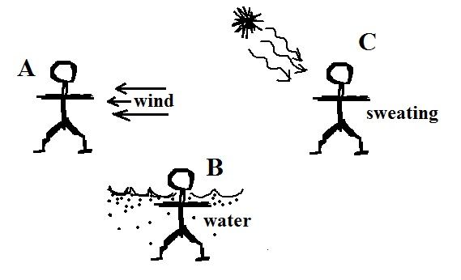
8. We are able to see the moon at night because it ABSORBS EMITS REFLECTS TRANSMITS visible light.

9. A person is standing outside on a cold windy day in Fig. A
at right. The person has fallen into cold water in Fig. B. In
Fig. C the person is perspiring heavily on a hot dry summer
day. Match each of the energy transport processes below
with the most appropriate situation at right.
conduction______ convection______ latent heat_____

10. An object with a mass of 40 grams absorbs 200 calories of energy and warms 15º C. You could use this information to determine the object's
a. density b. kinetic energy c. latent heat d. specific heat e. thermal conductivity

